St. Andrew’s C of E Infant School – Curriculum Newsletter
Autumn 1
Year 1
Science
The Human Body and Senses
- Identify, name and draw and label basic parts of the human body and say which part is associated with each sense.

English
Core Texts: Peace at last, Just one of those days, Whatever Next
Genre: Stories by the same author, recount
Marvellous Me!

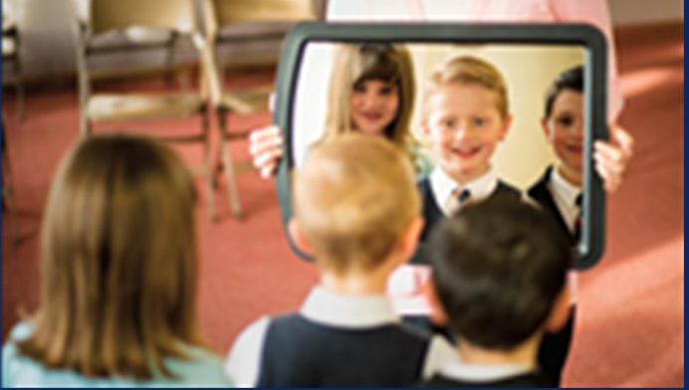

Maths
- Place Value
- Length
- Addition and Subtraction
- 2D and 3D Shape

Music
Hey, You!
- Develop vocal skills
- Rhythm, pitch, pulse

Geography
Our school and the surrounding area of Leyland
Making maps of the school grounds.
Exploring Leyland (small area of the United Kingdom)
Identifying human and physical features.

$$Value$$
Thankfulness

Art
Artist: Pablo Picasso Painting: Portraits
- Mix primary shades and tones.
- Mix secondary colours.

PSHRE

MyHappyMind – Meet your brain

Learn about the different parts of their brain and how understanding how it works can help them manage their emotions, behaviour and learning.
Religious Education
Creation
- Talk about what we find amazing, interesting or puzzling in creation.
- Understand that we are creative beings and enjoy their creative skills.
Harvest
- How and why we celebrate the harvest festival.
- How the Jewish festival Sukkot is celebrated.

Computing
Online Safety and Exploring Purple Mash

PE
Year 1 FMS Baseline Unit – Supertato
Year 1 FMS – Rolling a Ball

