Living Out Our Christian Vision

Owls Class

Here’s how we flourish

Spring 2

History
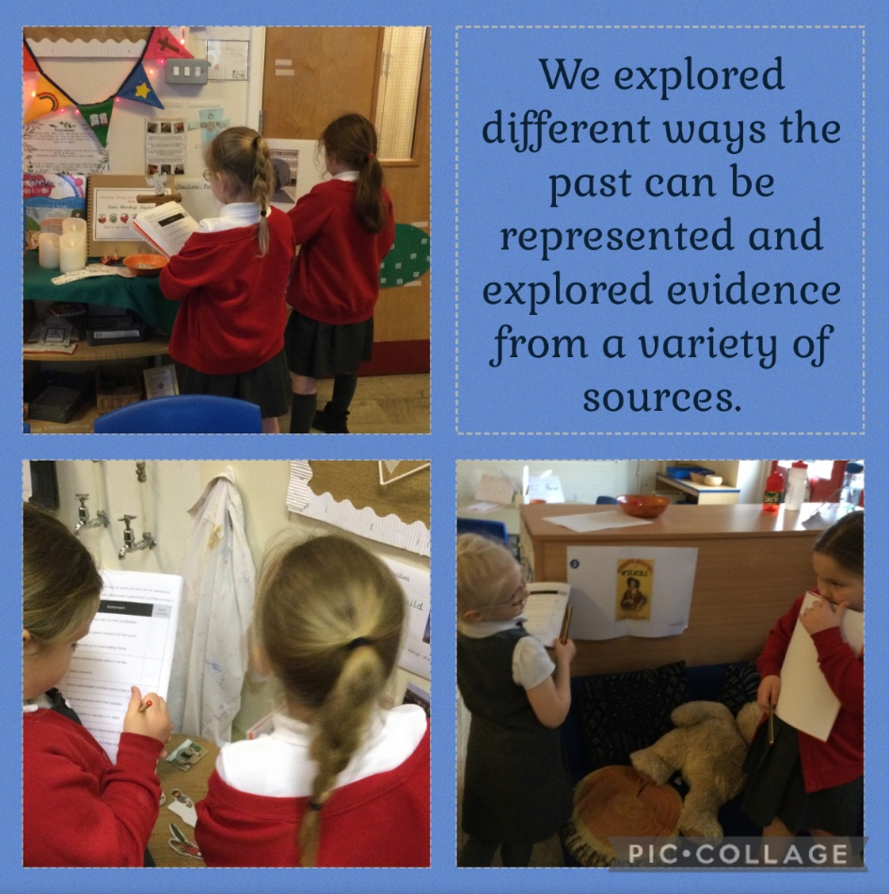
In History we looked at evidence to see which source matched the statements.

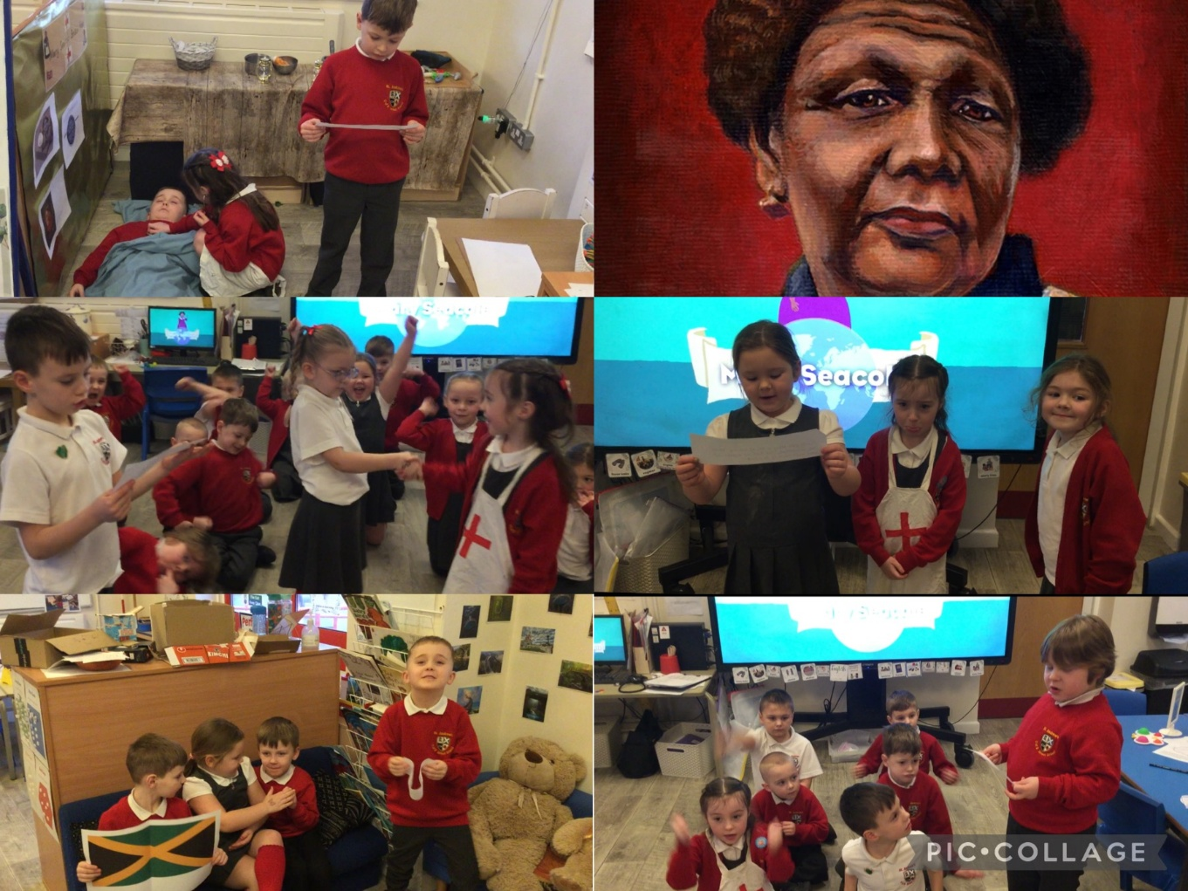
We made a VAK timeline to help us to remember the life of Mary Seacole and understand why she was a significant person.

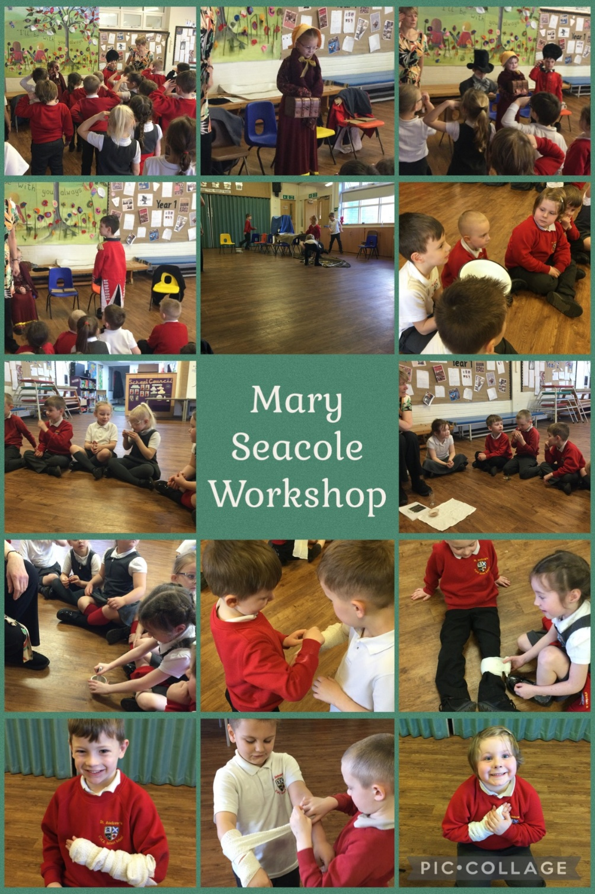
We enjoyed a Mary Seacole workshop.

Science
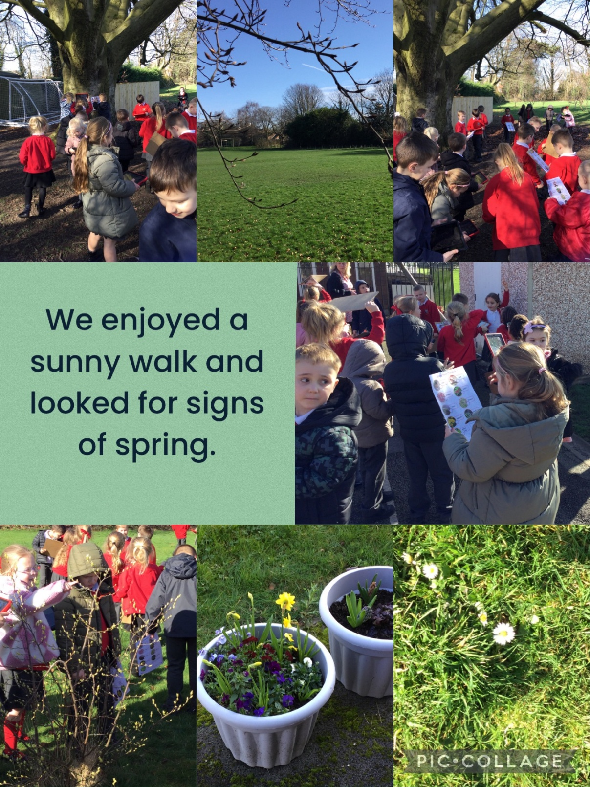

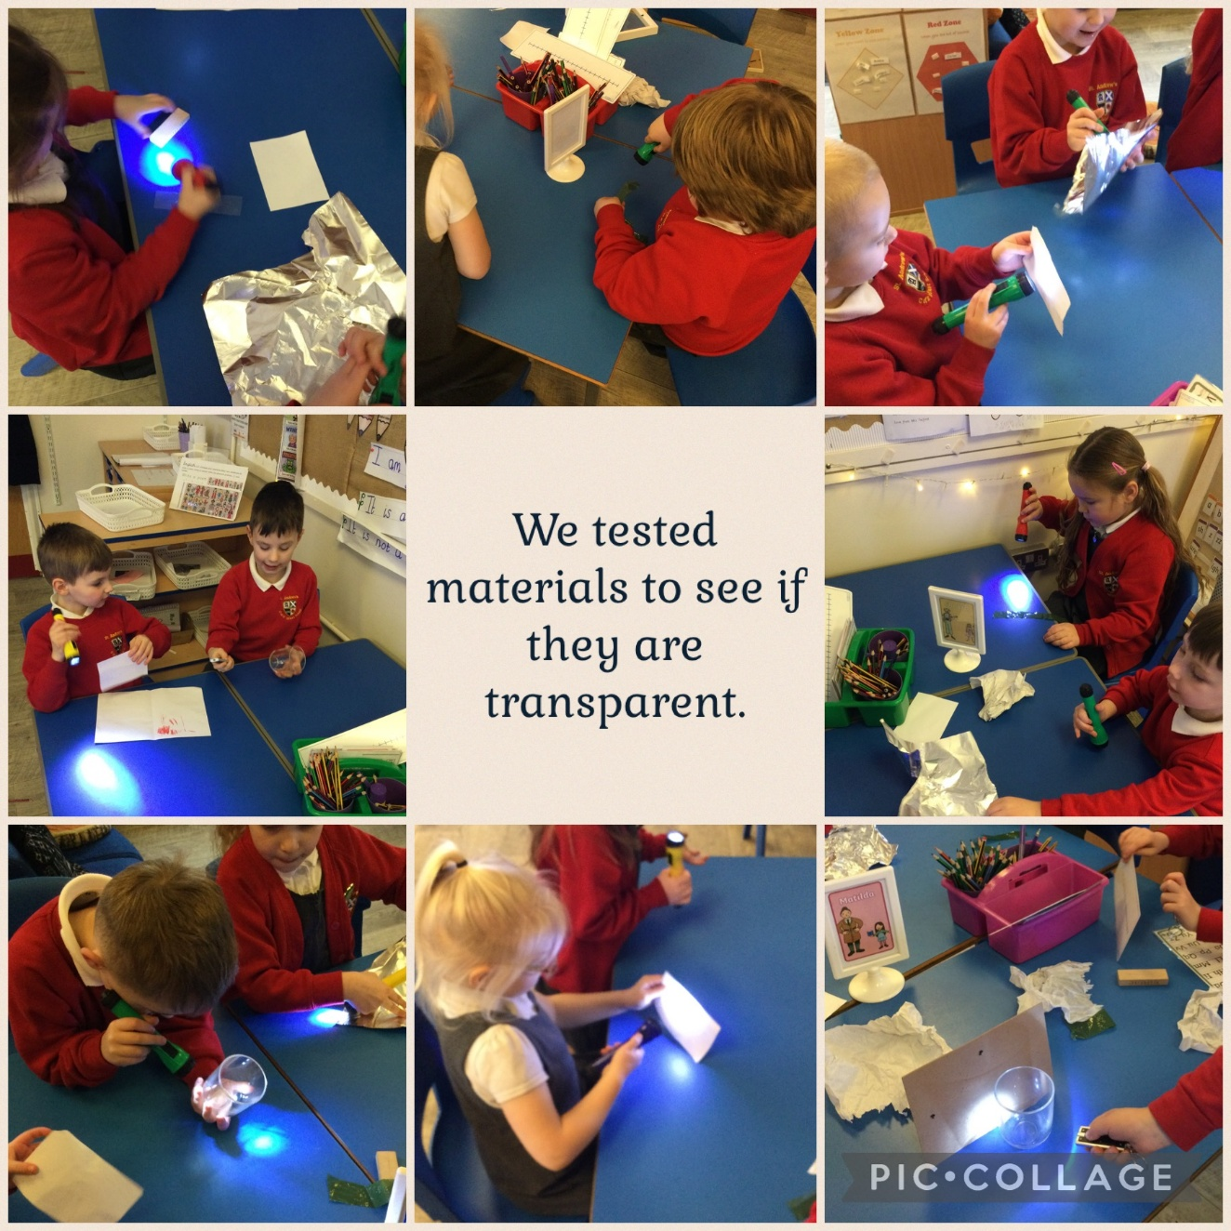
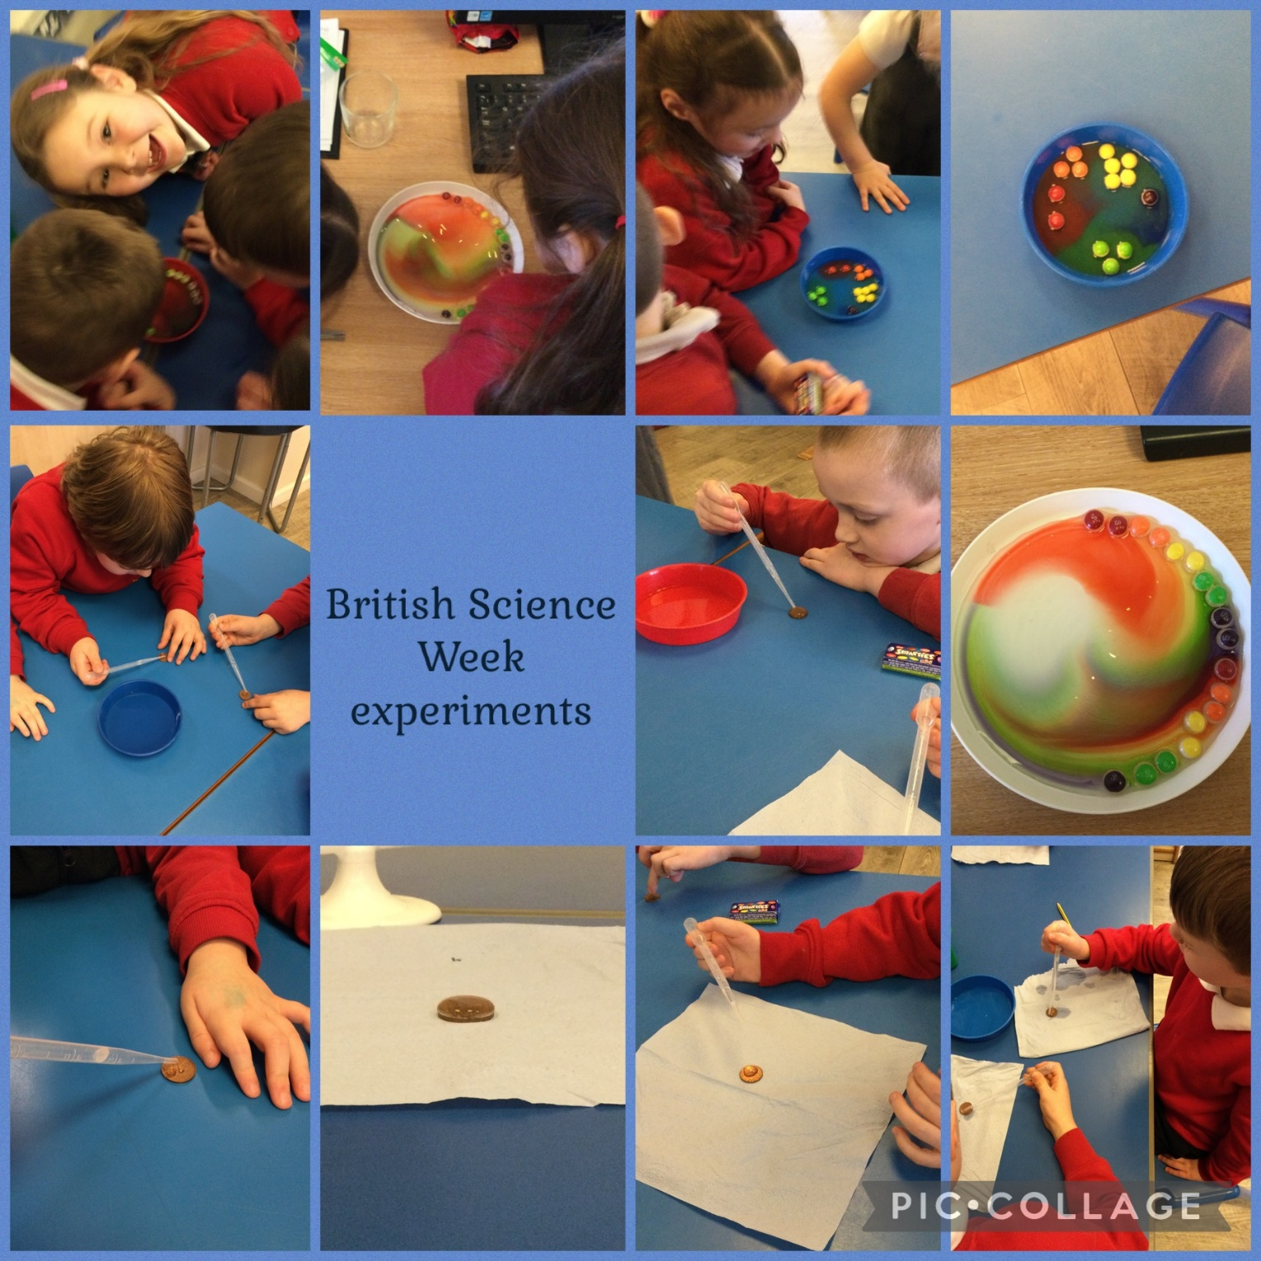

DT
In DT we explored how to make structures stronger by rolling paper and cutting the bottom of the roll to make it stronger.
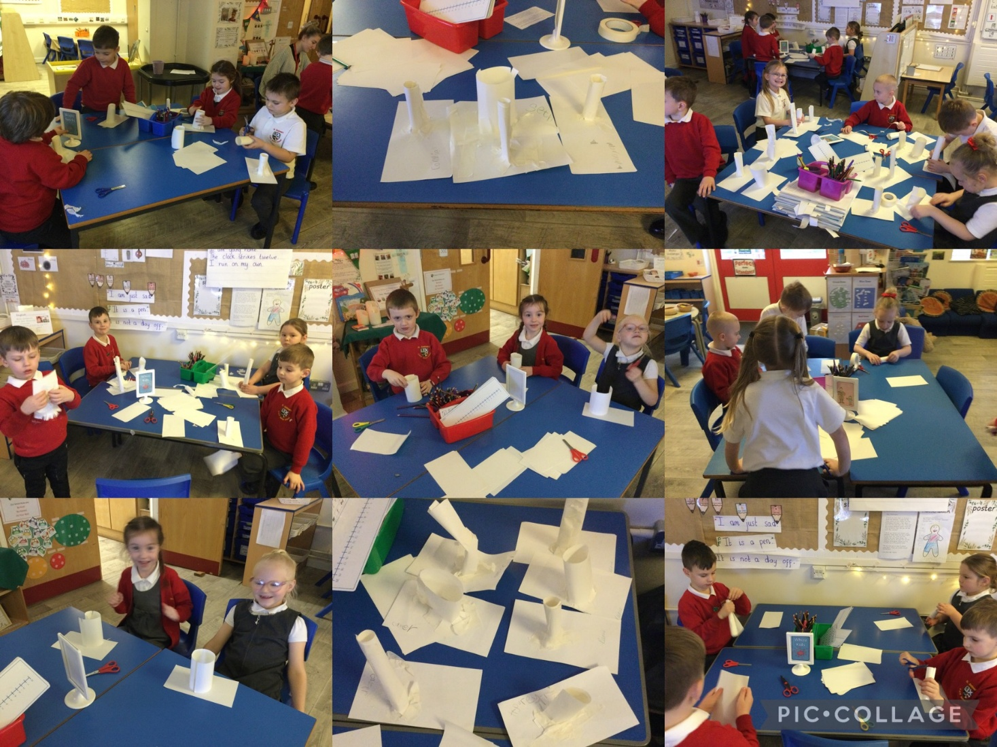

We also explored building strong structures using a variety of different resources.
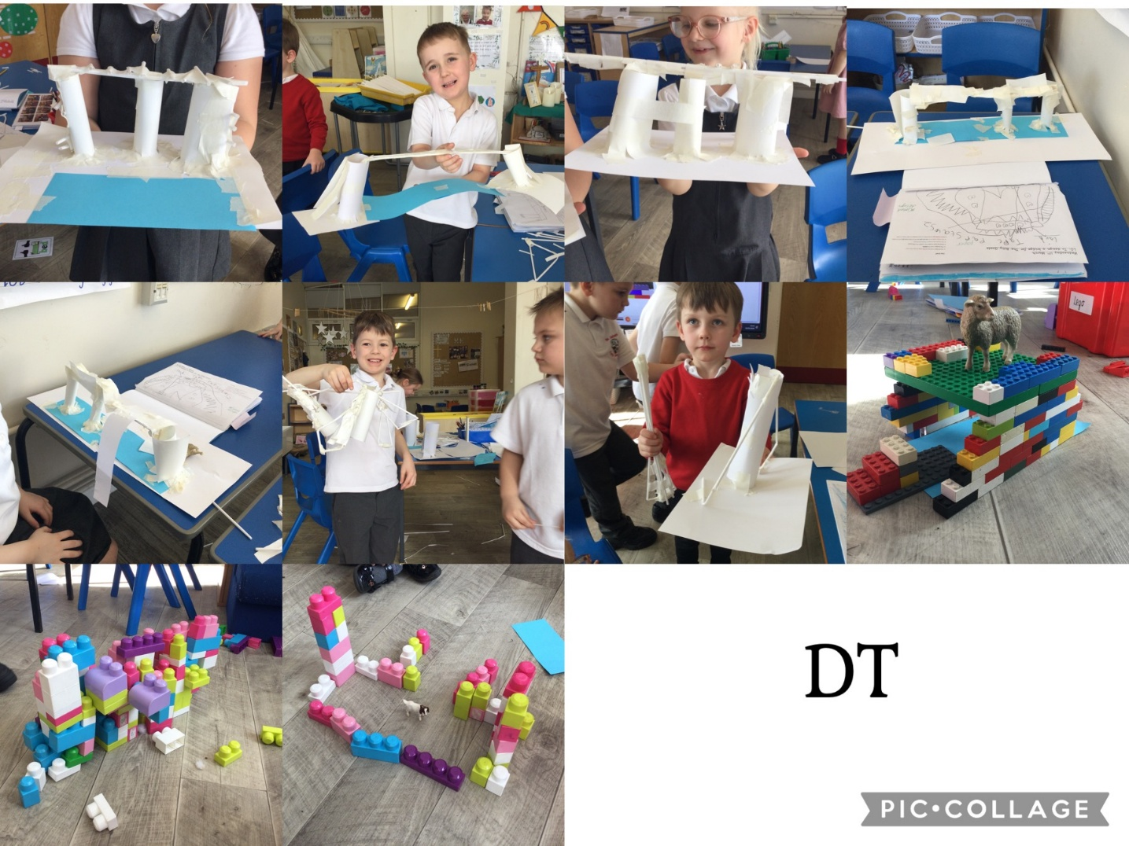

PSHRE
We have been learning all about our brains in Happy Minds. We made glitter jars to help us control our emotions.

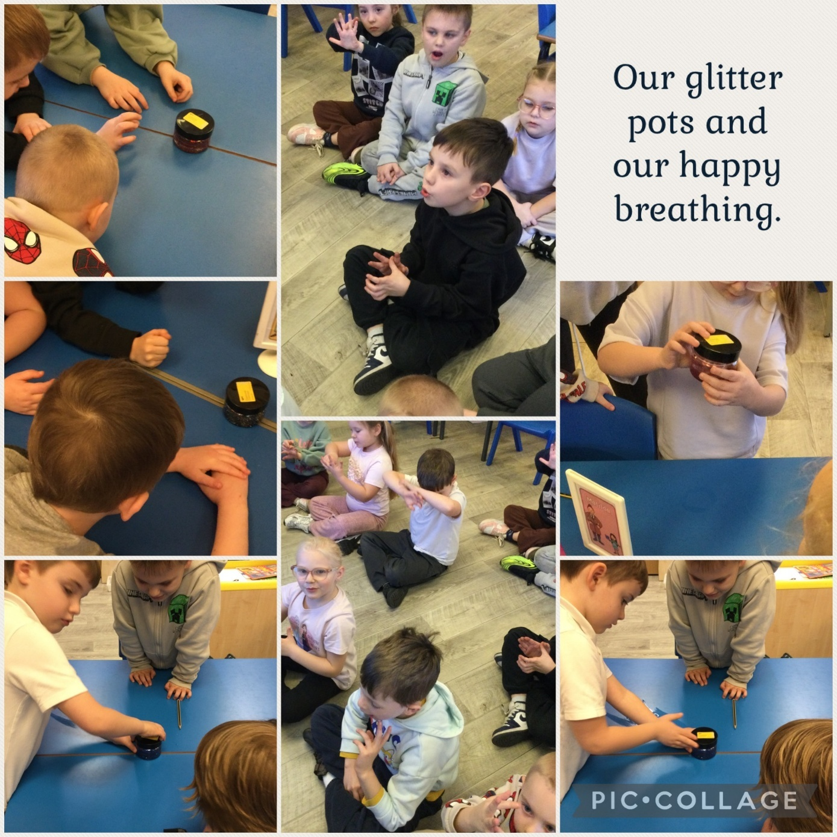

English
An intruder had been in our classroom, we hunted for clues and guessed that it was a Troll!
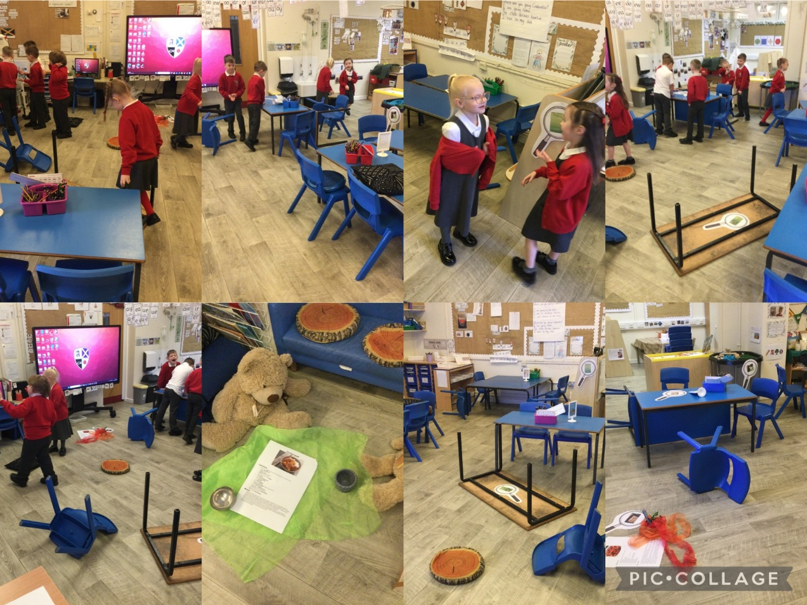

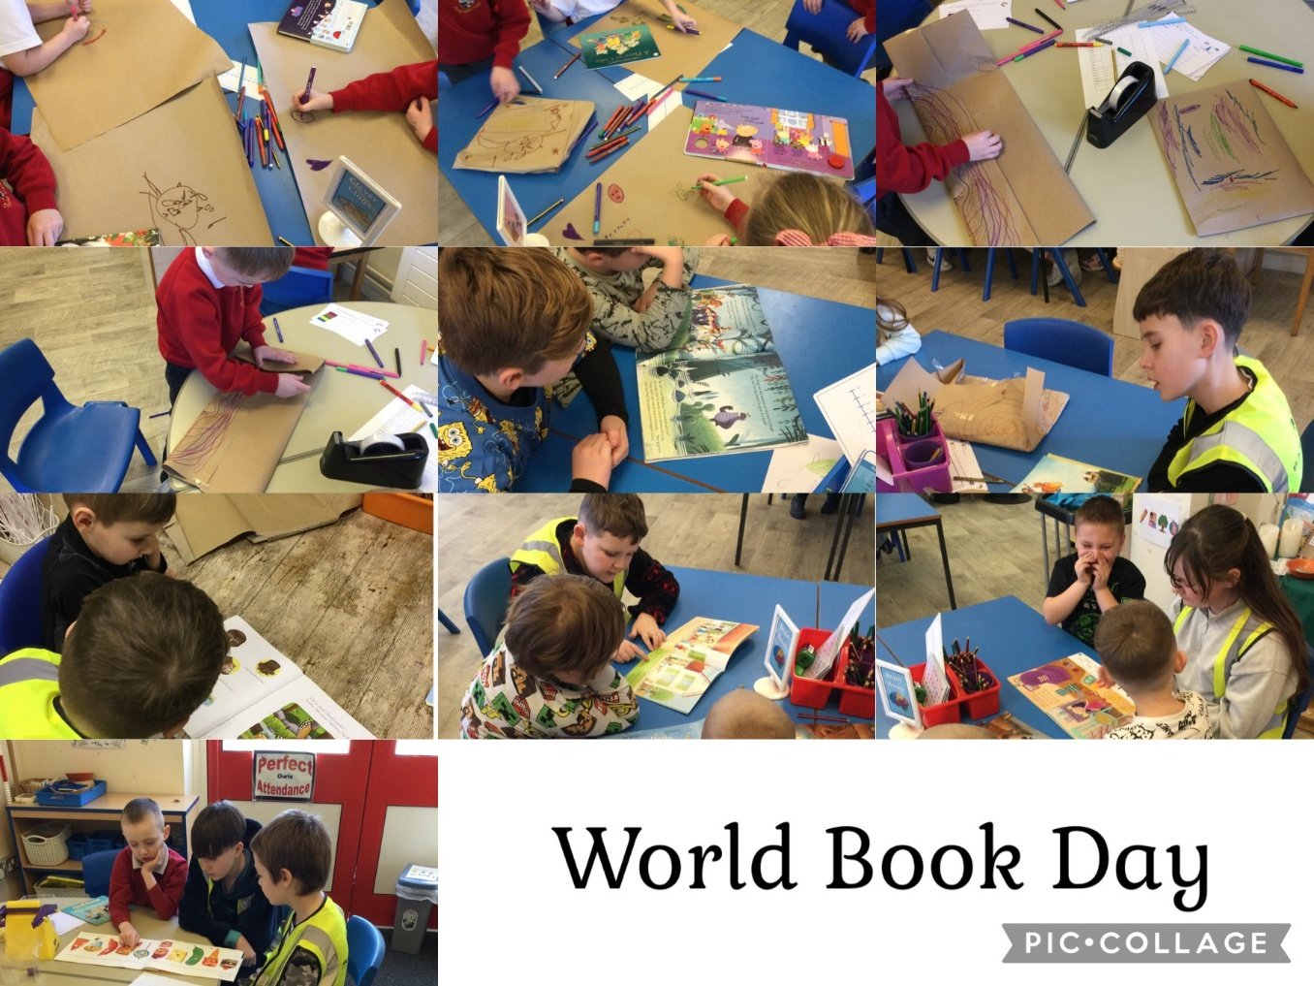During World Book Day we decorated wrapping paper and wrapped our books to exchange with each other. Year 5 children from Woodlea came to read us stories.

PE
In PE we have been perfecting our overarm throws and got to take part in a wellbeing festival.
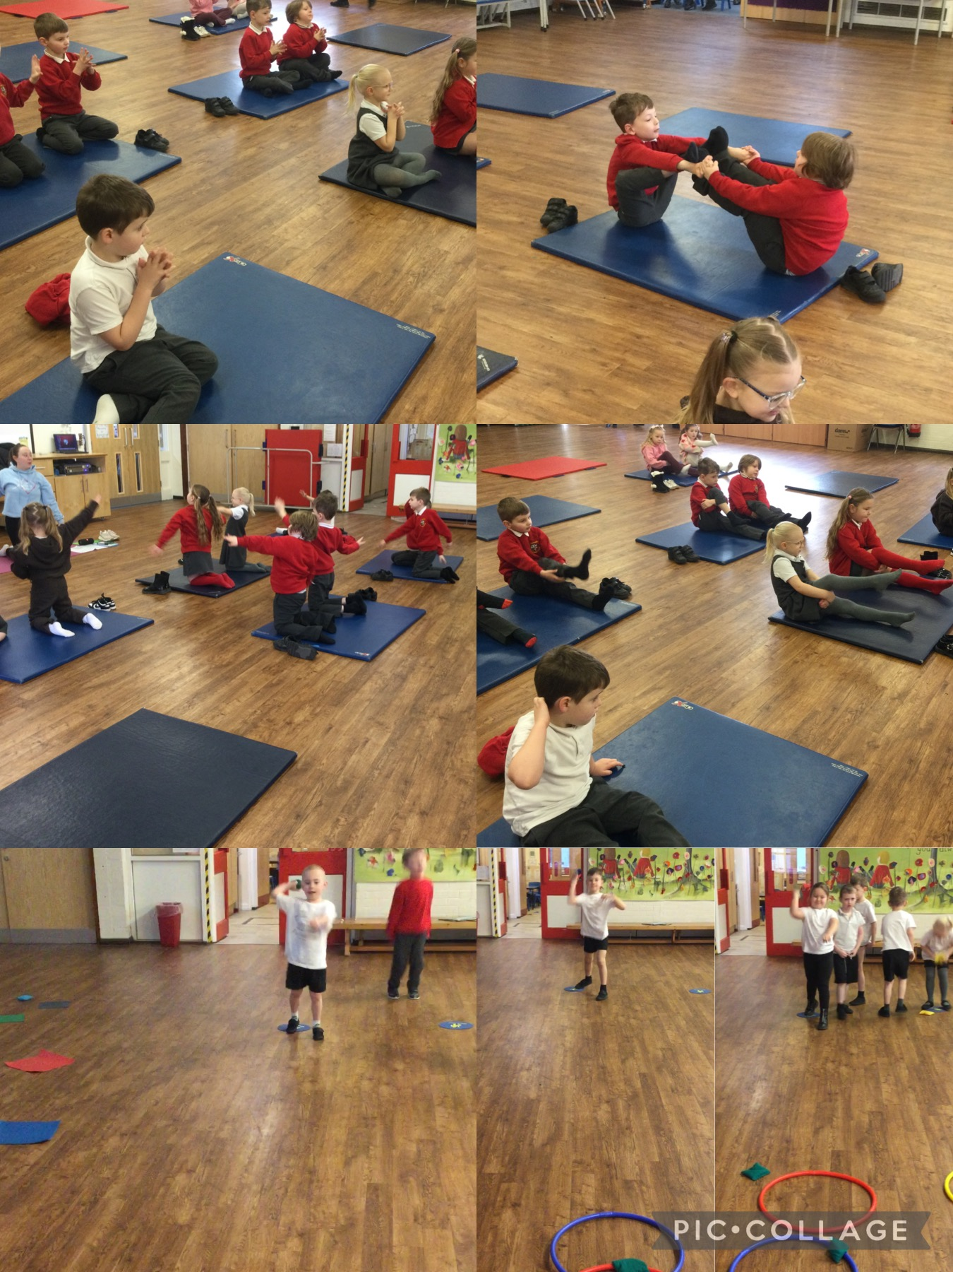
Independent learning areas
The children have enjoyed exploring in our independent learning areas this half term.
