RE Blog

Owls Class
Spring 2

This half term we have been learning about the Easter story. We reflected in the awe and wonder of new life and changes in nature. We talked about our own experiences of Easter and springtime.

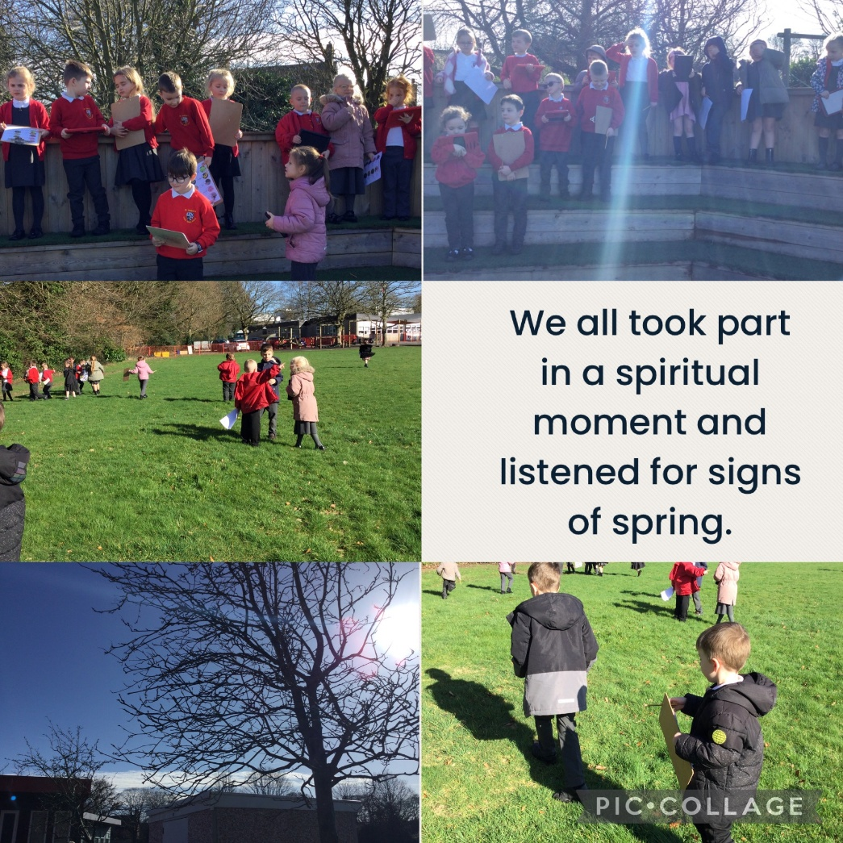

We linked the Easter story to the lifecycle of a butterfly.

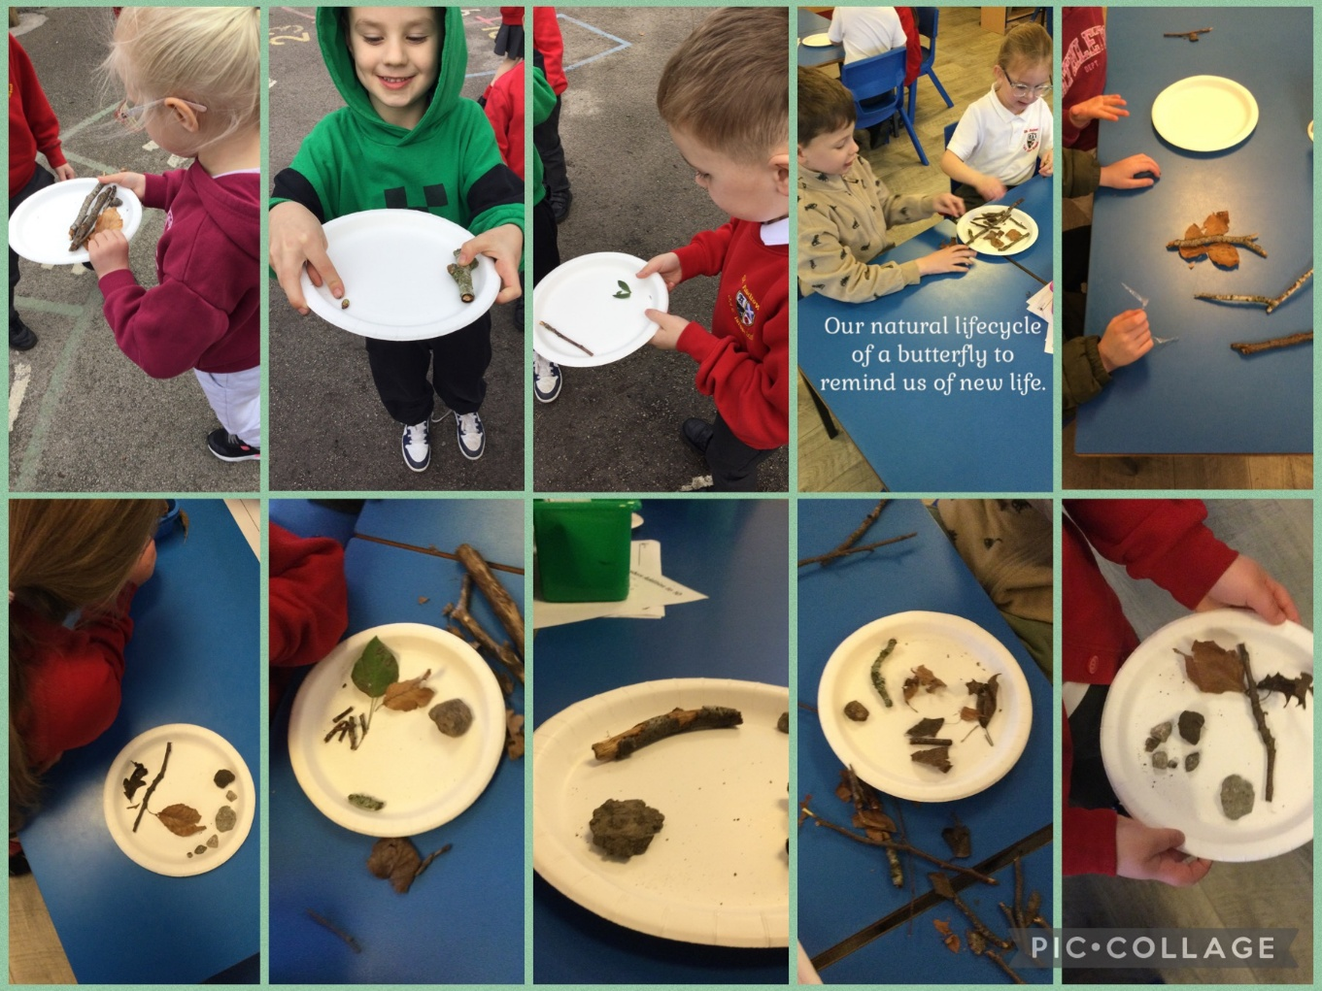
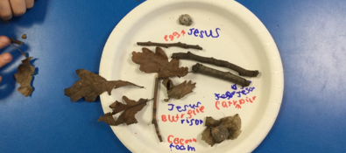

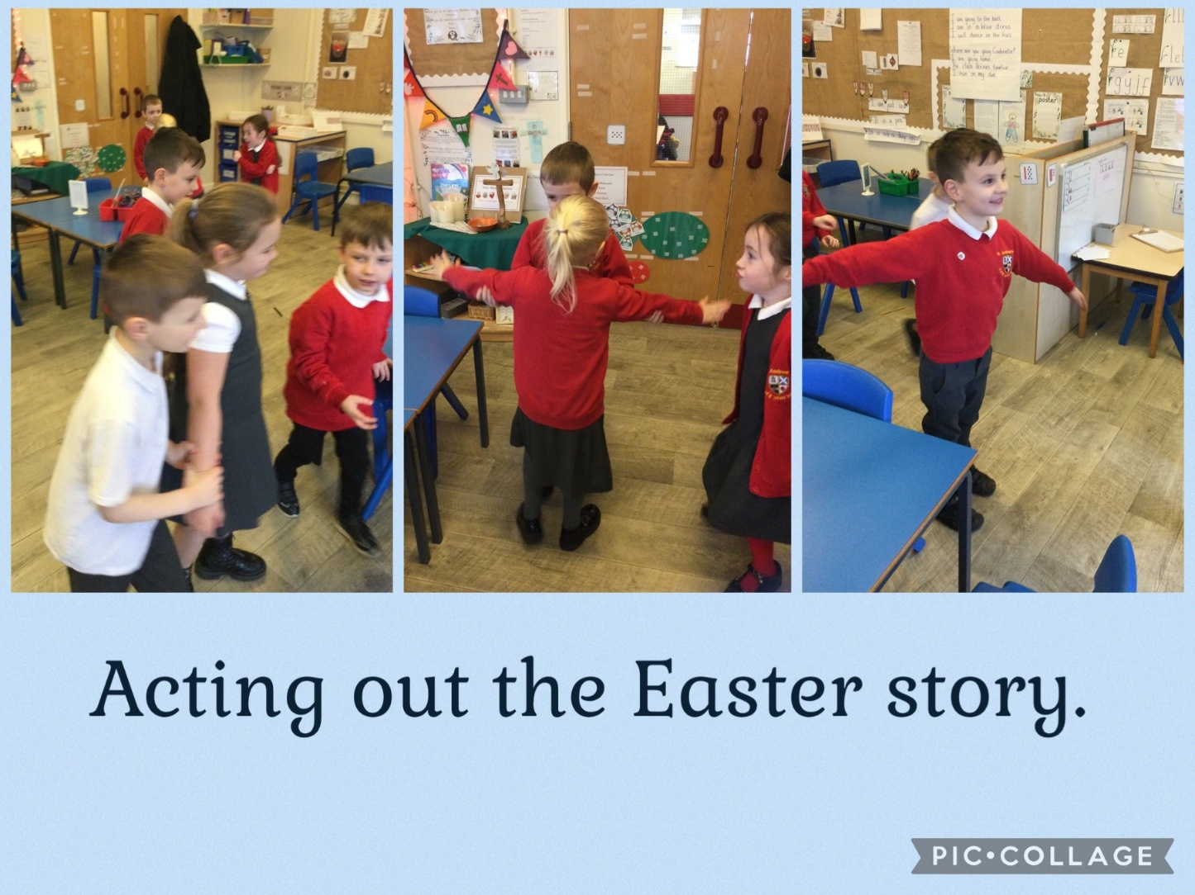

The children explored how Easter is celebrated in other countries.
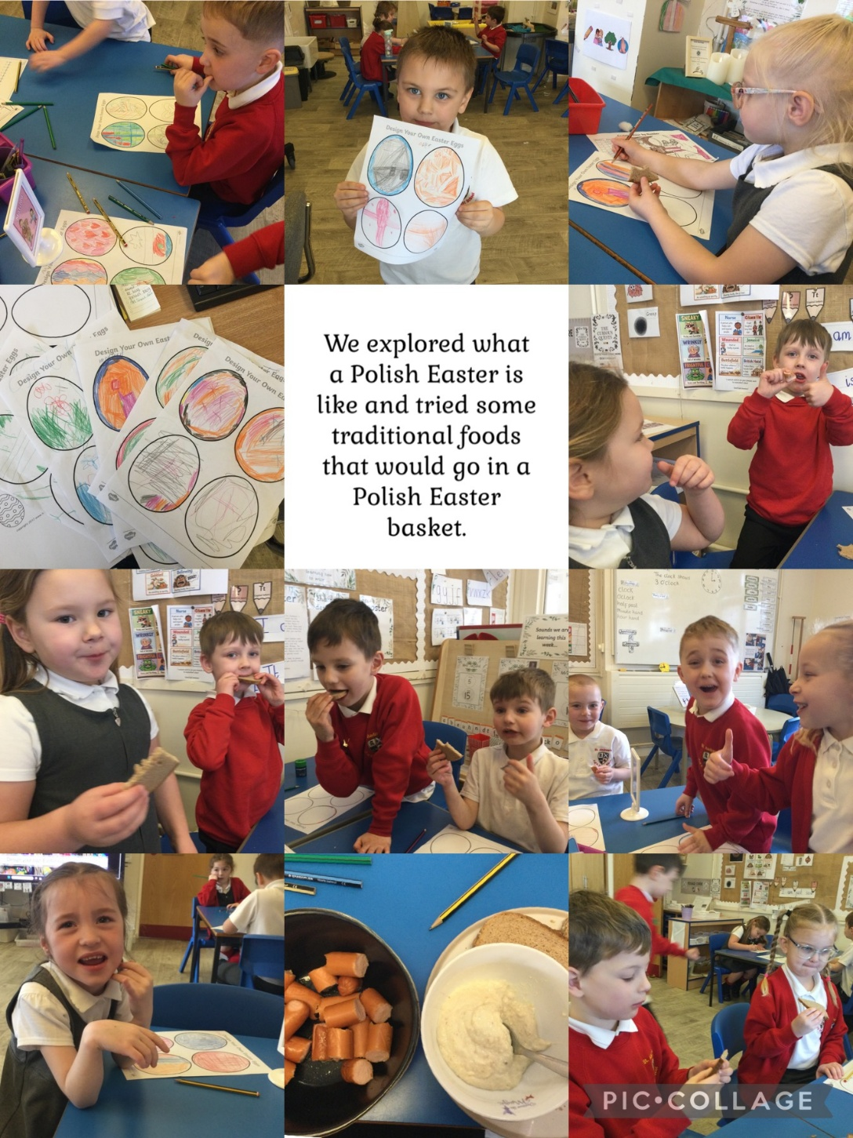
Our Easter service. 