St. Andrew’s C of E Infant School – Home Learning Ideas.
Spring Term 2
Year 1
Science
Key Vocabulary: Object, material, properties, transparent, opaque, rough, smooth, shiny, smooth

Collect a selection of objects from around your home, sort them into objects made of the same materials.
Photograph and post on dojo. Sign and date here to show it is done________________________________

English
Key Vocabulary: Fairy tale, poem, Instructions.

Draw and write about your favourite fairy tale character.

Fighting Fit

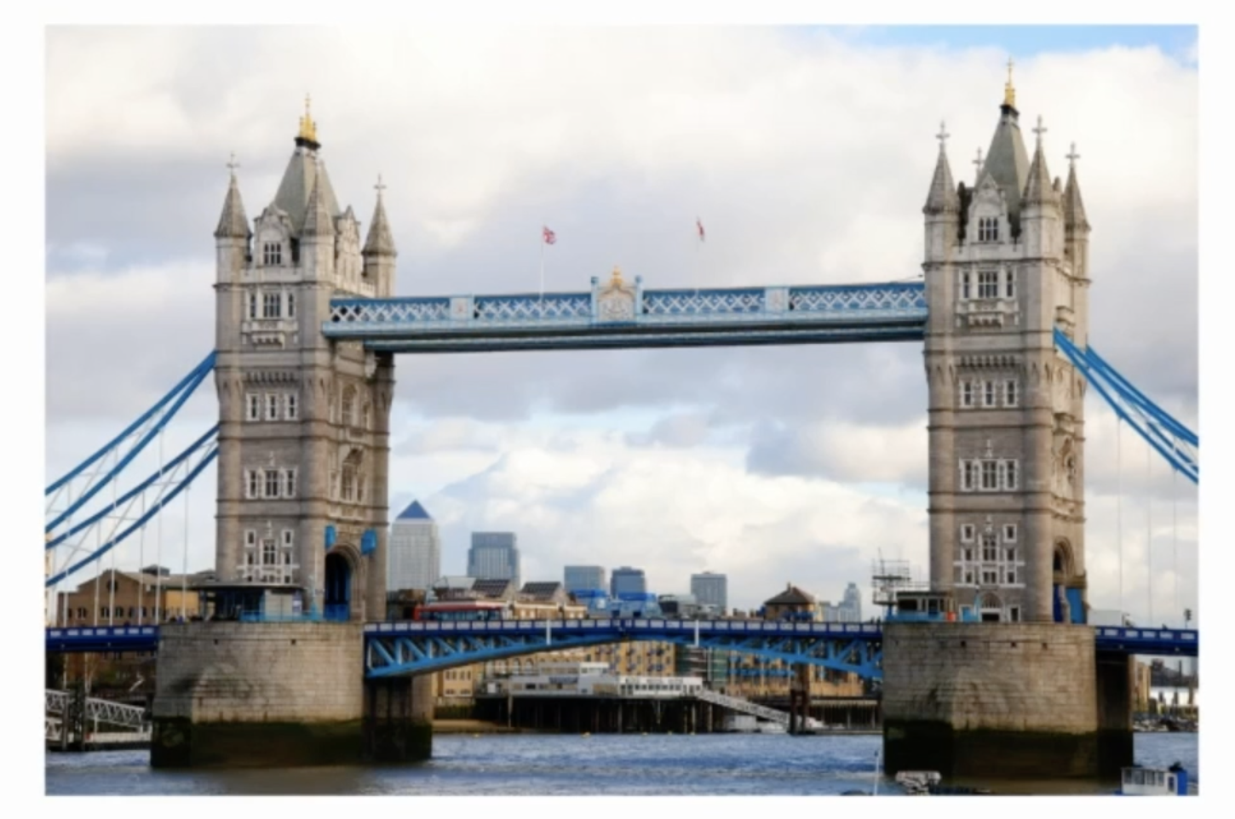

Maths
Key Vocabulary: length, subtract, add, O’clock, half past, fractions, half, quarter, whole.
Practise writing numbers to 100. Can you write a random number when it is said to you?

Music
Key Vocabulary: rhythm, rhyme, beat, pulse, tune, pitch.

Make your own musical instrument Photograph and post on Dojo. (Sign and date here to show it is done________________________________

Christian Value
Foregiveness

History
Key Vocabulary: Mary Seacole, Jamaican, significant person, hotel, battlefield, leadership, patient, Crimea War, soldier.

Make a simple fact file about Mary Seacole.

PSHE
Key Vocabulary: Brain, Cells, Team H-A-P, Hippocampus, Amygdala, Prefrontal Cortex, Happy Breathing, Neuroplasticity, Big Emotions
Tell your grown ups how your brain works.
DT
Key Vocabulary: design, model, structure, arrange, material, join, strong/weak, stable, bridge.

Find out about different types of bridges, draw some in your homework book.

Religious Education
Key Vocabulary: Good Friday, Easter Sunday, Jesus, new life, holy week, disciples, Mary, resurrection, garden, tomb.

Create an Easter garden.
Photo and post on Dojo or we would love you to bring them in. (Sign and date here to show when it was made) ________________________________

Information Technology
Key Vocabulary: maze, technology, online safety.
List all the types of technology that you have within your home.
Physical Education
Key Vocabulary: dance, beat, rythmn, over arm throw

Practise your over arm throw, how far can you throw a ball? – (Sign and date here to show it is done________________________________)

