RE Blog
Owls Class

Autumn 2 - Sukkot
We have been learning about the Jewish celebration of Sukkot. We learnt about how God led the people out of Egypt to freedom and how the people sheltered in Sukkah’s. We enjoyed learning about how Sukkot is celebrated by Jewish families. We made Sukkah’s as a group.

Our Sukkah’s
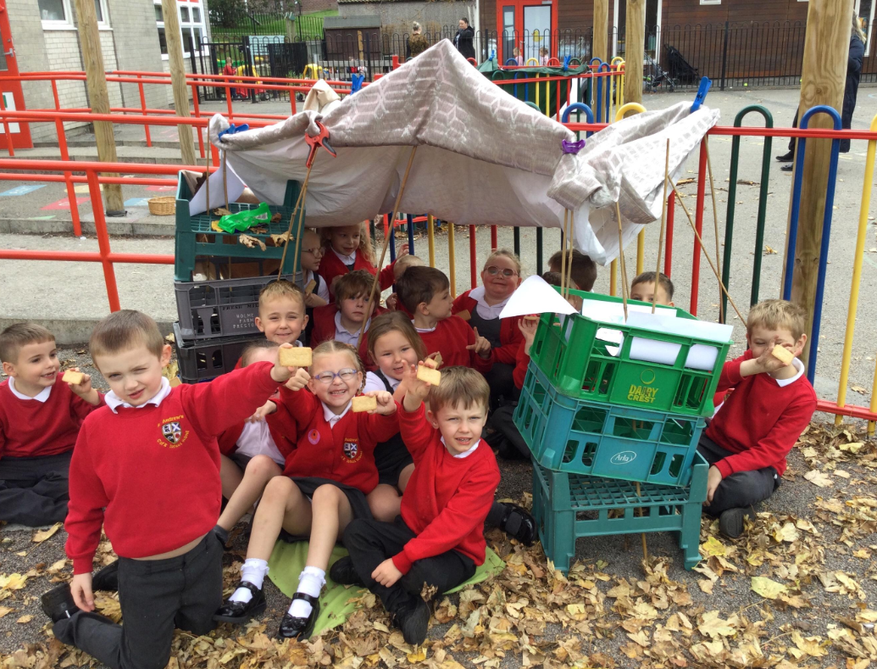
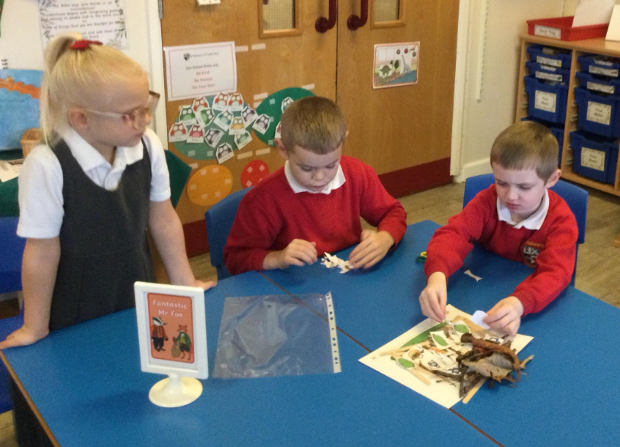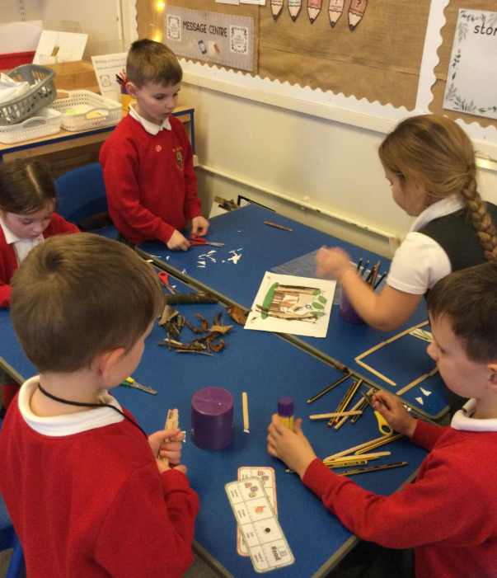
Black History Month

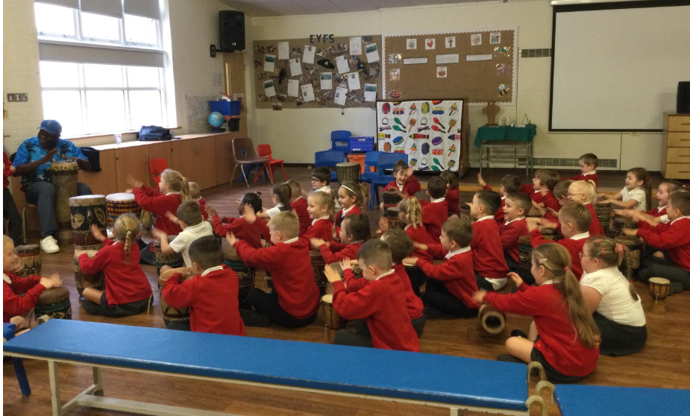
We celebrated Black History Month
with a drumming workshop and dancing. We talked to the children from the school in Choma.

World Faith Week
To celebrate World Faith Week, Imran came in to talk to us about his religion, Islam. We got to ask questions and found out lots of interesting things. We also create our own Islamic art. We used shapes and bright colours to create patterns.
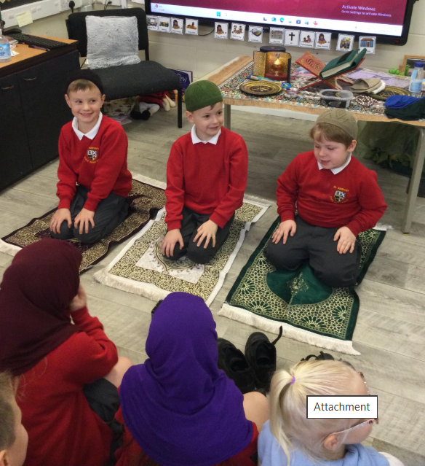
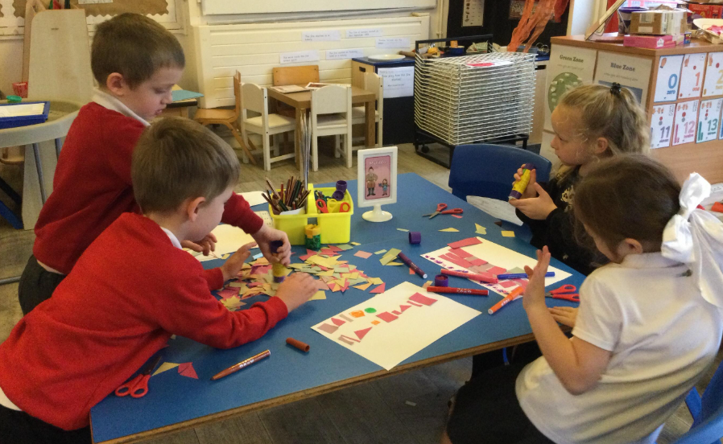

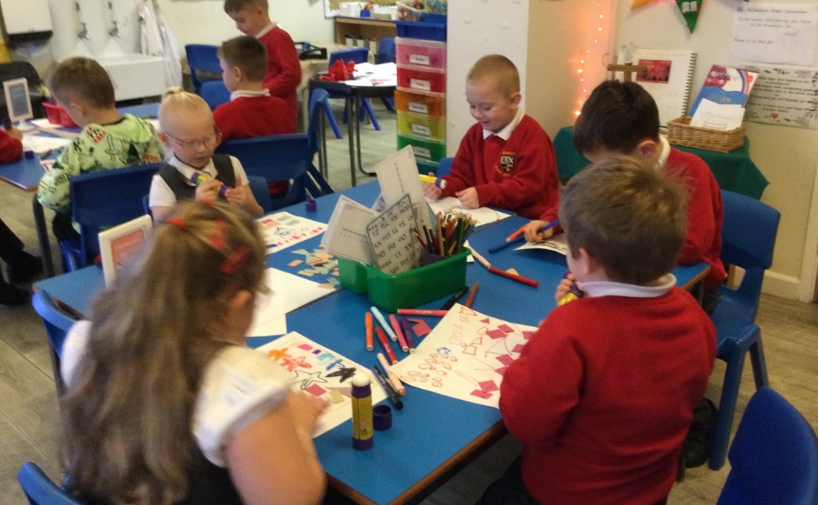

Autumn 2 – Christmas
We have been learning about giving and receiving gifts and that Jesus was a promised gift from God.
We talked about gifts that are not objects e.g. love.
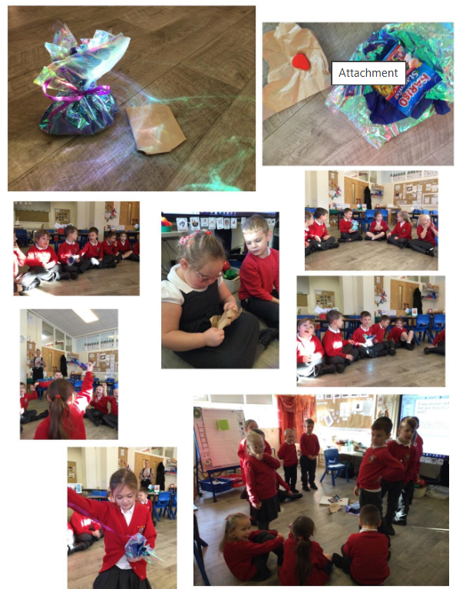

We made gifts for our families. We made calendars.
We shared our ideas about what our gift to Jesus would be this Christmas.
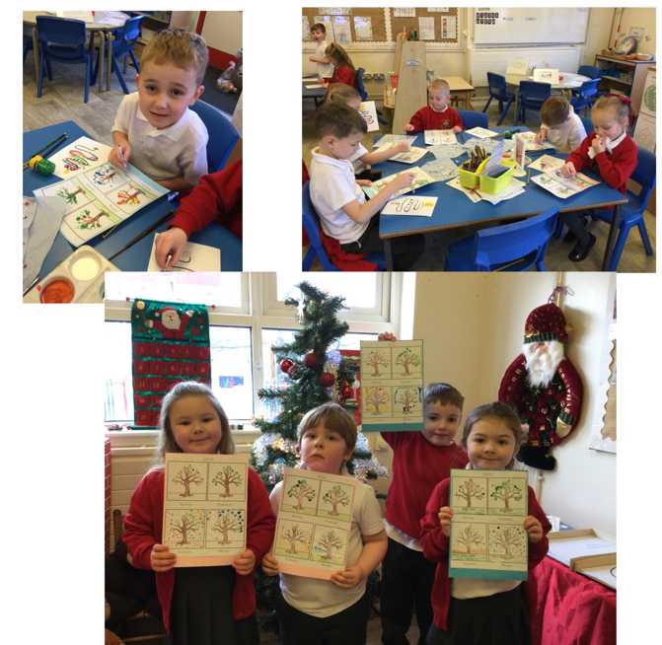
‘My gift to Jesus this Christmas is love. I’m going to give hugs to my family’

The Nativity Story
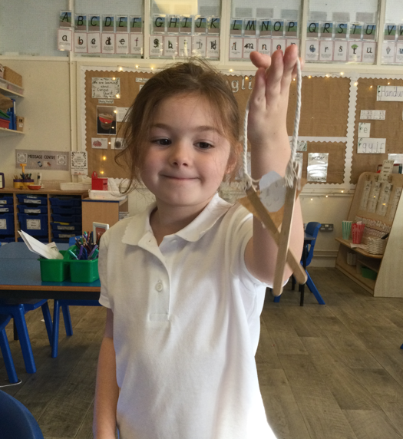
We read the nativity story in the Bible and we retold the story in a variety of ways. We used Lego and playdough to create the nativity scene, sequenced pictures and did our own drawings. We used the small world area to role play the very important story.
