Living Out Our Christian Vision
Owls Class
Here’s how we flourish …

Autumn 2
We made fruit salad in DT

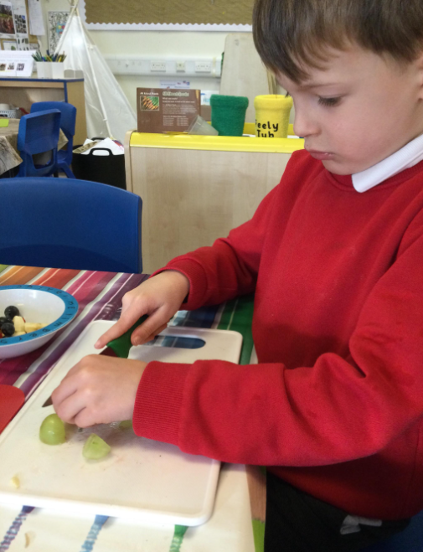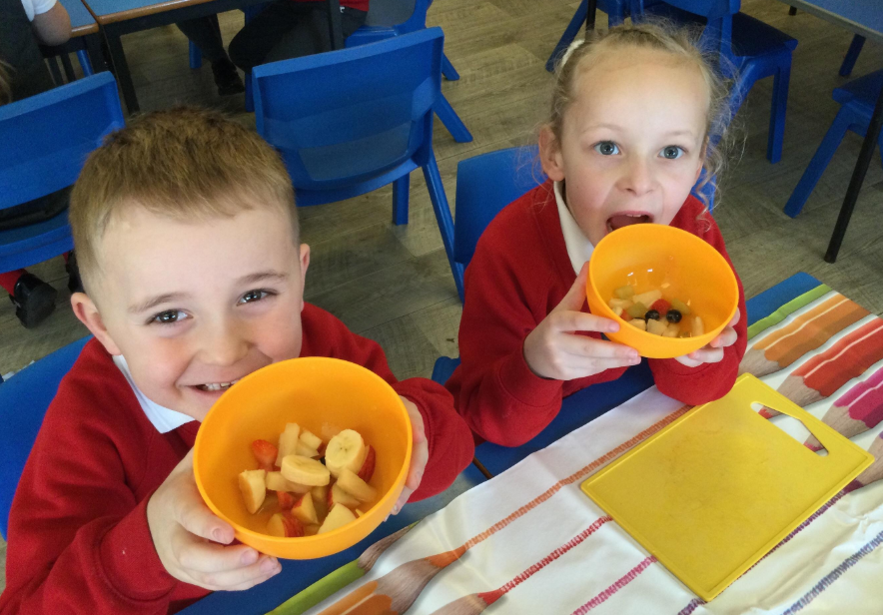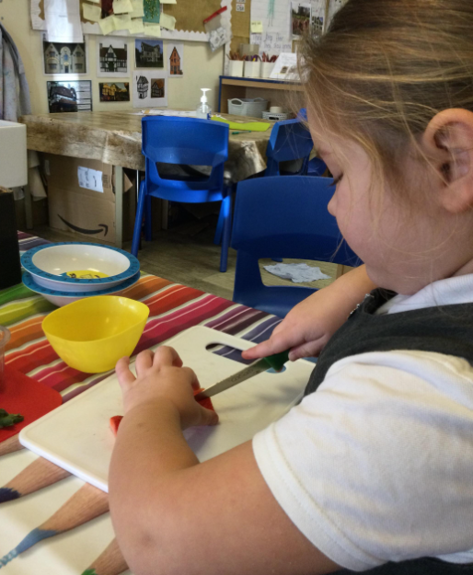

‘It was delicious!’

We went on an autumn walk, we enjoyed kicking leaves and looking for signs of autumn.

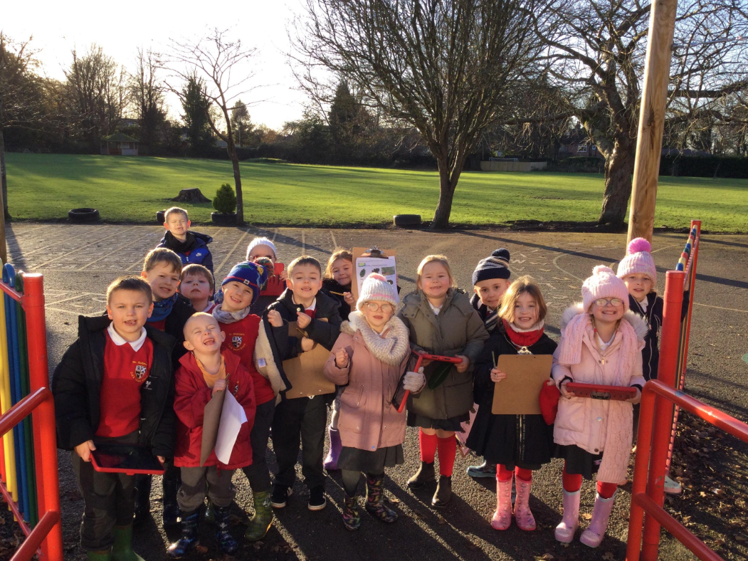

We labelled trees in Science…

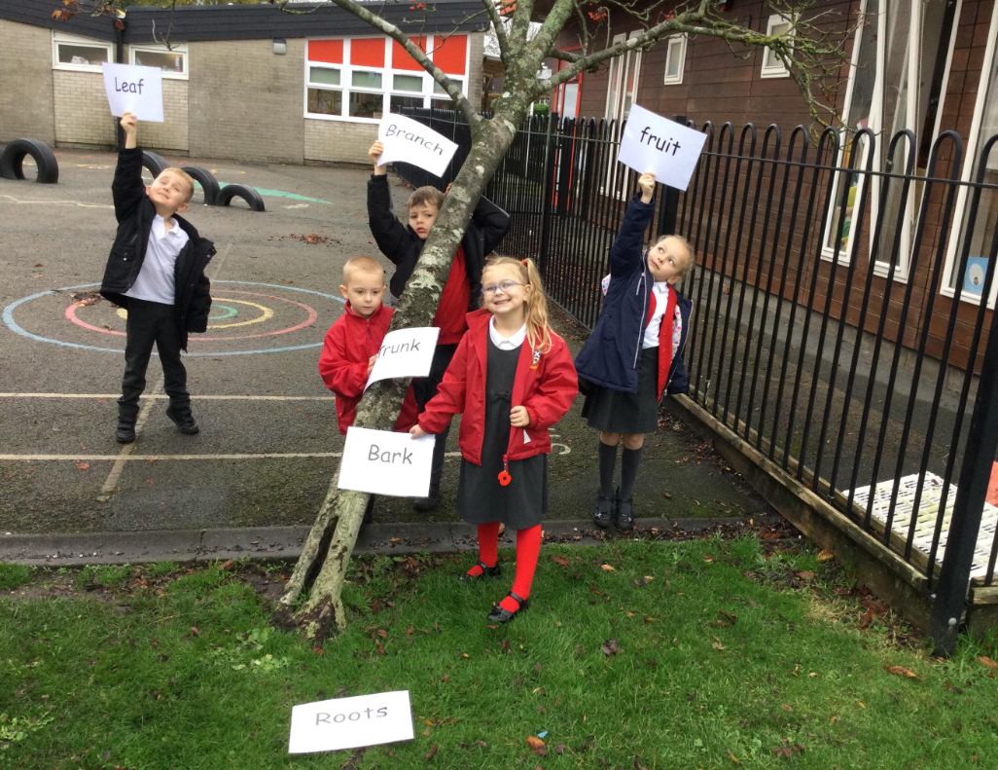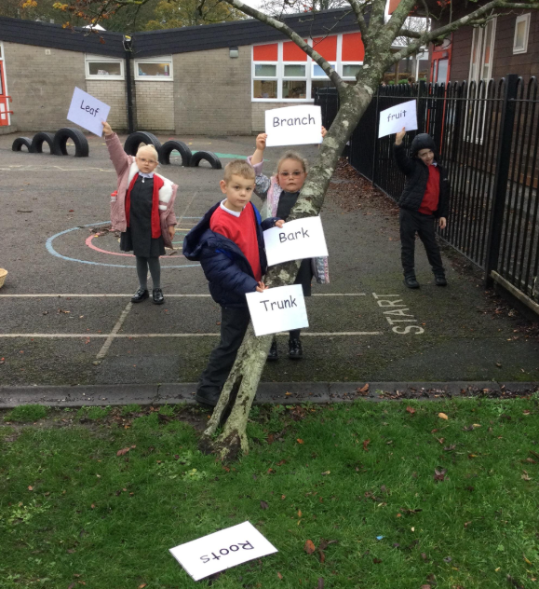

We loved the dance festival
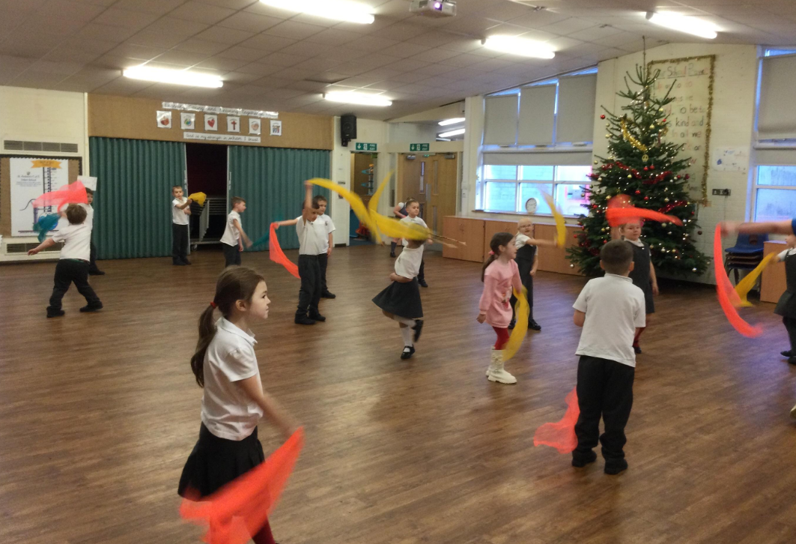

We celebrated ….

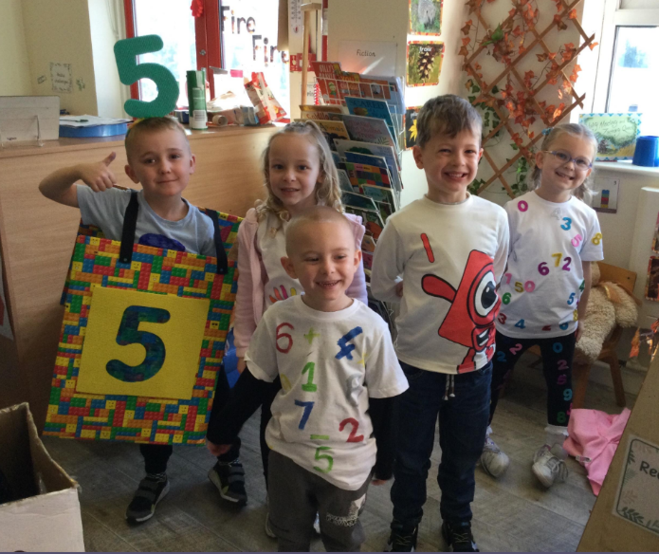
St Andrews Day Dress as a Digit Day
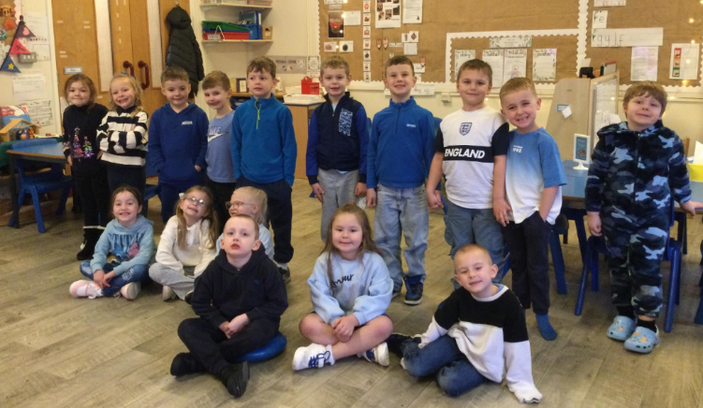

Children In Need and Friendship Week
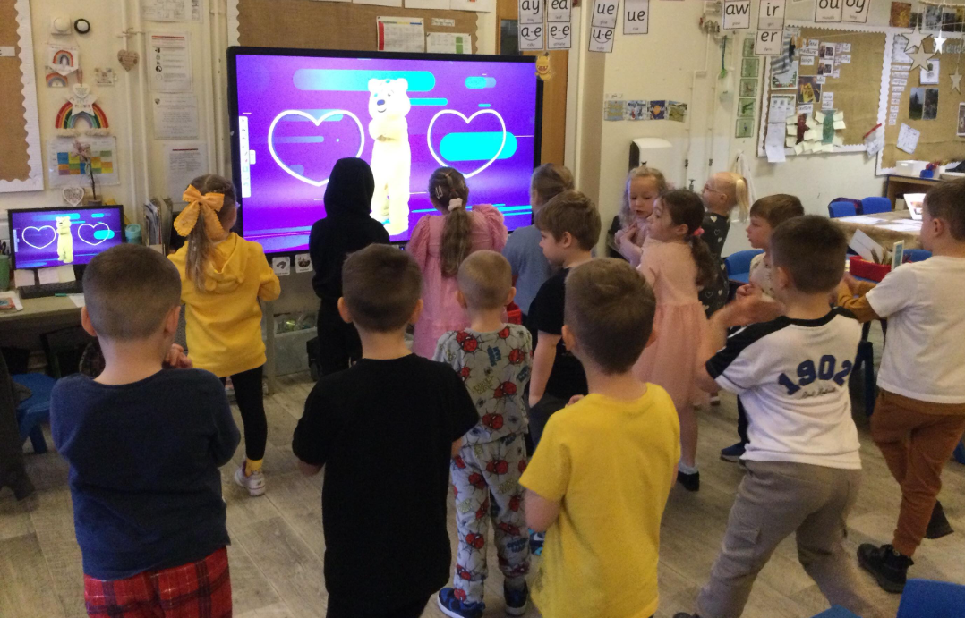

Michael Rosen Poetry Day- We read the poem ‘I’m hungry’. Children recited their own poems to the class.

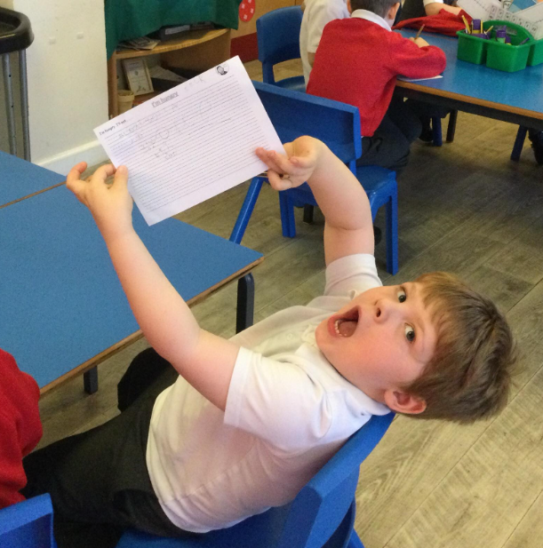
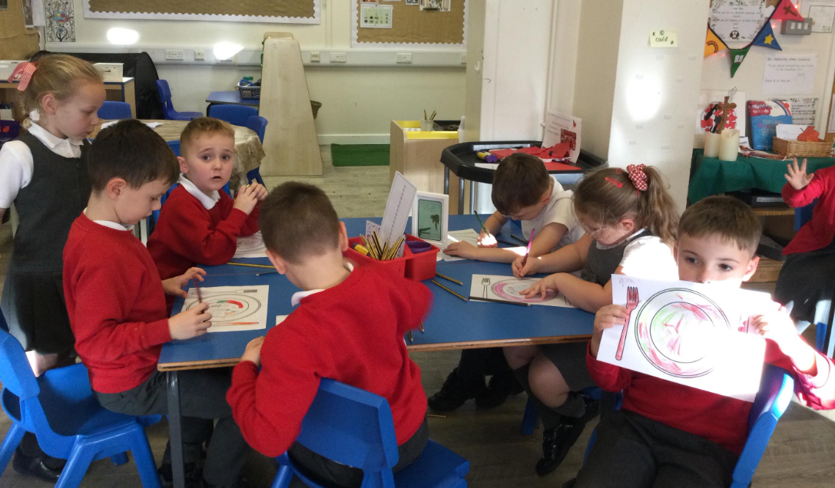

“I’m so hungry I would eat…”

We loved learning about The Great Fire of London in History. We went to the fires station and tried to put out the fire with buckets.

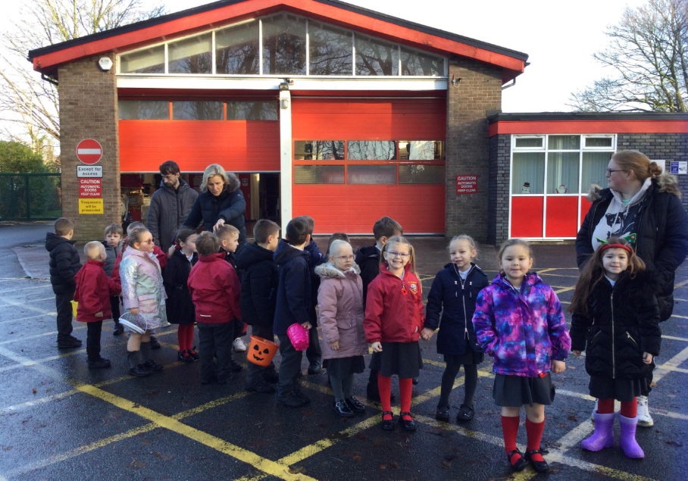
‘We enjoyed watching the houses burn’

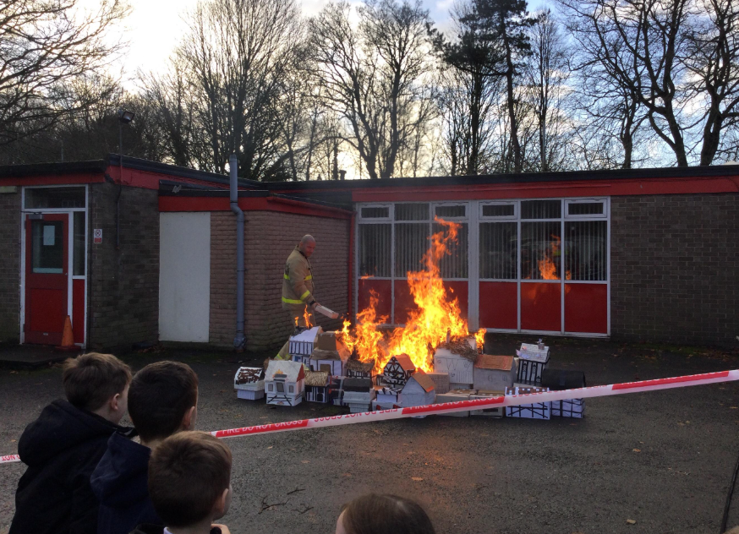

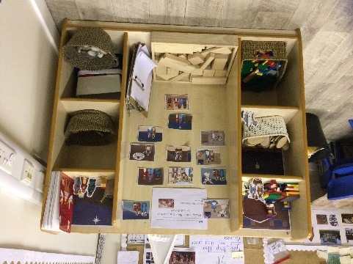
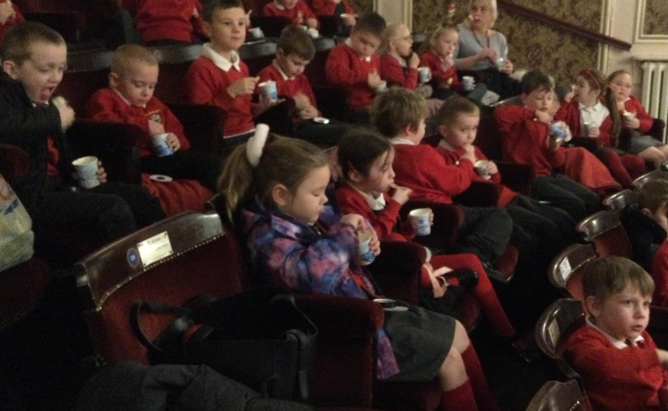
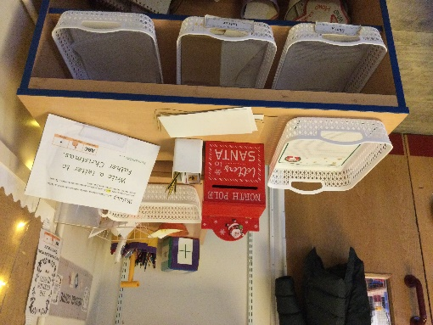
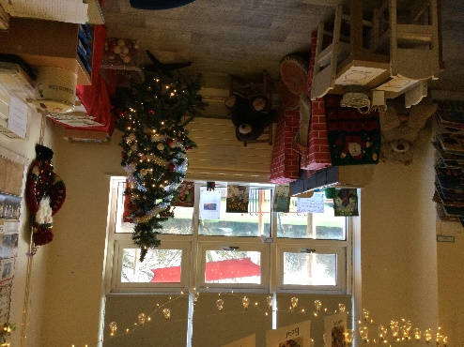
Christmas
We went to the pantomime. We had a party and Christmas dinner together.

