RE Blog

Owls Class

Autumn 2 - Sukkot

We have been learning about the Jewish celebration of Sukkot. We enjoyed learning about Sukkot is celebrated by Jewish families. We made our own Sukkah’s.

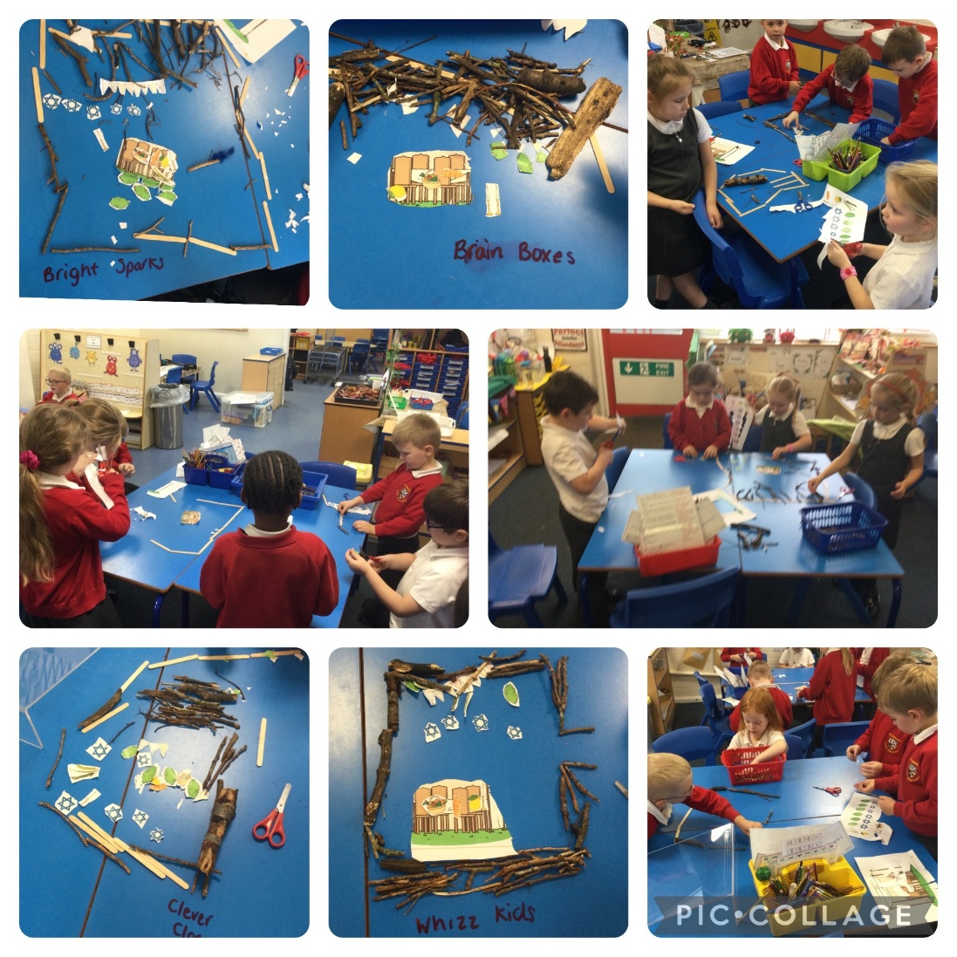
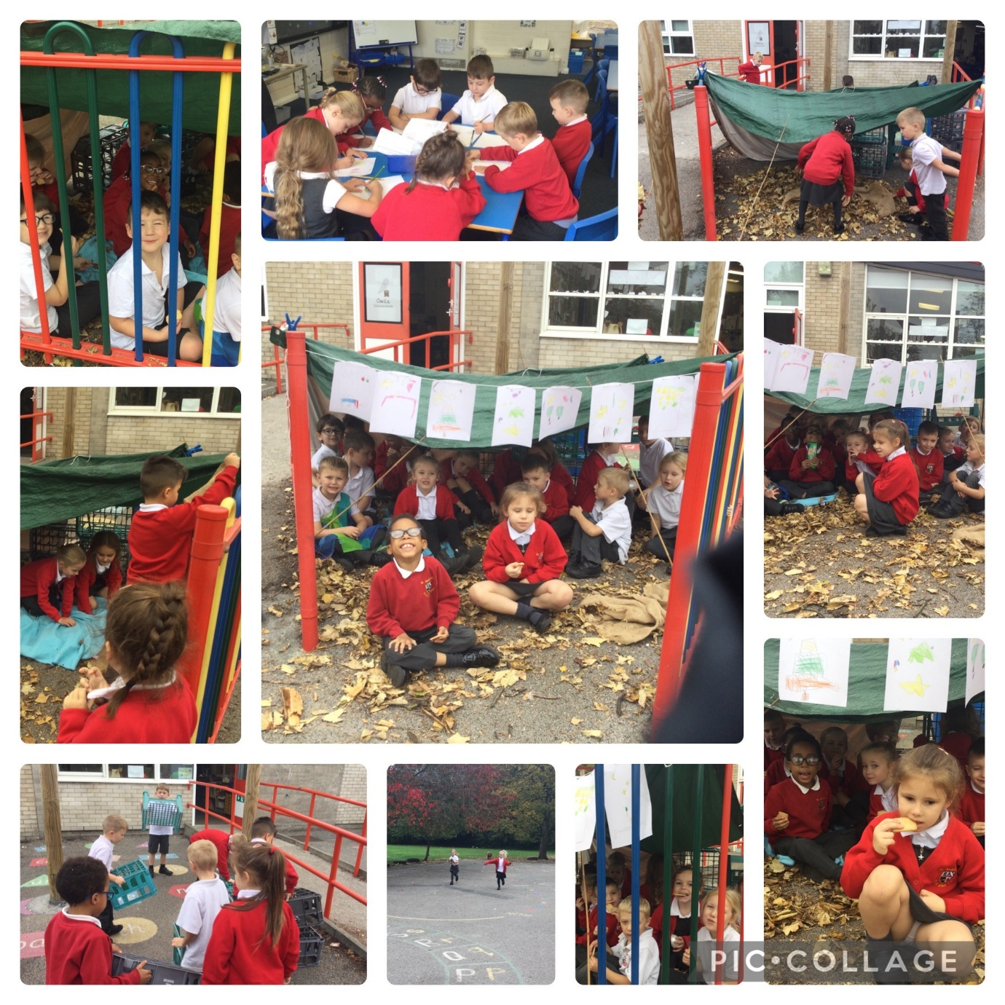

“I made a picture to decorate it. It was fun and we ate biscuits!” (Nico)

Autumn 2 – Christmas

We have been learning about giving and receiving gifts and that Jesus was a promised gift from God.
We talked about gifts that are not objects e.g. love.
We made our own gift for our family. We shared our ideas about what our gift to Jesus would be this Christmas.
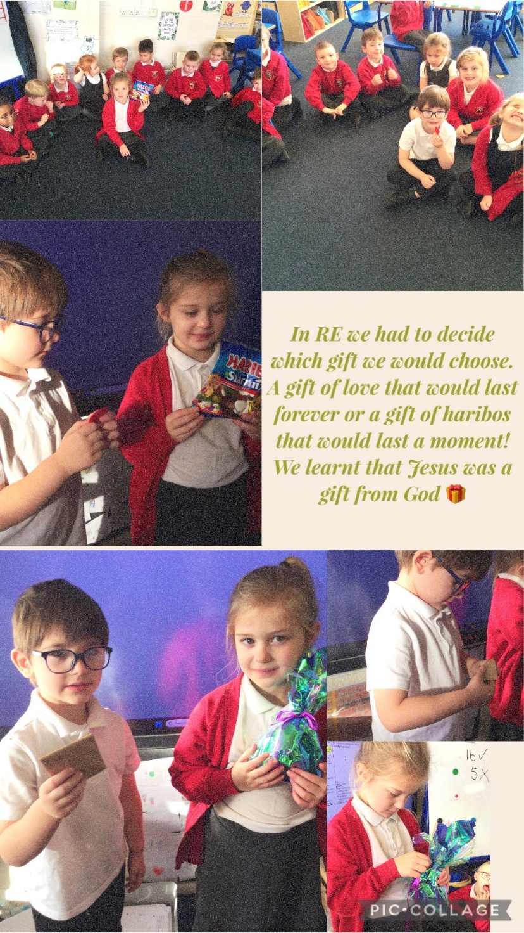

Retelling the nativity story
We read the nativity story in the Bible and we retold the story in a variety of ways. Using Lego to create the nativity scene, sequencing pictures, drawing the nativity scene and retelling the story using puppets.
