RE Blog

Kingfishers Class

Autumn 2
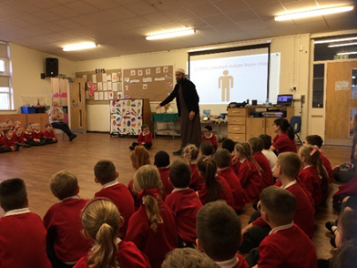
In RE this half term, we have learned more about holy books from other world faiths, the Qur’an and the Torah. We have made comparisons between these holy books and the Bible. We were surprised to find that there were so many similarities!
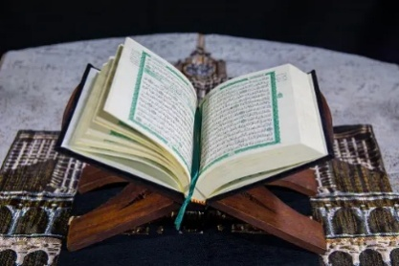
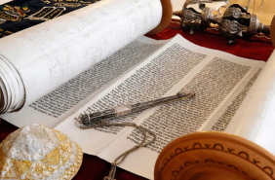
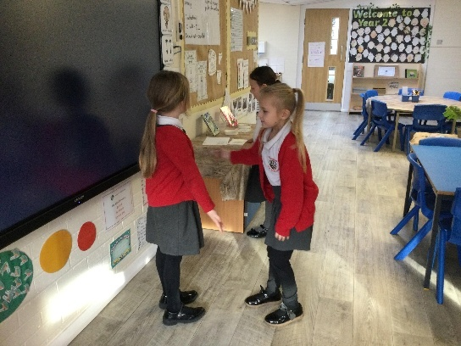
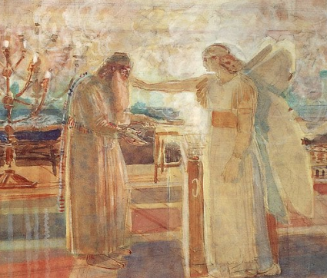
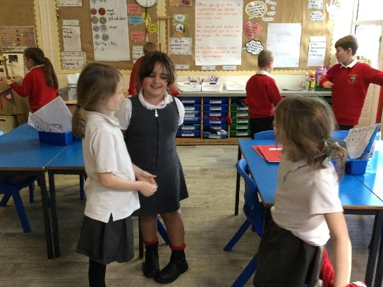
Also, this half term we have learned about good news. We know that angels are the ones who bring good news. We have learned that Christians believe that the good news is that Jesus is saviour of the world and that the Christmas story was good news.

