RE Blog
Butterflies Class
Autumn 1 - Creation
We have been learning about Creation. We know that Christians, Hindus and Muslims all believe that God created our world and God would like us to take care of it.
We demonstrated how we are creative beings by making our own creations. We made posters about how to look after our world as God would want us to.
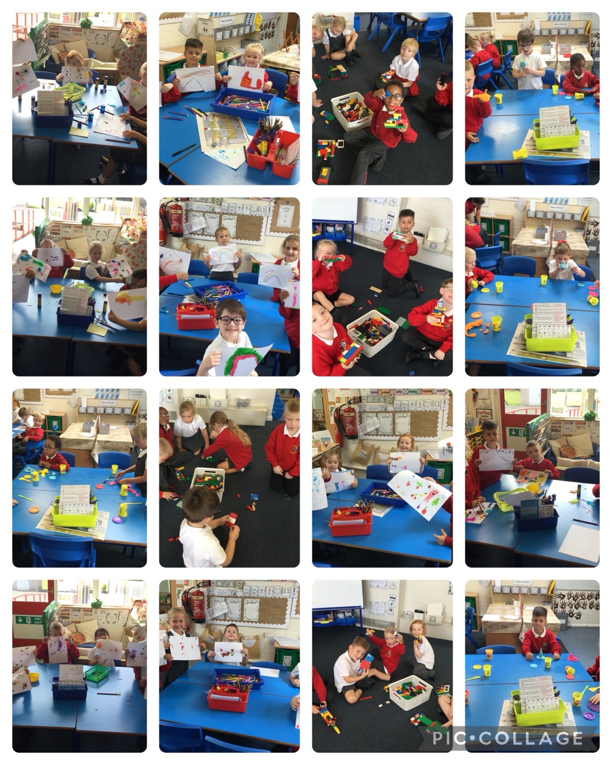

Autumn 1 - Harvest

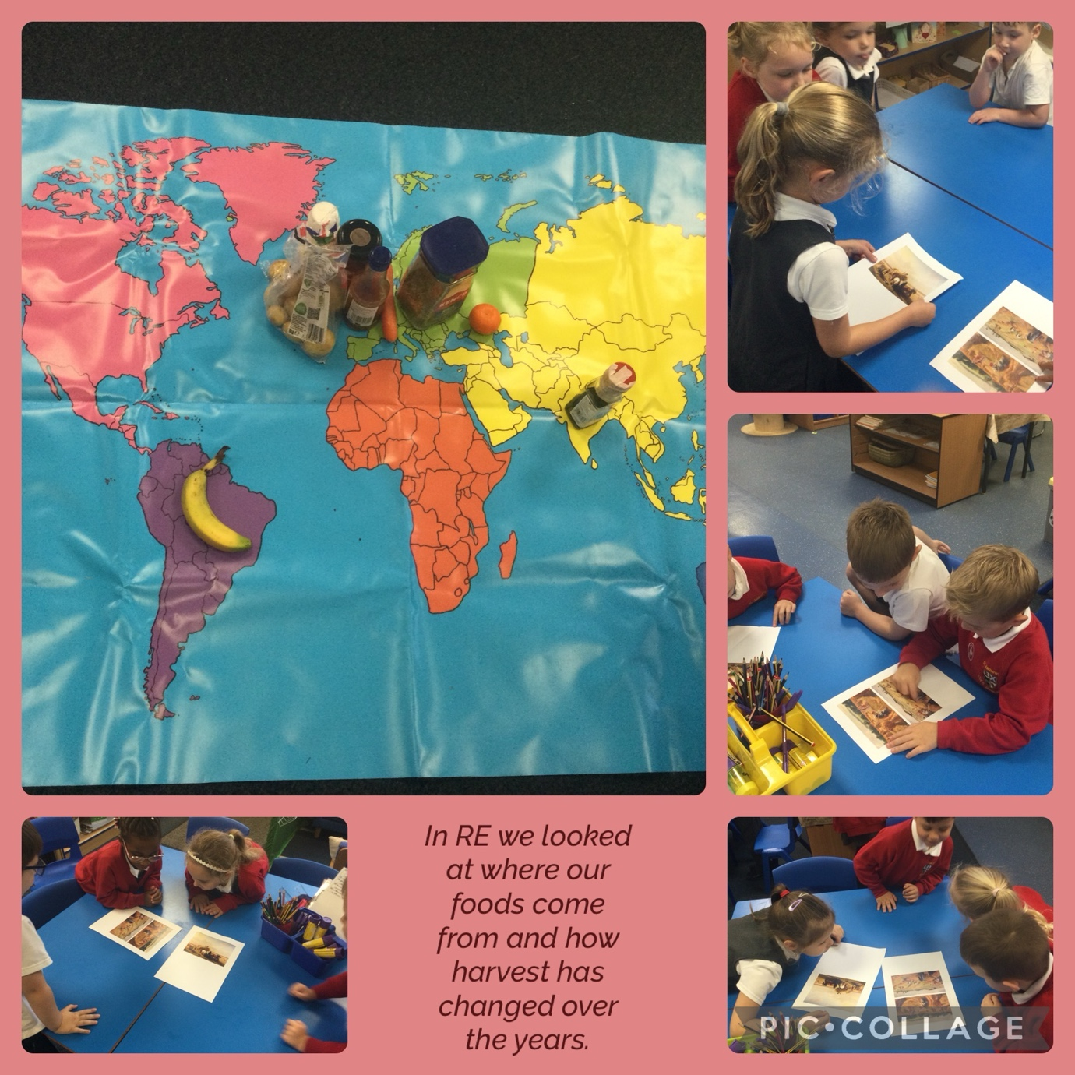

We learnt how harvest time is an opportunity to think about how usually the harvest in the UK is plenty but in other countries the harvest can often fail. We role played taking good and bad harvests to market and how we got little or no money if it was bad.
We found out that there are Christian charities working worldwide to improve the lives of people living in countries where the harvest has failed.

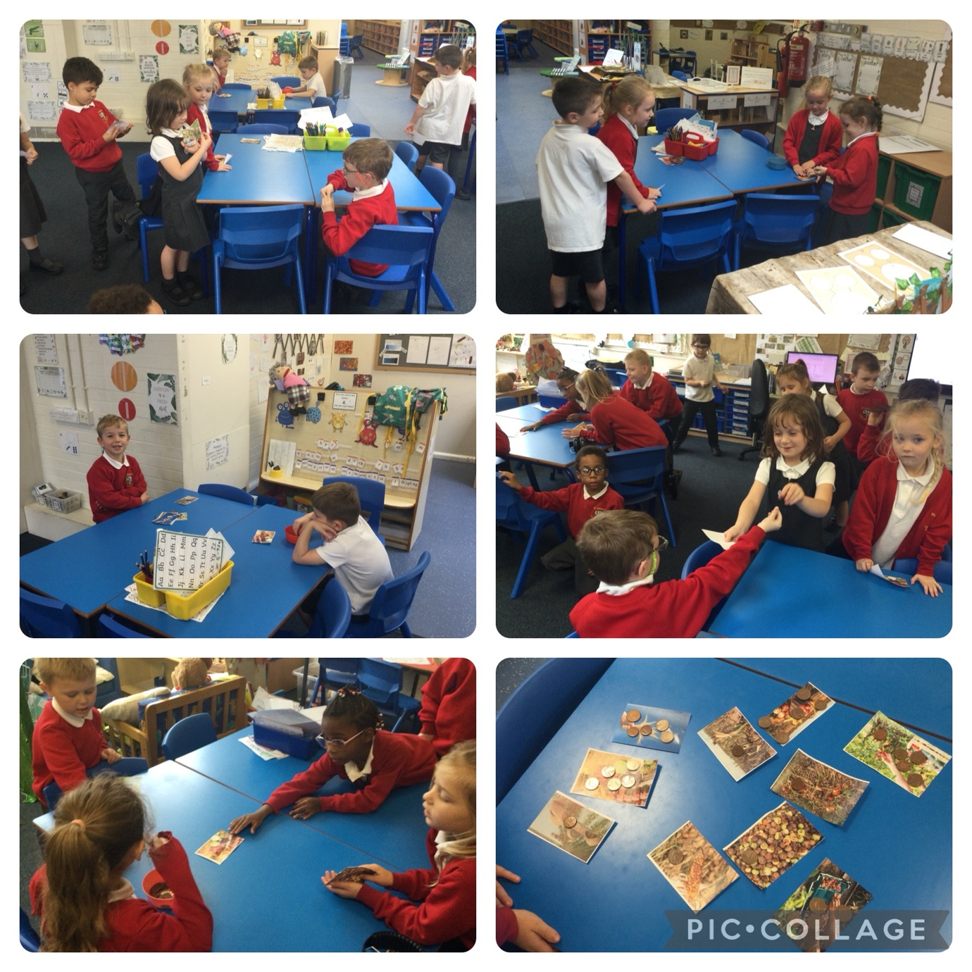

We learned that Jewish people also celebrate harvest and this is called Sukkot. We imagined what the festival of Sukkot and building the Sukkah must feel like for the Jewish children by building our own Sukkah.
