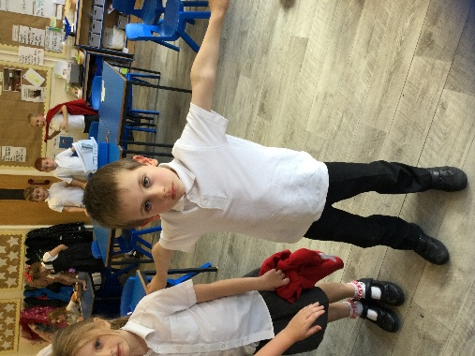
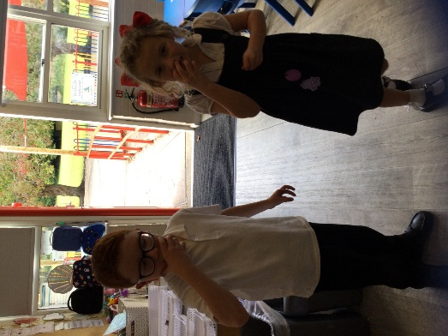
RE Blog

Kingfisher Class

Autumn 1

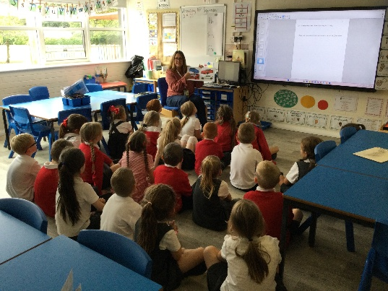
In RE this half term, we have been learning about The Bible. We have found out that it is the Christian Holy Book and is split up into two sections, The Old Testament and the New Testament. We know that it is important for Christians to own a Bible. We heard the story of Mary Jones, who inspired the work of the Bible Society. This inspired us to raise money for The Bible Society. We had a cake sale.
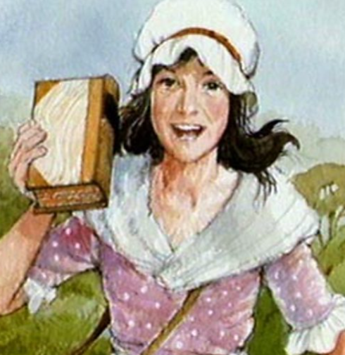
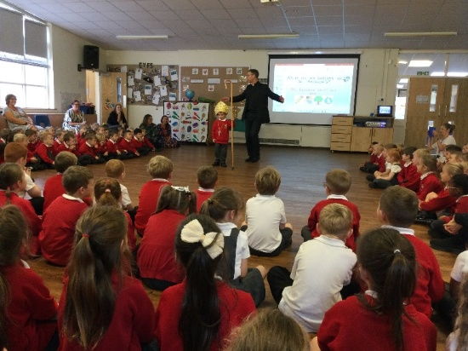
Katy, from St Andrew’s C of E Church, came into school to talk to us about her collection of Bibles and why they were important to her. Bishop Philip came to our school for a worship assembly and we went to church for our Harvest Festival.

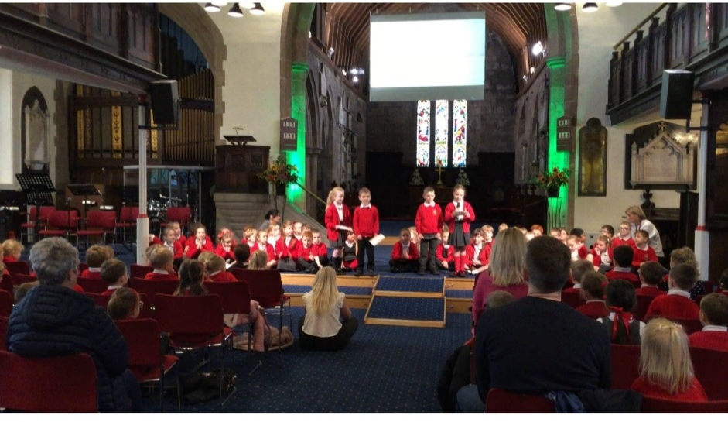

We have found out about Holy books from other world faiths, the Qur’an and the Torah, and why these books are special. We have compared the similarities and differences between these books and the Bible.
