St. Andrew’s C of E Infant School – Curriculum Newsletter
Autumn 2
Year 1
Science
Trees
- Know the basic structure of a tree
- Name common trees
- Know the difference between deciduous and evergreen trees.

FIRE FIRE!!

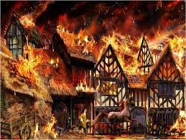
English
Core Texts: Dragon Post, fire poems, selection of Great Fire of London non-fiction texts
Genre: Letters. Poems on a theme: fire. Non-fiction texts on the Great Fire of London.

Maths
- Sequencing and Sorting
- Fractions
- Money
- Capacity and Volume
- Time

Music
Rhythm in the way we walk / Banana rap
- Reggae and rap
- Develop vocal skills
- Rhythm, pitch, pulse

History
Events beyond living memory: Great Fire of London
Compare people or events in the past
Know and recount about the Great Fire of London, knowing and understanding key events.

$$Value$$
Thankfulness
DT
Preparing and combining foods: fruit salad
- Where foods come from
- Healthy eating
- Safe and accurate cutting skills.

PSHRE
What is the same and different about us?
- Know what makes us special and that everyone has different strengths.
- Use the correct name for body parts.
Religious Education

Christmas
- Deepen the children’s understanding of the true meaning of Christmas through emphasising that Jesus was a gift from God.
- Discuss the thoughts and feelings associated with giving and receiving gifts.

Computing
Pictograms
Lego Builders

PE
- Dance – fire fire

