History Policy

Handbook

St. Andrew’s CE Infant School

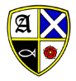

Our School Motto
‘Learning, Caring and Growing together in Faith’

Our Vision
St Andrew’s Infant School is a Christian school where children are happy, nurtured and love learning. Through an inspiring and aspirational curriculum, we strive to ensure our children flourish spiritually, academically, and creatively to become confident, resilient learners. Everyone here learns, cares and grows together in faith.

Our Values
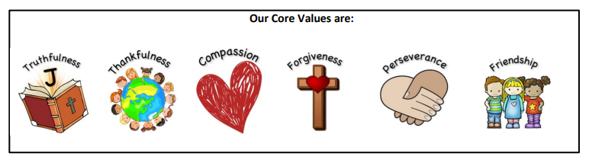
Our Christian Narrative:

‘God is my strength in whom I trust.’ Psalm 18

Our Bible story:

The parable of the Two Builders - Matthew 7

Intent
‘The more you know about the past, the better prepared you are for the future.’
Theodore Roosevelt

History is all around us. The study of history ignites children’s curiosity about the past in Britain and the wider world. Through finding out about how and why the world, our country, culture and local community have developed over time, children understand how the past influences the present. We have designed a history curriculum that reflects the needs of our children and:
- Is progressive in skills and knowledge.
- Builds on children’s prior knowledge.
- Provides relevant and stimulating learning experiences.
- Promotes diversity and inclusion.
- Develops spirituality
- Allows them to gain and use a wide range of historical terms and vocabulary.
- Allows them to gain an understanding of historical concepts.
- Develops effective and successful communicators of the future.

Our history curriculum provides adaptable learning experiences that foster children’s curiosity about their local area and their place in history. They will also explore key events that have shaped the world today. Children will be respectful of events that have affected our lives.
Our History curriculum allows our children to:
- Develop an increasing awareness of how historical events have shaped the world that they currently live in.
- Develop a further understanding of History on a local level and on a small-scale.
- Develop enquiry skills to pursue their own interests within a topic and further questioning.
- Encounter or participate in high-quality visits/visitors to further appreciate the impact of History.
- Retain prior-learning and explicitly make connections between what they have previously learned and what they are currently learning.
- Become increasingly analytical within their thinking. Making informed and balanced judgements based on their knowledge of the past.
- Develop a passion for history and an enthusiastic engagement in learning, which develops their sense of curiosity about the past and their understanding of how and why people interpret the past in different ways.
- Develop a respect for historical evidence and the ability to make critical use of it to support their explanations and judgements.

Implementation
We teach the National Curriculum, supported by a clear skills and knowledge progression. This ensures that skills and knowledge are built on year by year and sequenced appropriately to maximise learning for all children. It is important that the children develop progressive skills of a historian throughout their time at St Andrew’s C of E Infant School and do not just learn a series of facts about the past. As historians, pupils need to be able to research, interpret evidence, including primary and secondary sources, and have the necessary skills to argue for their point of view; skills that will help them in their adult life. Our history units of work are linked to each half termly topic. Where possible they have links to our locality and community. There are close links between our English units and history curriculum providing enhanced opportunities to immerse our children in high quality texts to deepen their understanding and develop topic vocabulary.

Subject content
EYFS (Past and Present Early Learning Goal)
Children at the expected level of development will:
- Talk about the lives of the people around them and their roles in society;
- Know some similarities and differences between things in the past and now, drawing on their experiences and what has been read in class;
- Recall some important narratives, characters and figures from the past encountered in books read in class.
Key stage 1
- Pupils should develop an awareness of the past, using common words and phrases relating to the passing of time.
- They should know where the people and events they study fit within a chronological framework and identify similarities and differences between ways of life in different periods.
- They should use a wide vocabulary of everyday historical terms.
- They should ask and answer questions, choosing and using parts of stories and other sources to show that they know and understand key features of events.
- They should understand some of the ways in which we find out about the past and identify different ways in which it is represented.

Pupils should be taught about:
- changes within living memory – where appropriate, these should be used to reveal aspects of change in national life e.g. the Queen’s 90th Birthday, Remembrance Day
- events beyond living memory that are significant nationally or globally for example the Great Fire of London
- the lives of significant individuals in the past who have contributed to national and international achievements, some should be used to compare aspects of life in different periods E.g:
- Mary Anning (EYFS)
- Mary Seacole (Y1)
    - Tim Peake, Neil Armstrong and Katherine Johnson (Y2)

- significant historical events, people and places in their own locality
    - Our school (Y2)
    - Worden Park and the Farrington family (Y2)
    - Leyland Motors (Y2)

Working Wall
Our history working walls include;
- Vocabulary
- key question
- key knowledge
- Examples of work and picture prompts to support recall of prior learning during that topic.

Recording our Work
We use a variety of recording methods in history, these include;
- Writing – eg diary entries, letters, chronological reports.
- Photographs
- Floor books (EYFS)
- Drawing
- Videos – eg VAK time lines.
- Class timelines (updated half termly)

Resources
We have a variety of resources located in the staffroom history cupboard or in relevant classrooms. We make use of local history resources such as Worden Park and Leyland Motors. We also have access to our own page on the National Archives.

Additional Resources
Lancashire Archives - Leyland St Andrews CE Infant School
Lancashire County Council's Archaeology Service. https://www3.lancashire.gov.uk/environment/oldmap/
Historical maps and links with geography http://digimapforschools.edina.ac.uk
Google Street View. https://www.google.com/streetview/
BBC Teach online videos https://www.bbc.co.uk/bitesize/subjects/zkqmhyc

Planning
We use the National Curriculum scheme of work as the basis for our planning in history, but we have adapted this to our local context. We ensure that there are opportunities for children of all abilities to develop their skills and knowledge in each unit, and we plan progression into the scheme of work, so that the children are increasingly challenged as they move through the school.
The planning of the history curriculum is organised through:
- Skills progression document (Subject leader)

- Knowledge organisers for each topic (Subject leader)

- Medium Term planning (Class teacher and monitored by subject leader)
These can all be accessed on the teacher drive in school.

Historical Concepts
Historical concepts have been woven through our history curriculum in such a way that they can be revisited and embedded. These concepts are;
Substantive concepts;
- Civilisations
- Childhood
- Leadership
- Civilisations
- Trade
Disciplinary concepts;
- Cause and consequence
- Similarities and differences
- Historical Significance
- Sources and evidence
- Change and continuity
Questions
In key stage 1, each of our history topics has a carefully chosen overarching question. This question links to the history concepts for that topic and aims to be a focus for assessment at the end of the topic.

Assessment
The knowledge, skills, understanding and vocabulary identified in the history knowledge organisers for each unit identify the aspects of history in which pupils make progress:
- Children demonstrate their ability in history in a variety of different ways.
- Teachers will assess children’s work by making informal judgments during lessons.
- On completion of a piece of work, the teacher assesses the work and uses this information to plan for future learning.
- Written or verbal feedback is given to the child to help guide his or her progress.
- For each unit, pupils are assessed to be on target, to be working towards them or exceeding. These assessments can be accessed on the teacher drive.

Summative Assessment
At the end of each History unit, children complete an assessment task. Examples of these could be in the form of an information poster, letter, leaflet or a quiz type activity.
For each unit, pupils are assessed to be on target, to be working towards them or exceeding. These assessments can be accessed on the teacher drive.

Impact
Staff identify the impact of our history curriculum through a variety of ways. These include:
• Observations
• Regular recall and retrieval activities
• Targeted questioning
• Marking and feedback
• Teacher assessment
• Pupil interviews
• Analysis of data

We use these strategies to review our curriculum offer, inform our strategic action planning and make adaptations where necessary.

Roles and Responsibilities
Class Teacher
- Use the knowledge organisers to write medium term plans.
- Use the key vocabulary in the knowledge organisers, display this on working walls and create a vocabulary sheet to be displayed in books at the start of each history topic. This vocabulary should be imbedded and children should be able to use it both in conversations and in writing.
- Provide enrichment opportunities where possible.

Subject Leader
- Ensure progression and continuity across the EYFS and Key stage one, through the development of skills progression document and knowledge organisers.
- Support colleagues in the implementation of the medium term plans and provide support within units of work.
- Monitor the progress and standards within the subject.
- Keep up to date with developments in history and disseminate information to the teaching staff.

Inclusion
At our school we teach history to all children, whatever their ability and individual need. This is in accordance with the school’s curriculum policy of providing a broad and balanced education to all children. Through our history teaching we provide learning opportunities that enable all pupils to make good progress. We strive hard to meet the needs of those pupils with special educational needs, those with disabilities, those with special gifts and talents, new arrivals and those learning English as an additional language, and we take all reasonable steps to achieve this.
Teachers’ planning will set high expectations and provide opportunities for all pupils to achieve, so that everyone can take part in lessons fully and effectively. Teachers will take specific action to respond to pupils’ diverse needs.
Health and safety
We enable all pupils to have access to the full range of activities involved in learning history. Where children are to participate in activities outside the classroom, teachers should be aware of health and safety issues. Risk assessments are undertaken prior to activities, to ensure that they are safe and appropriate for all pupils.

Features of an effective History Teaching Sequence

Throughout a unit of work, children build on previous knowledge and skills. Lessons should be clearly focused on the learning objectives that are taken from the knowledge organisers. Vocabulary should be explicitly taught in relevant lessons throughout the unit.
Lessons will include;
- Revisiting prior learning
- Focus made to the over arching question and if we are beginning to answer it yet.
- Include references to the substantive and disciplinary concepts, located on the relevant knowledge organiser.
- Active learning strategies
- Opportunities for children to ask and answer questions.
- A variety of independent and group work activities planned.
- Use of visitors or visits to enhance the topic where possible.
- Children using a range of sources where possible.
Subject overview
 | Autumn 1 | Autumn 2 | Spring 1 | Spring 2 | Summer 1 | Summer 2
EYFS | Past and present events in their own lives  Create a class now and then book using baby pictures and pictures of them at school. | As we learn about celebrations – compare and contrast how people celebrated in the past | Researching towns in the UK where dinosaur remains have been found  Mary Anning study  History of Luna New Year and why it is celebrated |  |  | Recap seasons of the year, developing an understanding of chronology. Create a class timeline of the year with events.  Compare and contrast pictures from stories, including pirates from the past.  Learn about famous pirates from the past – Anne Bonny, William Kid, Blackbeard, Black Bart
Year 1 |  | Events beyond living memory: Great Fire of London | Changes within living memory: toys | A significant historical person: Mary Seacole
Year 2 | Significant place in own locality and how it has changed (Our school and Worden Park). The Farington Family |  | Significant people: Tim Peake and Neil Armstrong  Katherine Johnson | Significant events in own locality and changes over time: Invention of the Motor Car, Leyland Trucks & Tractors

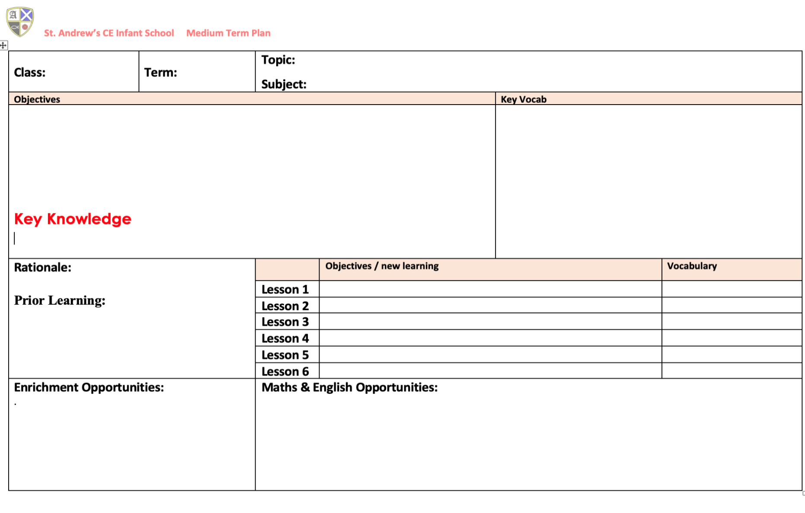
Example Medium Term Plan

Example of Summative Assessment
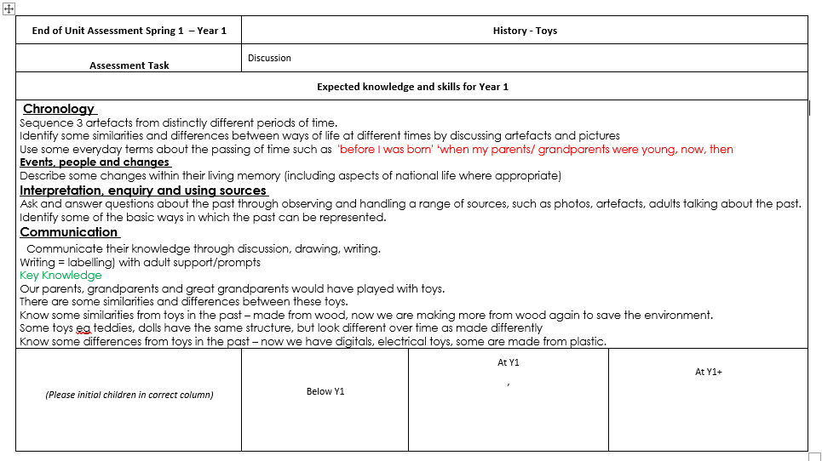
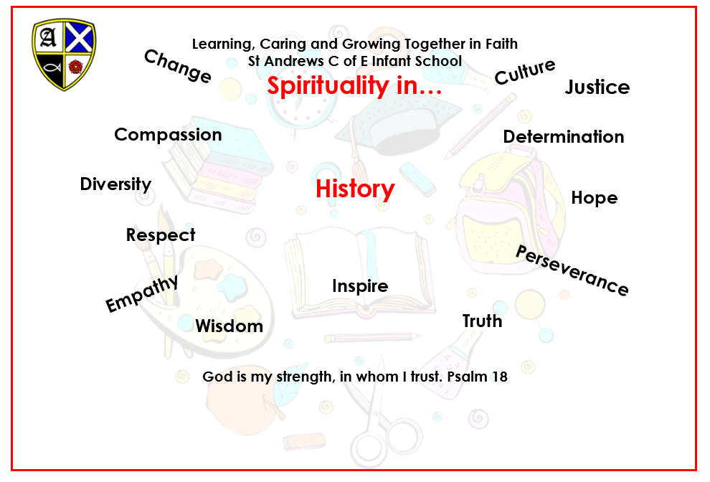
Spirituality

