PSHRE Policy
Handbook

St. Andrew’s CE Infant School



Our School Motto
‘Learning, Caring and Growing together in Faith’

Our Vision
St Andrew’s Infant School is a Christian school where children are happy, nurtured and love learning. Through an inspiring and aspirational curriculum, we strive to ensure our children flourish spiritually, academically, and creatively to become confident, resilient learners. Everyone here learns, cares and grows together in faith.

Our Values
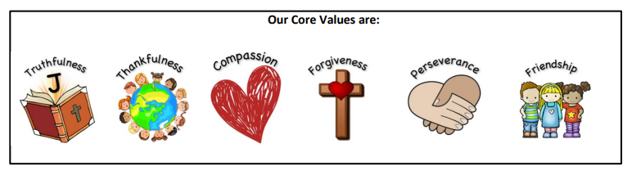
Our Christian Narrative:

‘God is my strength in whom I trust.’ Psalm 18

Our Bible story:

The parable of the Two Builders - Matthew 7

Intent
At St Andrew’s we are guided by our Christian values which are: Truthfulness, Thankfulness, Compassion, Perseverance, Forgiveness and Friendship. These values underpin our broad and balanced curriculum and we believe that our PSHRE curriculum enables our children to become healthy, independent and responsible members of society. Our curriculum aims to help all children understand how they are developing personally and socially, and tackles many of the moral, social and cultural issues that are part of growing up.
We provide our children with opportunities for them to learn about rights and responsibilities and appreciate what it means to be a member of a diverse society. Our children are encouraged to develop their sense of self-worth by playing a positive role in contributing to school life, our Christian family and the wider community. We teach children to develop resilience, to manage risks and to know how and when to ask for help. Through PSHRE and our wider curriculum, we promote the spiritual, moral, social, cultural, mental and physical development of all our children. We nurture and inspire children to achieve their very best, in the knowledge that with God, they can achieve anything.
At St Andrew’s our aim is to plan for a PSHRE curriculum that engages, excites and empowers our children to have high aspirations, resilience and self-confidence. We have designed a curriculum that reflects the needs of our children and:
- Is progressive in skills and knowledge
- Provides relevant and stimulating learning experiences where confidence is developed and children are encourage to share their own thoughts and opinions with others
- Develop interpersonal skills and attributes to keep themselves healthy and safe
- Develop an attitude of a responsible global citizen
- To show tolerance of others beliefs, religions and life choices by promoting diversity and inclusion
- To build positive, respectful relationships with other people
- Key vocabulary is at the heart of excellent teaching practice
- Allows our children to develop spiritually

Implementation
At St Andrew’s C of E Infant School, PSED is taught in EYFS using key questions that link to overarching topics. When teaching PSED, teachers are adaptable and respond to children’s needs, planning appropriate tasks. We use key questions each half term, based on the model we use for Key Stage One from the PSHE Association, to support teachers with their planning and teachings.
In Key Stage One, PSHRE is taught using the PSHE Association questions-based model. This is a progressive scheme of work and comprehensively covers the statutory Health Education and Relationships guidance.
Our curriculum is carefully planned to support the development of the following skills;
- Health and Well-Being
- Relationships
- Living in the Wider World
In planning our curriculum we take into account our pupils’ prior learning and experiences. Our programme reflects the universal needs shared by all children as well as the specific needs of our pupils.

Presentation of Work
PSHRE learning takes place in a variety of ways. Children are encouraged to reflect on their work as individuals and as part of a group. In EYFS learning is recorded in a class floor book. In KS1 children have their own individual PSHRE book in which they record in, alongside the work in a class floor book. Individual PSHRE books will not have work in from every lesson. Children use pencil to complete their work in their PSHRE books.

Resources
Physical resources are stored in classrooms so all teachers have access to them when needed. Whole school books linked to PSHRE learning are also available in the school library. Teachers use resources from the PSHE Association website, all teachers have a login. Teachers also use CORAM resources to supplement their teaching. This is available online; all teachers have a login. The curriculum leader will regularly review resources with staff and obtain, within the constraints of the allocated budget, additional resources as necessary.

Additional Documents
In addition to this PSHRE Policy, the following documents are in place to support the implementation of PSHRE:
- Progression in PSHRE
- Knowledge organisers
- Knowledge hands
- PSHE Association resources
- SCARF resources

Creating a Safe and Supportive Learning Environment
At St Andrew’s, we endeavour to provide a safe, secure learning environment for PSHRE that enables all our children to gain accurate knowledge, develop their own values, attitudes and opinions and develop skills to grow into healthy, independent and responsible members of society.
Staff must report any concerns they may have by following the school’s safeguarding procedures.

Planning
The planning of the PSHRE curriculum is organised through:
- Long term planning is demonstrated through the yearly overviews which show the organisation of the PSHRE topics across the year for each year group, and the coverage and progression of knowledge, skills and understanding.
- Medium term planning is demonstrated through the unit overviews which reveal the progression of knowledge, skills and understanding within each topic.
- Short term planning is demonstrated through weekly planning on a medium-term plan. Activities, resources and learning is personalised to meet the needs of the children in each class.

Teaching and Learning
All pupils have a weekly timetabled lesson.
PSHRE; including the Spiritual, Moral, Social and Cultural and British Values, is an integral part of the whole school curriculum, and is therefore often taught within other subject areas such as science, PE, computing and RE.
Visitors such as emergency services and dentists enrich and complement our curriculum to offer additional learning.
Whole school worships and awareness days are planned to cover any additional sessions that would benefit the whole school.
Lesson content is taught carefully and sensitively. In Key Stage One, children are introduced to the use of correct vocabulary to name parts of the body, including external genitalia (e.g. penis, vagina, testicles) examples given by PSHE Association - to be discussed.
Early Years Foundation Stage
PSED (Personal, Social and Emotional Development) is a prime area of learning therefore an integral aspect of daily planning, teaching and learning. It has three core themes:
- Making relationships
- Self-confidence and self-awareness
- Managing feelings and behaviour
Planning is child led to reflect the interests of the children and the needs of the school. Children take part in circle time and discuss topics and themes that are at their level. Teachers look at the three core themes and take aspects of these to inform their planning. PSED is a fundamental building block in a child’s development and underpins the whole curriculum. In addition to this, each half term teachers use a key question, similar to those taught in Key Stage 1, and base PSHRE lessons on these. These questions cover a range of themes – feelings, choices, keeping healthy, differences and how to stay safe.

Key Stage One Themes
The PSHE Association takes a thematic approach to primary PSHE education, ensuring all three core themes of the Programme of Study (Health and Well-being; Relationships; and Living in the Wider World) are covered over the school year. This is broken down into topics each half term that begin with a question. This approach allows different year groups to work on similar themes at the same time, building a spiral programme year on year. It also offers flexibility in terms of medium term planning.

Core theme 1: Physical Health and Well-being
Pupils will be taught:
- What is meant by a healthy lifestyle including benefits of physical activity and rest, healthy eating and dental health
- How to maintain physical and emotional health and well-being
- How to manage risks to physical and emotional health and well-being
- Ways of keeping physically and emotionally safe, understanding what positively affects their physical, mental and emotional health
- About managing change, such as transition and loss
- How to make informed choices about health and well-being and to understand the concept of a balanced lifestyle
- How to respond in an emergency
- To identify different influences on health and well-being
- To communicate feelings to others and how to respond to feelings
- To develop vocabulary to describe feelings to others
- To recognise different types of teasing and bullying, to recognise these are wrong and unacceptable
- That household products including medicines can be harmful if not used properly
- The importance of and how to maintain personal hygiene
- About special people who work in their community and are responsible for looking after them

Core theme 2: Relationships
Pupils should be taught:
- How to respond to risky or negative relationships and ask for help
- How to respect equality and diversity in relationships
- To recognise people who look after them and their family relationships and who to go to if they are worried and how to attract attention
- How to identify and respect the differences and similarities between people
- How to identify special people and how special people should care for one another
- To recognise that they belong to different groups and communities such as family and school
- To recognise different types of relationships including those between acquaintances, friends, relatives and families
- To recognise what constitutes a positive healthy relationship and develop the skills to form and maintain positive and healthy relationships
- To recognise how behaviour can affect other people, to listen to one another and play and work co-operatively
- To recognise what is fair and unfair, kind and unkind, right and wrong
- That people’s bodies and feelings can be hurt
- To recognise different types of teasing and bullying, to recognise these are wrong and unacceptable
- To develop strategies to resolve disputes and conflicts
- That people and other living things have rights and that everyone has a responsibility to protect those rights
- To understand rules for keeping physically and emotionally safe including responsible ICT use
- To recognise a responsibility for keeping themselves and others safe
- To understand personal boundaries and rights to privacy
- What is meant by privacy
- The difference between secrets and nice surprises and the importance of not keeping secrets that makes children feel uncomfortable, anxious or afraid

Core theme 3: Living in the Wider World
Pupils should focus on ‘economic well-being and being a responsible citizen’ and be taught:
- About respect for the self and others and the importance of responsible behaviours and actions
- About rights and responsibilities as members of families, other groups and ultimately as citizens
- About different groups and communities
- To respect equality and to be a productive member of a diverse community
- About the importance of respecting and protecting the environment
- About where money comes from, keeping it safe and the importance of managing it effectively
- How money plays an important part in people’s lives
- To understand ways in which they are all unique

Baseline Assessment
Teachers will undertake some form of baseline assessment, prior to teaching a topic or unit of work, to determine where to start and to guide them in how the work should be developed. This will inform their own planning and ensure that their lessons are suitable and relevant to each classes needs and abilities. Knowledge organisers and long-term plans provide teachers with the information of prior learning. This is used to plan further units of work.

Formative Assessment
Teachers use their professional judgement to decide what children need to learn and when to move on to the next step of learning. Formative assessment (or responsive teaching) is a key feature of PSHRE lessons. Teachers use effective questioning to determine the extent of children’s understanding before deciding on what the children need next (support, extension, next steps). Teachers also respond swiftly to incidents or events that might occur during the school day and will provide impromptu PSHRE lessons where appropriate.

Summative Assessment
Children in Reception will complete PSED baseline assessments in September and will then be assessed at the end of each term. Assessments will be made based on children’s understanding throughout lessons including during provision.
Children in Key Stage One are assessed at the end of each half term. This involves an activity linked to the unit of work. It assesses the knowledge that they have retained. Formative assessments throughout the unit of work assess children’s personal development.
Impact
We firmly believe that a meaningful PSHRE curriculum is the key to children becoming confident, resilient, tolerant and well-rounded adults.
By the time our children leave our school they will:
- Be able to approach a range of real life situations and apply their skills and attributes to help navigate themselves through modern life.
- Be on their way to becoming healthy, open minded, respectful, socially and morally responsible, active members of society.
- Appreciate difference and diversity.
- Recognise and apply the British Values of Democracy, Tolerance, Mutual respect, Rule of law and Liberty.
- Be able to understand and manage their emotions.
- Be able to look after their mental health and well-being.
- Be able to develop positive, healthy relationships with their peers both now and in the future.
- Have respect for themselves, others and the environment.
- From exposure to a range of global issues and problems, children can build up tolerance and a sense of responsibility of being a global citizen.
- Have positive self-esteem and set high aspirations for themselves.

Creating a Safe and Supportive Learning Environment
At St Andrew’s, we endeavour to provide a safe, secure learning environment for PSHRE that enables all our children to gain accurate knowledge, develop their own values, attitudes and opinions and develop skills to grow into healthy, independent and responsible members of society.
Staff must report any concerns they may have by following the school’s safeguarding procedures.

PSHRE Ground Rules
Ground rules are shared at the beginning of each PSHRE lesson to help to minimise unintended disclosures, disclosures at inappropriate times or comments of a negative nature made towards other pupils (whether intentional or not). Such ground rules support broader class rules and the school’s behaviour policy. To be effective, pupils and teachers should develop ground rules together, re-visit them at the start of every lesson and apply them in all discussion and group activities, amending them as necessary.
Examples of ground rules include:
- respecting what people say
- listening to others
- not asking personal questions or putting people ‘on the spot’
- not making assumptions about other people
- having the right to ‘pass’ if you do not wish to comment

Features of an effective PSHRE Teaching Sequence
- Ground rules to be shared at the start of the lesson and acknowledged by all, teachers and children participating.
- Opportunities for questions and contributions from children.
- A combination of group work and individual work.
- Variety of activities that aren’t always written outcomes.
- High quality resources utilised.
- Good understanding and knowledge of content from staff.
- Opportunity to reflect on learning.

Roles and Responsibilities
Class Teacher
- Provide engaging, age-appropriate lessons using the long term plan to support. Teachers should plan in conjunction with knowledge organisers, knowledge hands and support/resources from PSHE Association.
- Staff must report any concerns they may have by following the school’s safeguarding procedures.
Subject Leader
- Subject leader must regularly monitor and review the teaching and delivery of PSHRE across the school.
- The Subject Leader receives information from class teachers (end of unit assessments and end of year) to ascertain how PSHE is being delivered. This helps to identify strengths and any areas for development which can be tackled appropriately.
- Feedback from monitoring must be regularly fed back to staff.
- Subject leader to keep up to date with current topics and changes with regards to PSHRE.
- Subject leader to disseminate information from training CPD with all staff.

SLT
- The school leadership team will review this policy at least once a year and assess its implementation and effectiveness. The Chair of Governors approves the policy.

Monitoring and Evaluation
At St Andrew’s C of E Infant School, we will have high expectations of the quality of pupils’ work.
We achieve this by:
- Having regular feedback provided on pupil progress
- Lessons are planned to ensure that pupils of differing abilities, including the most able, are suitably challenged
- Teaching is assessed and assessments used to identify where pupils need extra support or intervention
It is the responsibility of the PSHRE lead to monitor the impact of the PSHRE curriculum.

Inclusion
St Andrew’s C of E Infant School are committed to providing effective learning opportunities for all pupils. Suitable learning challenges will be set for all pupils with the aim of maximizing achievement for all individuals. Teachers will respond appropriately to pupils’ diverse learning needs and be aware of the needs of differing genders, SEND, as well as different cultural, social and ethnic backgrounds. We are committed to the principle of equality of opportunity and this will be reflected in the curriculum offered to pupils and in the conduct of staff and pupils.

Professional Development and Training
https://pshe-association.org.uk/
https://www.coramlifeeducation.org.uk/scarf

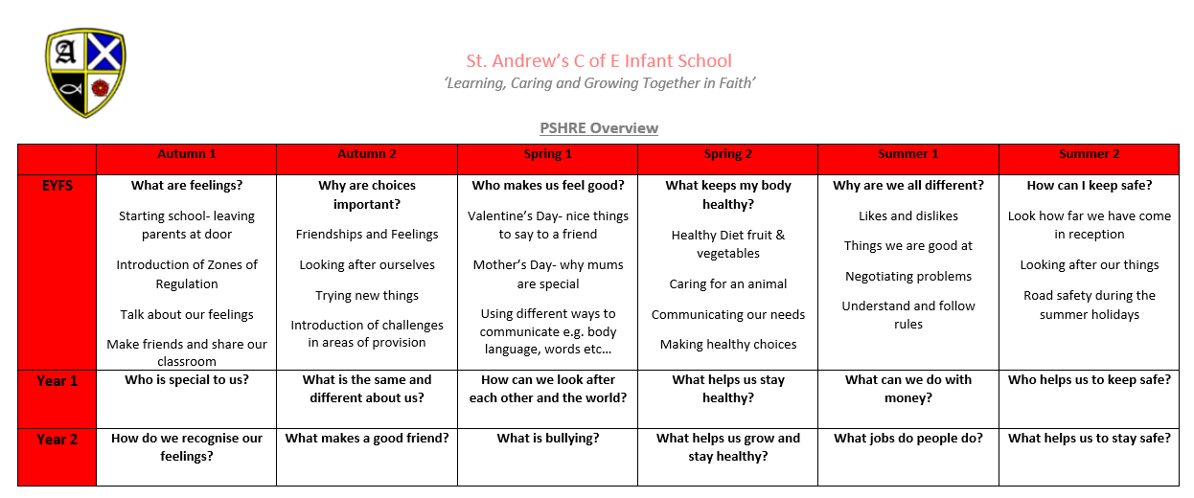
Subject Overview

Example of Summative Assessment
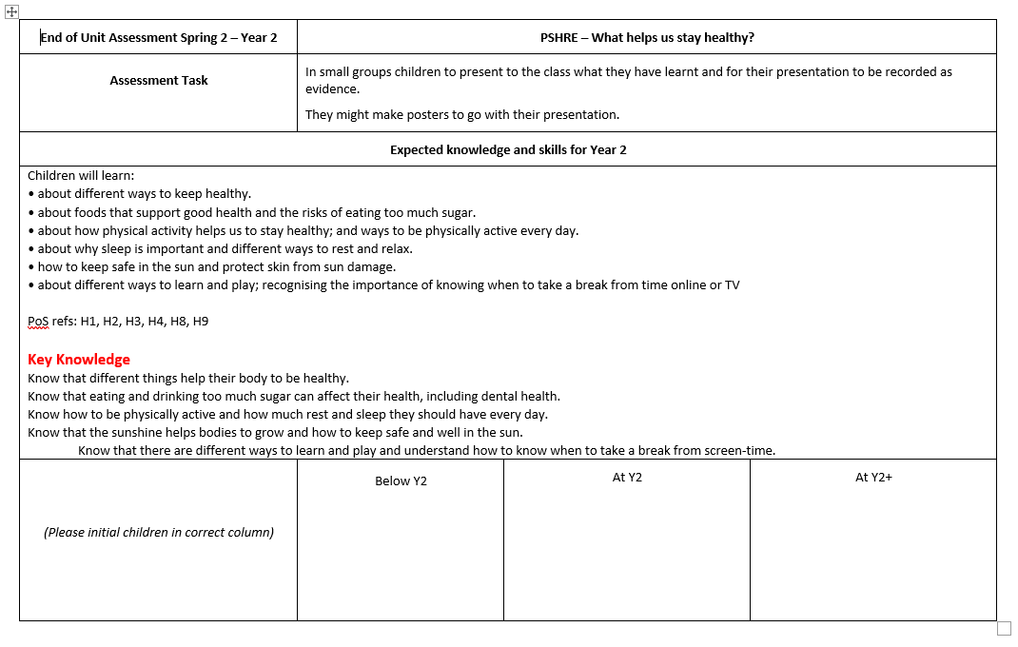

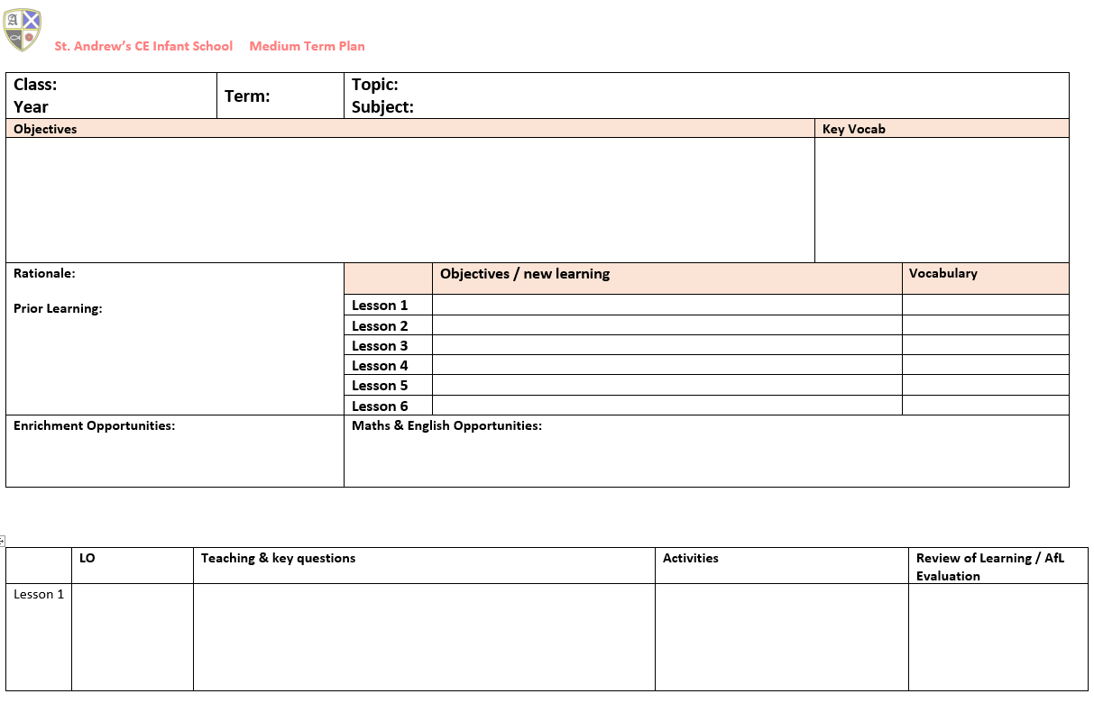
Medium Term Plan Template

