Dear parent(s)/carer(s)    Welcome to Art and Design; an inspiring, rigorous and practical  subject. Using skills, concepts and knowledge, pupils express their responses to ideas and experiences in a visual or tactile form. It fires their imagination and is a fundamental means of personal expression.  While it is essentially a practical subject, art provides opportunities for reflection and, with increasing sensitivity, pupils acquire the ability to make informed, critical responses to their own work and that of others.  There is great pleasure to be derived from Art and Design and through deeper understanding; pupils access cultural richness and diversity. The appreciation and enjoyment of the visual arts enriches all our lives.  Art & Design  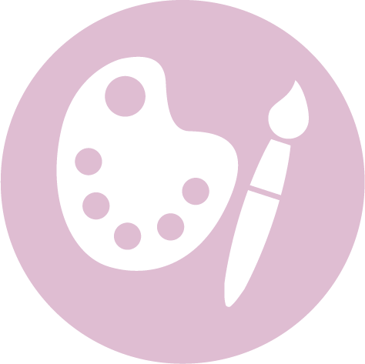 | What we have learnt in KS1  - Use artwork to record ideas, observations and experiences.  - Know the names of tools, techniques and elements that I use.  - Try out different activities and make sensible choices about what to do next.  - Select particular techniques to create a finished piece - develop some care and control over materials and their use.  - Give reasons for my preferences when looking at art work.  - Know that different artistic works are made by craftspeople from different cultures and times.  - Explore mark-making using a variety of tools.  - Make marks in print using found objects and basic tools and use these to create repeating patterns.  - Use a variety of printing techniques.  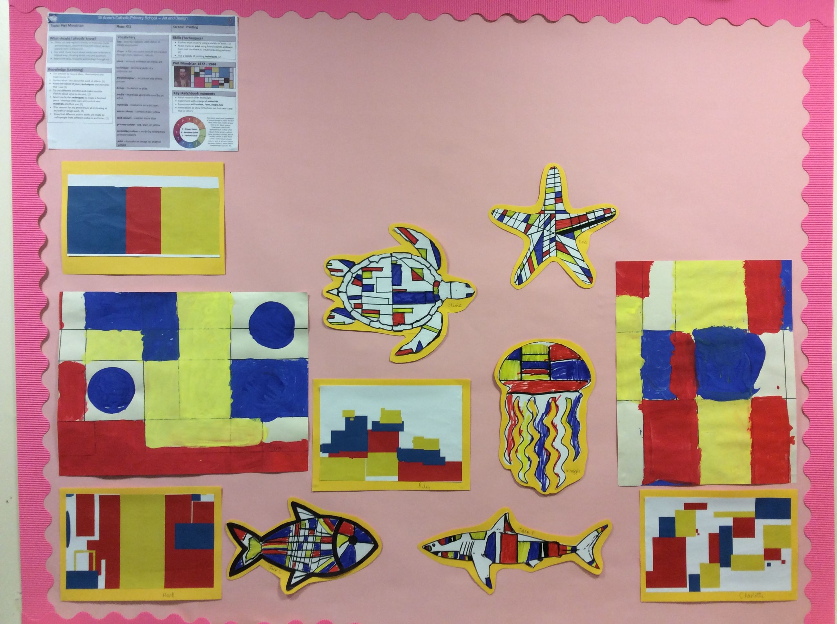
What we have learnt in LKS2  - Experiment with different materials to create a range of effects and use these techniques in the completed piece of work.  - Know about some of the great artists, architects and designers in history and describe their work.  - Use a sketchbook for collecting ideas and developing a plan for a completed piece of artwork.  - Use taught technical skills to adapt and improve my work.  - Articulate how I might improve my work using technical terms and reasons.  - Understand and identify key aspects such as complementary colours, colour as tone, warm and cold colours.  - To use a variety of printing techniques.  - Compare and recreate form of natural and manmade objects.  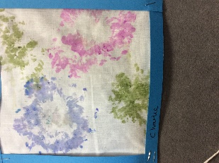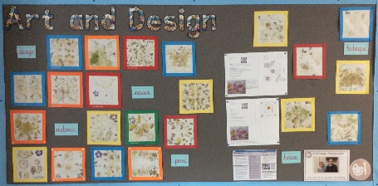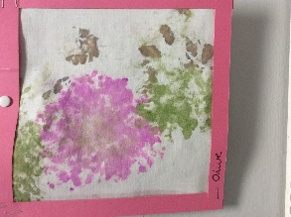 | What we have learnt in UKS2  - Develop different ideas which can be used and explain choices for the materials and techniques used.  - Confidently and systematically investigate the potential of new and unfamiliar materials and use these learnt techniques within my work.  - Adapt my final work following feedback or discussion based on my ideas.  - Describe the work and ideas of various artists, architects and designers, using appropriate vocabulary and referring to historical and cultural contexts.  - Explain and justify preferences towards different styles and artists.  - Return to work over longer periods of time and use a wider range of materials.  - Use different techniques, colours and textures when designing and making pieces of work and explain his/her choices.  