St Anne’s Catholic Primary School



Breakfast and Afterschool Club Policy

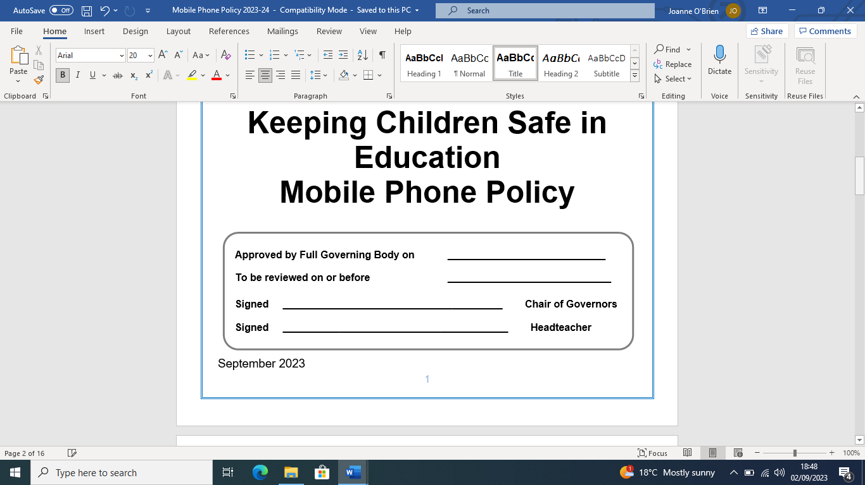

September 2026 (to be reviewed annually)

St Anne’s Catholic Primary School

Breakfast & Afterschool Club Policy

Contents

Introduction
- Admission
- Arrival and Departure
- First Aid
- Missing or unallocated children
- Payment of Fees
- Related Whole School Policies

Introduction
The Breakfast and After school club exists to provide high quality out-of-school hours childcare for our parents and carers. It provides a range of stimulating and creative activities in a safe environment, within our ethos of ‘Learn to Love and Love to Learn in readiness for life’. The club will be run by staff from the school.

Breakfast​ Club operates​ from 7:45 am – 8:45am during term time only
After​school Club​ operates from 3:15pm – 4:15pm during term time only (except for the last day of a full term.)

All parents must complete a registration form for each child attending the club and sign an agreement to adhere to the terms of this policy.

- Admission
- Only children attending St Anne’s R C Primary School are eligible to attend.
- Nursery Children are currently not eligible to attend these clubs.
- All places are subject to availability.
- The registration process must be completed prior to the child’s commencement at these Clubs.
- All parents will receive a paper copy of this policy, and this policy is available to view via our school website.
- All staff are made aware of the details of a new child, including allergies and intolerances from the completed registration forms.
- Children’s attendance is recorded manually and on the signing in and out sheets.
- Only Children booked in via MCAS can attend – failure to do this may result in your child being turned away due to staffing levels.

- Arrival​ and Departure
- Parents/Carers must enter the arrival time and sign their child in on the Breakfast Club provision signing in paperwork.
- After school club will be registered as the teacher drops them off in the Hall.
- At the end of the breakfast session, children in Reception, Year 1 and Year 2 will be escorted to their classrooms by the club staff and Year 3, Year 4, Year 5 and Year 6 will make their own way to their classrooms.
- For After School Club. Parents MUST collect their child from the hall door and sign the log before their child will be released to them.

Daily Routine

Morning session

- Parents/Carers bring their children to Breakfast Club situated in the hall where a range of activities are set out.

- 7:45am – 8:20am children wishing to have breakfast wash their hands ready to enjoy a freshly prepared breakfast.

- 8.35am tidy up time encouraging the children to take responsibility for the environment.

- 8.40am children collect their coats and bags. Reception, Year 1and Year 2 will be escorted by a member of staff directly to their appropriate classrooms and Year 3, Year 4, Year 5 and Year 6 will make their way to their class where they meet up with the rest of the children awaiting the start of the school day.

After school session

- 3:15pm - Children in Reception, Year 1 and Year 2 will be escorted by a member of staff directly from their classroom. Children in years 3, 4 ,5 and 6 will make their way directly to hall to be greeted by a member of the club staff for registration.

- 3:15pm – 3:30pm children will be given a healthy snack/ biscuit and drink: staff members will sit with the children at this time. Children can then choose from a range of play and planned activities, both indoors and outdoors.

- 4:15pm - children will be collected by an adult.

Behaviour

Whilst attending the Club children are expected to follow the school ethos, rules and behaviour policy. The school behaviour management policy applies at all times, including the process of rewards and sanctions.

- First Aid
The school first aid and administration of medication policy applies at all times. All our first aid staff are Paediatric First Aid trained.
If a child is to become unwell within the breakfast/Afterschool Club provision normal school practice will be followed and parents will be contacted.

- Missing or Uncollected children

The school safeguarding procedures are followed at all times, and the site is safe and secure whilst children remain on site.
In the event that a child goes missing, the following procedure will be undertaken:

- Senior school staff will be informed of the missing child.

- On site staff will search the inside of the building and delegate an outside search of the building to another member of staff. If the child remains missing, the emergency services will be contacted.
- Parents will be contacted.

Uncollected children
- The school’s Late Child Collection Policy is followed at all times.

- If​ a child attending the club has not been collected by 4.15pm parents will be contacted in the first instance by telephone.
- The additional contacts parents have provided will be telephoned in the second instance.
- If these contacts are unavailable and no contact can be made, the police and Social Services will be informed.

- Payment of Fees
Fees are to be paid in advance into a ‘Breakfast and After School account’, and payment is due for all contracted sessions even if your child is unable to attend their booked session*.
The parent signing the club’s registration form is known as the ‘contracting parent’ and is responsible for payment of all fees.
If a parent is experiencing difficulty with payment of their fees, they should contact the Headteacher/school office staff as soon as possible. Our staff will treat all matters confidentially and arrange for discussions in private.

All fees must be paid via our online booking system. If you would like support or advice to access this, you can ask at the school office. The name of the booking system is My Child at School ( MCAS ).

Payment can also be made through childcare vouchers; further information is available at the school office.
Sessions can be booked and paid for in advance.
The current session capacity is 30 children.
*Parents can change or cancel their sessions up to 1 week prior to their child attending a specific session without incurring a charge. Any​ change or cancellation after this point is non-refundable.

- Related Whole School Policies:
The Breakfast/Afterschool club is an extension of the school, so all school policies apply to the running of this provision. Of particular note are but are not exhaustive to:

- Safeguarding and Child Protection Policy.

- Health and Safety Policy.

- Online safety Policy.

- Positive Relationships and Behaviour Policy

All statutory polices can also be found on the School Website ; stannessutton.co.uk

Breakfast Club Provision Agreement
I …………………………………… parent/carer of………………………………………….. have read and accept a copy of the Breakfast Club Provision Policy and agree to abide by the terms therein. The​ sessions in this contract are 7:45am – 8:45am for Breakfast Club. Sessions are booked on a first come, first served basis.
Name of Pupil/ Pupils and Year Group:
_____________________________________________________________________________________

I would like my child/ren to attend on the following sessions: (please tick the sessions you require)
Monday | Tuesday | Wednesday | Thursday | Friday
Allergies / Medical Conditions / Dietary Requirements
_____________________________________________________________________________________
_____________________________________________________________________________________
- I accept that I am the ‘contracting parent’ for the above child and agree to make payments in advance via the online booking system or through the school office. I understand that I must pay for all booked sessions even if my child does not attend without prior notification as set out in the policy.
- I understand I can change or cancel sessions up to 1 week prior to my child attending a specific session without incurring a charge and that any change or cancellation after this point is non-refundable.
- I will lose my child/ren’s place if my account is in arrears.
- I understand that fees may change without this policy being re-issued. The latest price schedule will be available on the school website or from the school office.
- I understand that there may be an additional charge if my child attends a club from an external provider. (For example, Fencing or Judo tuition)
- I agree to keep all contact, medical, dietary and other information up to date with the school office and Breakfast Club.

Parent/ Carer Signature …………………………………
Contact Number……………………………………..
2nd Emergency Contact Number…………………………………..
Date………………………………
PLEASE SIGN AND RETURN THIS PAGE TO SCHOOL
Office Use Only

Place confirmed by: _____________________________________________________

Date: _________________________

After School club Provision Agreement
I …………………………………… parent/carer of………………………………………….. have read and accept a copy of the After School Provision Policy and agree to abide by the terms therein. The​ sessions in this contract are 3.15pm – 4.15pm for After School Club. Sessions are booked on a first come, first served basis.

Name of Pupil/ Pupils and Year Group:
_____________________________________________________________________________

I would like my child/ren to attend on the following sessions: (please tick the sessions you require)
Monday | Tuesday | Wednesday | Thursday | Friday

Allergies / Medical Conditions / Dietary Requirements

_____________________________________________________________________________________
- I accept that I am the ‘contracting parent’ for the above child.
- I understand I can change or cancel sessions up to 1 week prior to my child attending a specific session.
- I will lose my child/ren’s place if my child is not regularly attending.
- I understand that fees may change without this policy being re-issued. The latest price schedule will be available on the school website or from the school office.
- I understand that there may be an additional charge if my child attends a club from an external provider. (For example, Fencing or Judo tuition)
- I agree to keep all contact, medical, dietary and other information up to date with the school office and After School Club.

Parent/ Carer Signature …………………………………
Contact Number……………………………………..
2nd Emergency Contact Number…………………………………..

Date………………………………
PLEASE SIGN AND RETURN THIS PAGE TO SCHOOL
Office Use Only

Place confirmed by: _____________________________________________________

