Useful websites for EYFS home learning

 | https://www.ruthmiskin.com/en/find-out-more/parents/  Daily phonics sessions at 9.30.  Reception children should focus on set 1 and set 2 sounds. Nursery children can access the nursery support and set 1 sounds.  Area of Learning – Literacy / Communication and Language
 | https://whiterosemaths.com/resources/schemes-of-learning/reception-sol/  Early Years Maths activities with pictures and prompts for parents.  Area of Learning – Maths
 | https://home.oxfordowl.co.uk/  Large selection of e-books for the children to access at home. RWI books the children are familiar with also available. Maths activities are now available.  Area of Learning – Literacy / Communication and Language / Maths /PSED
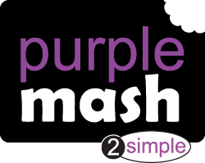 | https://www.purplemash.com/sch/stannesps  Weekly activities set on Purple Mash by staff. Please check you ‘2dos’ to see what has been set.  Area of Learning – all areas of learning
 | https://www.twinkl.co.uk/  Home learning resources available for parents.  Area of Learning – all areas of learning
ANDYS WILD WORKOUTS   | https://www.bbc.co.uk/programmes/p06tmmvz/episodes/player  Join Andy from Cbeebies for his home workouts aimed for younger children.  Area of Learning – Physical
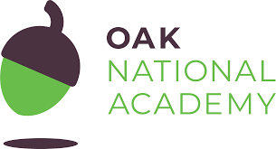 | https://classroom.thenational.academy/year-groups/reception/  Online classroom delivering lessons to children across all ages.  Area of Learning – all areas
 | https://www.topmarks.co.uk/  Interactive games for Early years children and links to other useful resources.  Area of Learning – all areas
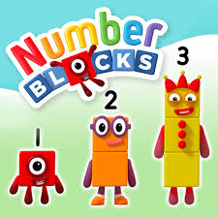 | https://www.bbc.co.uk/cbeebies/shows/numberblocks  Sing along and learn all about numbers with the numberblocks.  Area of Learning – all areas

