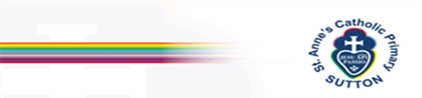St Anne’s Catholic Primary School – History Long Term Plan 

Significant Individual, Significant Event, Civilisation, Movement (Settlement/Migration/Invasion), Now (Modern History), Post 1066 Period

 | 1 week |  | 1 week |  |  |  | 1 week
 | All about me  How have I changed since I was a baby? |  | All about me  Our Families - Grandparents |  |  |  | All about me  What are our favourite celebrations each year?
EYFS | Running throughout the year: Understanding the world - Past and Present.  -Is beginning to make sense of his/her own life story and his/her family’s history.  -Comments on images of familiar situations in the past.  -Is able to compare and contrast characters from stories, including figures from the past.  -Knows some similarities and differences between things in the past and now, drawing on his/her experiences and what has been read in class.  -Talks about the lives of the people around him/her and their roles in society.  -Shows an understanding of the past through settings, characters and events encountered in books read in class and storytelling.
 | 2 weeks |  | 1 week |  |  | 1 week
Key stage 1 | A street in Sutton   |  | The Great Fire of London   | Mary Seacole and Edith Hughes  
Lower Key Stage 2 | Changes through the Stone Age, Bronze Age and Iron Age | The Roman Empire and its impact on Britain.   | Britain’s settlement by Anglo-Saxons and Scots | The achievements of the earliest civilisations – Ancient Egyptians
Upper Key stage 2 | The Viking and Anglo-Saxons struggle for the Kingdom of England to the time of Edward the Confessor. |  | Study of Greek life and achievements and their influence on the western world   |  | A non-European society that provides contrasts with British history: Early Islamic Civilisation  
Whole school | World War 1 and World War 2

