
Whole School Provision Overview
St.Anne’s Catholic Primary School
Area of Need | Universal  Wave 1 – High Quality Teaching  Baseline assessments | SEN Support  Wave 2 – Targeted Support  (in addition to Wave 1)  Delegated notional SEN budget | SEN Support  Wave 3 – Specialist Support  (in addition to Wave 1 & 2)  Specialist advice sought
Cognition & Learning  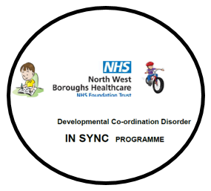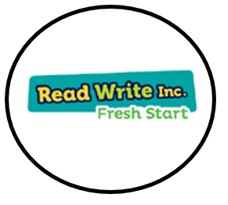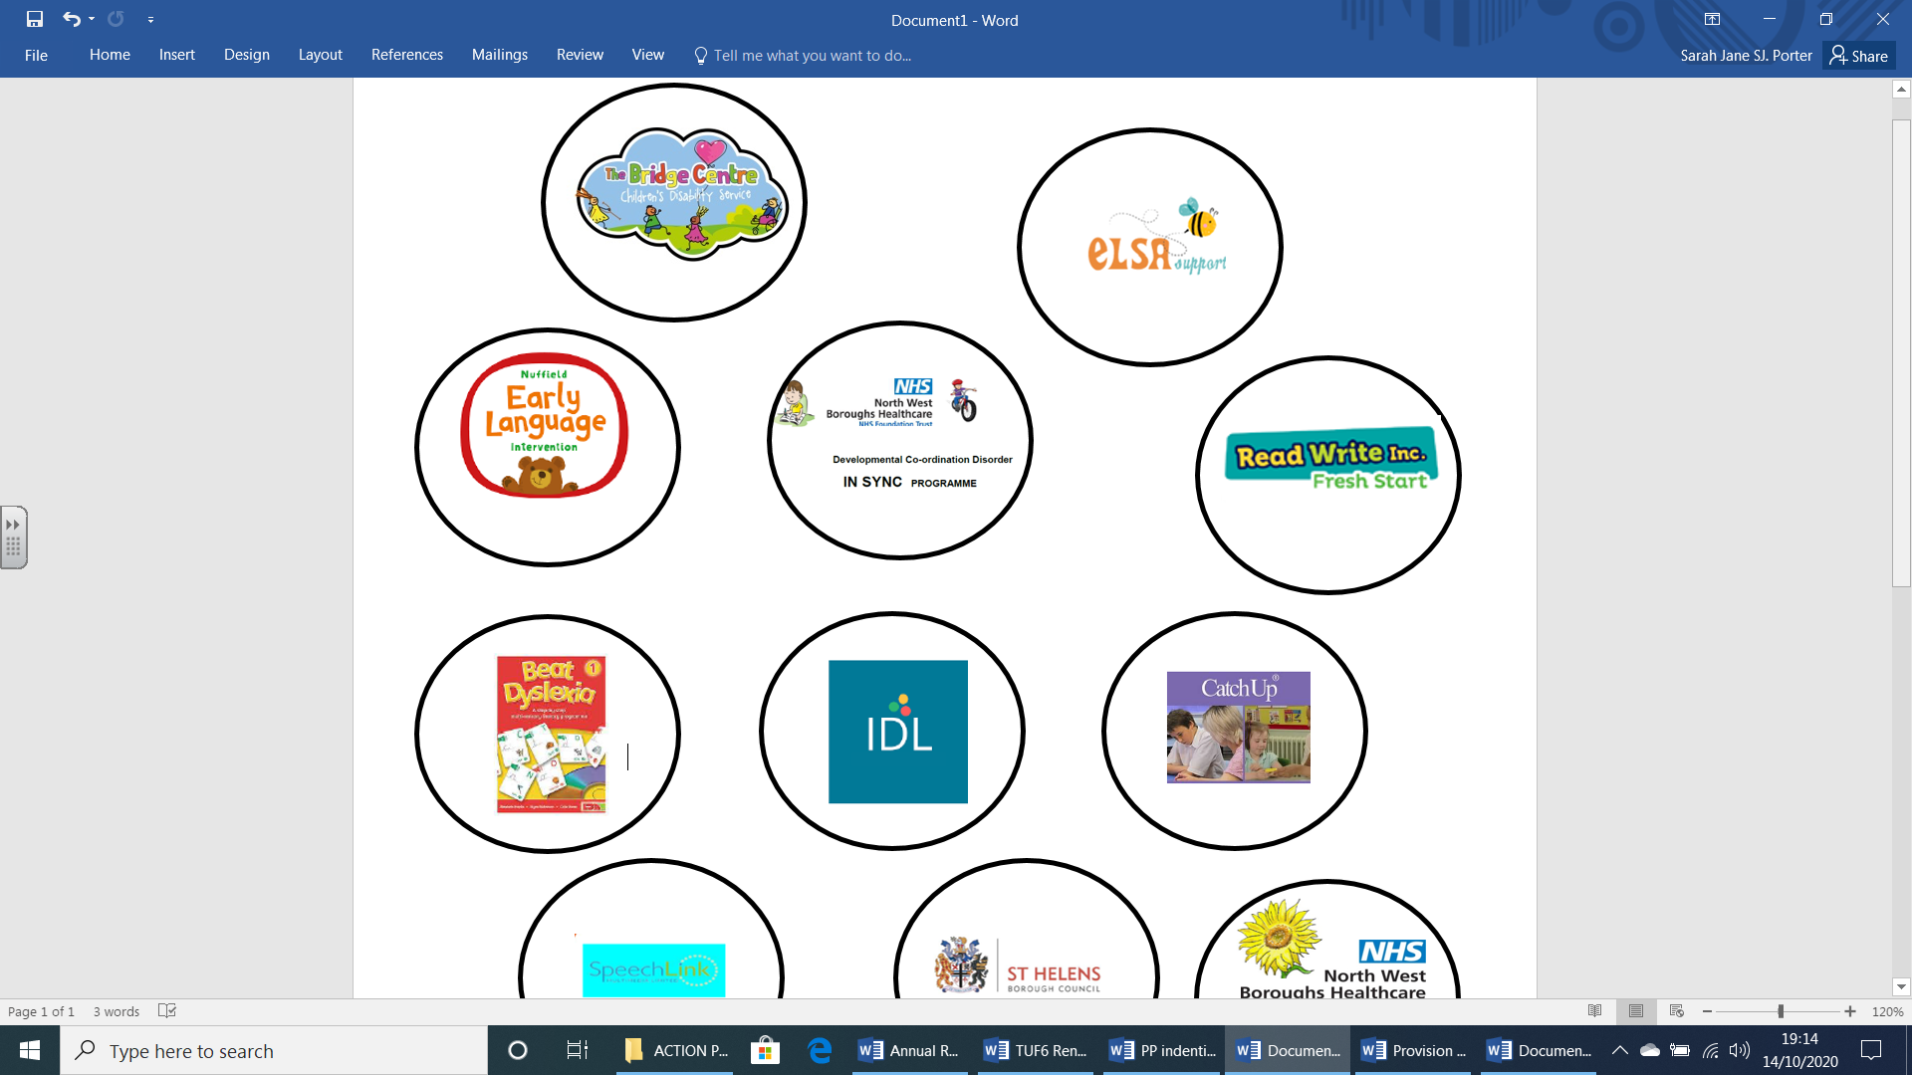  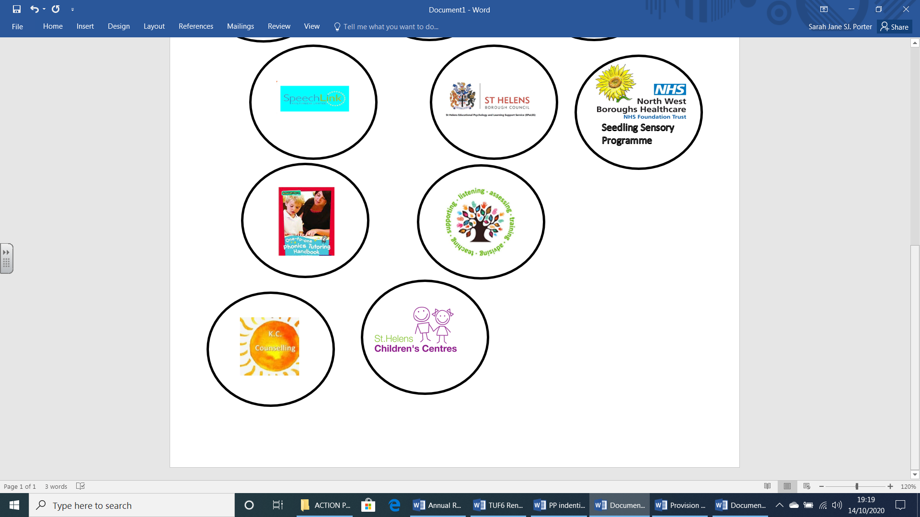  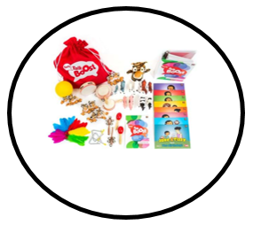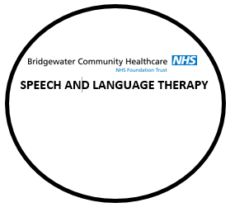 | - Flexible structure, groupings  - Increased visual aids  - Visual timetables  - Adaptive Teaching Strategies  - Writing frames  - Ipads/ kindles  - Now / Next boards  - Sentence Stems  - Word banks/ word mats – scaffolding  - Knowledge Organisers (All subjects)  - Number lines (Maths)  - Numicon / Bar Model / Manipulatives (Maths)  - Whole school staff training / CPD  - Differentiated pace/questioning  - Environmental changes / seating plans  - Resources and displays to promote independence | - Individual target plan  - Small group adult led – phonics, writing, reading, maths, handwriting interventions  - Further Adaptive Teaching Strategies  - Pre-learning  - Staff training / CPD  - Individual resources for independence e.g. timers, task boards  - Advice for parents to referral to Community Paediatrician if needed  - Referral to TESSA for further support | 1:1 support or small group support:  - Beat Dyslexia Intervention  - Language Link Intervention  - Speech Link Intervention  - NELI Intervention  - Speech and Language targeted packs intervention.  - Targeted interventions to address IBP/IEP targets  - Precision Teaching  - Bespoke provision in CASA Hub or Hub
Communication & Interaction | - Flexible structure, groupings  - Increased visual aids  - Visual timetables  - Adaptive Teaching Strategies  - Ipads/ kindles  - Now / Next boards  - Sentence Stems  - Word banks/ word mats – scaffolding  - Talk partners  - Structured routines  - Whole school Staff training / CPD | - Speech and language groups  - Individual targeted plan  - Referral to Speech and Language Services  - Chatty Words/ Language Link group  - Staff training / CPD  - Advice for parents to referral to Community Paeds or Neuropathway if needed.  - Referral to TESSA for further support | - Speech and Language programme of interventions as directed  - Pastoral - Individual interventions or group interventions.  - Bespoke provision in CASA Hub or Hub
Social, Emotional & Mental Health  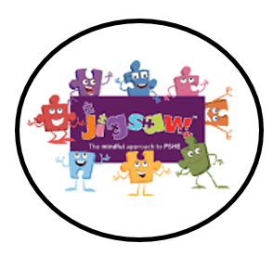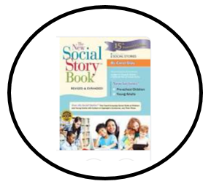  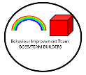  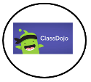  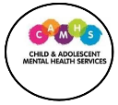  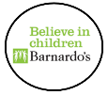 | - Whole class reward systems  - Whole class rules – visual  - Increased visual aids  - Visual timetables  - Adaptive Teaching Strategies  - Timers  - Task Boards  - Barnardos Paths Programme  - PSHE lessons  - Buddies  - Consider need for Early Help  - Workstations  - Whole school Staff training / CPD  - In class learning breaks  - Sensory Breaks | - Social groups – Pastoral Support either group or 1:1 support  - Nurture groups – Pastoral Support either group or 1:1 support  - Social Story groups  - School Score Reward system and Dojo rewards  - Home school communication sheets  - Mentoring  - Individual target plan  - Additional adult monitoring during transitions  - Staff training  - Supervised learning breaks  - ELSA intervention  - Advice for parents to referral to Community Paeds if needed.  - Advice for parents to referral to School Nurse if needed.  - Referral to TESSA for further support | - Individual programmes  - Counselling – external (Kelly Counselling, referral to Barnardos and CAHMS)  - Daily home-school contact  - Transition supervision  - Outside agency transition e.g. LASC  - Structured activities at lunchtime  - Frequent learning breaks  - TESSA Behaviour Interventions.  - Pastoral Support Plans (PSP)  - Bespoke provision in CASA Hub or Hub
Sensory & Physical  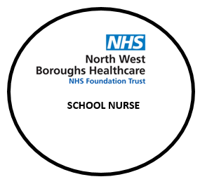 | - Training around impairment  - Adaptive Teaching Strategies  - Additional resources/tools  - Fine motor exercises  - Fiddle sensory boxes  - Fidget tools  - Pencil grips  - Workstation  - Whole school Staff training | - Gross motor group interventions  - Fine motor group interventions  - Handwriting group  - Funky Fingers/ Dough Gym  - Sensory resources / Sensory Interventions  - Safe place - CASA  - Individual target plan  - Staff training / CPD  - Advice for parents to referral to Community Paeds or OT/PT if needed.  - Advice for parents to referral to School Nurse if needed.  - Referral to TESSA for further support | - OT programme daily  - Physio daily  - Bespoke provision in CASA Hub or Hub

