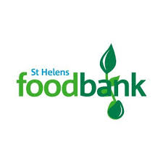
*Parents/Families in need, can come and speak in confidence to Mrs Pointon, if you need a Foodbank voucher - up to three can be given each year

