

Computing Essential Knowledge and skills Spring KS1 2025-2026
N.C Objectives: Key Stage 1 | Essential 1 | Essential 2 | Essential 3
Use technology safely and respectfully, keeping personal information private; identify where to go for help and support when they have concerns about content or contact on the internet or other online technologies.  (Digital Literacy)  Use technology purposefully to create, organise, store, manipulate and retrieve digital content. (IT) | Knowledge  Understand the importance of keeping information, such as their usernames and passwords, private and actively demonstrate this in lessons.  Understand where to go for help and support if they have concern about content or contact online. | Knowledge  Understand the importance of keeping information, such as their usernames and passwords, private and actively demonstrate this in lessons.  Begin to understand how things are shared electronically.  Know ways of reporting inappropriate behaviours and content to a trusted adult. | Knowledge  Know the implications of inappropriate online searches.
 | Skills  Take ownership of their work and save this in their own private space such as their My Work folder on Purple Mash.  Purple mash 2be safe unit – Year 1 Privacy and Security | Skills  Develop an understanding of using email safely by using 2Respond activities on Purple Mash  Purple mash 2be safe unit – Year 2  Privacy and Security | Skills  Use technology purposefully to create, organise, store, manipulate and retrieve digital content.  Purple mash 2be safe unit –  Managing information online
 | Sonar objectives:  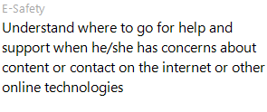 | Sonar objectives:  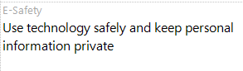

Computing Essential Knowledge Spring LKS2 2025-26
N.C Objectives: Key Stage 2 | Essential 1 | Essential 2 | Essential 3
Key Stage 2  N.C Objectives:  Use technology safely, respectfully and responsibly; recognise acceptable/ unacceptable behaviour; identify a range of ways to report concern about content and contact.  (Digital Literacy)  Select, use and combine a variety of software (including internet services) on a range of digital devices….(IT) | Knowledge  Demonstrate the importance of having a secure password and not sharing this with anyone else.  Explain the negative implications of failure to keep passwords safe and secure.  Understand the importance of staying safe and the importance of their conduct when using familiar communication tools such as 2Email in Purple Mash.  Know more than one way to report unacceptable content and contact. | Knowledge  Explore key concepts relating to online safety using concept mapping such as 2Connect.  Help others to understand the importance of online safety.  Know a range of ways of reporting inappropriate content and contact. | Knowledge  Recognise acceptable/unacceptable behaviour online.
 | Skills  IT – Present online safety information using a selection of software, e.g. using a branching database (2Question), using software such as 2Graph.  Purple mash 2be safe unit – Year 3 Privacy and Security | Skills  IT – Present online safety information using a range of software such as 2Connect and 2Publish+.  Purple mash 2be safe unit – Year 4 Privacy and Security | Skills  Share digital content within their community, i.e. using Virtual Display Boards.  Purple mash 2be safe unit -  Managing information online
 | Sonar objectives:  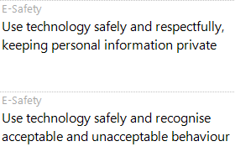 | Sonar objectives  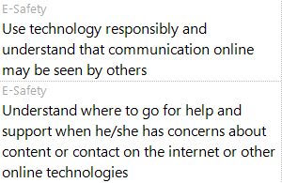

Computing Essential Knowledge Spring UKS2 2025-2026
N.C Objectives: Key Stage 2 | Essential 1 | Essential 2 | Essential 3
Key Stage 2  N.C Objectives:  Use technology safely, respectfully and responsibly; recognise acceptable/ unacceptable behaviour; identify a range of ways to report concern about content and contact.  (Digital Literacy)  Select, use and combine a variety of software (including internet services) on a range of digital devices….(IT) | Knowledge  Recognise what personal information is and explain how this can be kept safe.  Have a secure knowledge of common online safety rules and can apply this by demonstrating the safe and respectful use of a few different technologies and online services.  Relate appropriate online behaviour to their right to personal privacy and mental wellbeing of themselves and others. | Knowledge  Demonstrate the safe and respectful use of a range of different technologies and online services.  Identify more discreet inappropriate behaviours through developing critical thinking. (e.g. 2Respond activities.)  Recognise the value in preserving their privacy when online for their own and other people’s safety. | Knowledge  Understand why age limits are set relating to content.
 | Skills  Present online safety information using digital features within software such as collaborative mode.  Use several ways of sharing digital content. ( i.e. 2Blog, Display Boards and 2Email)  Purple mash 2be safe unit – Year 5 Privacy and Security | Skills  Design and create their own blogs to become a content creator on the internet, (e.g. 2Blog.)  Purple mash 2be safe unit – Year 6 Privacy and Security | Skills  Present online safety information using clear connections to the audience when designing and creating digital content.  Purple mash 2be safe unit –  Managing information online
 | Sonar objectives:  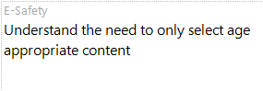 | Sonar objectives  