St Anne’s Catholic Primary School – Geography Long Term Plan 

EYFS | Autumn |  | Spring |  | Summer
EYFS | -Seasons and seasonal change.  -Senses and nature walks  -Celebrations and traditions in this country and in other countries  -Maps (drawing information from simple maps)  -Building/landmarks within our school grounds and our local area |  | -Seasons and seasonal change.  -Senses and nature walks  -The Antarctic and Arctic  -Africa  -Animal habitats  -Celebrations and traditions in this country and in other countries. |  | Seasons and seasonal change.  -Senses and nature walks  -Animal habitats  -Gardening.
 | 1 week | 1 week |  | 1 week |  | 1 week
Key stage 1 | What is in our school?   | What countries make up the United Kingdom?   |  | Which continent is the hottest and coldest?  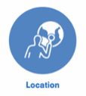 |  | How are Nairobi and St Helens similar/different?  
Lower Key Stage 2 | What is in our local area?   | Why is most of Iceland uninhabited?  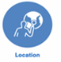 |  | How are The community of Madrid, The North West of England and The Andean region similar/different?  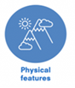 |  |     How are goods transported internationally?
Upper Key Stage 2 | What are landscapes like in the UK?    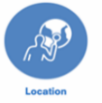     | How do you use a map to find a location? |  |   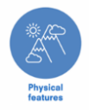  What is special about the continent of Europe? |  | Why does the Earth have different biomes?  

