Year: | EYFS | Aim | To explore the wonder of being special and unique.
Strand | Physical | Learning intention | To recognise that we are all different and unique.

What should I already know? | What will I learn?
The joy of being a special person in my family. | How we are different from each other.  What it is that makes us all different.  Why God made us all different and special to him.  How we can be friendly to each other; making and keeping friends, showing care and being generous when we are together.
Key words I will need to understand: |  | Key skills I will need to use: | Songs I will hear during reflection time:
unique | Being the only one of its kind. | 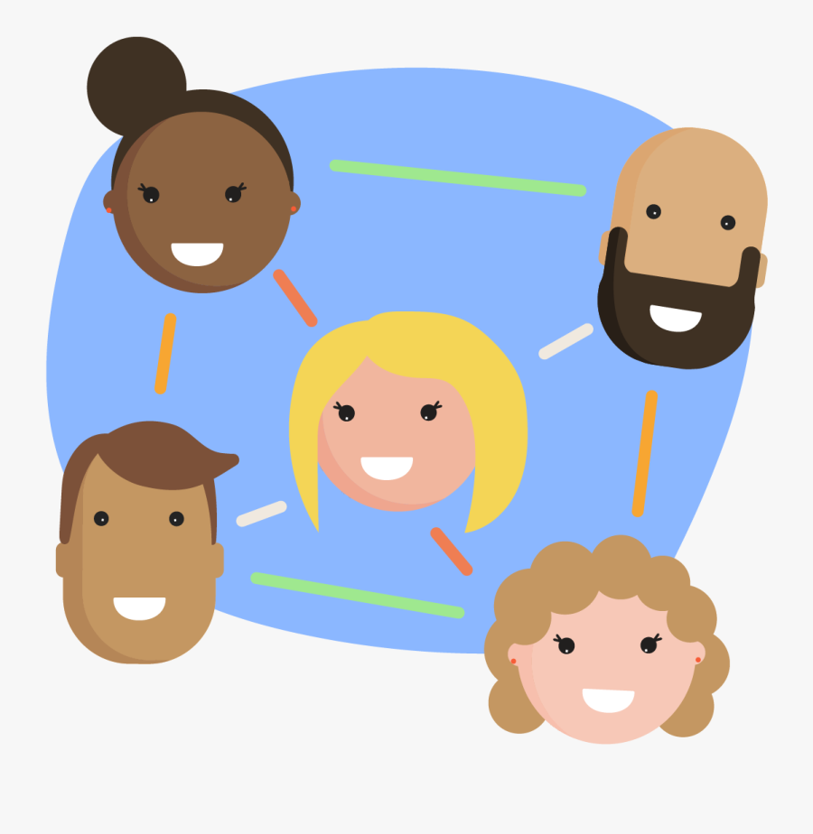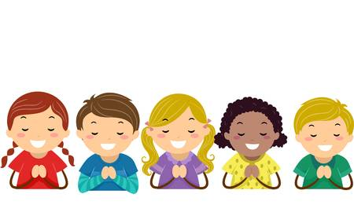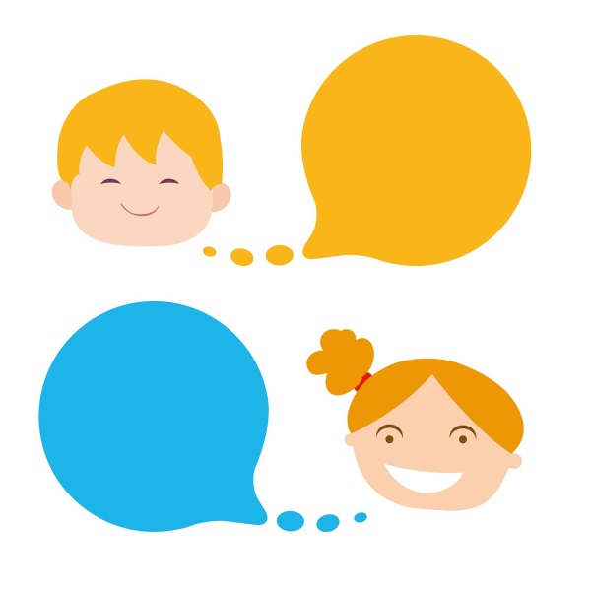  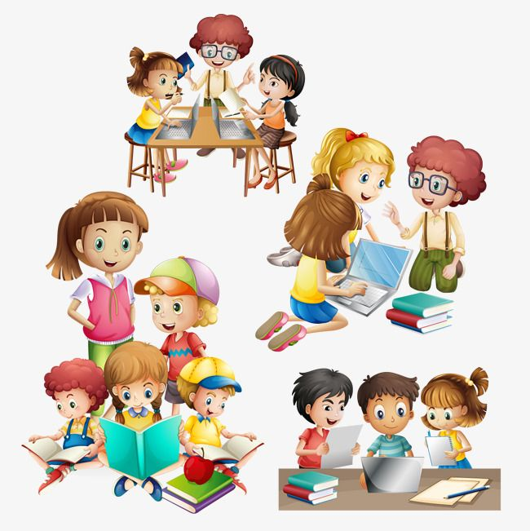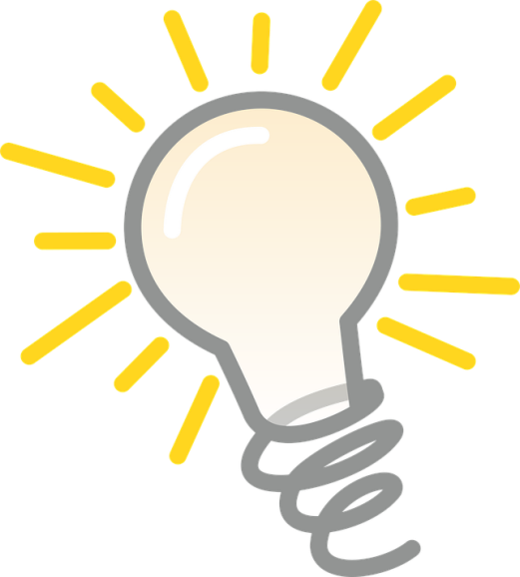 | 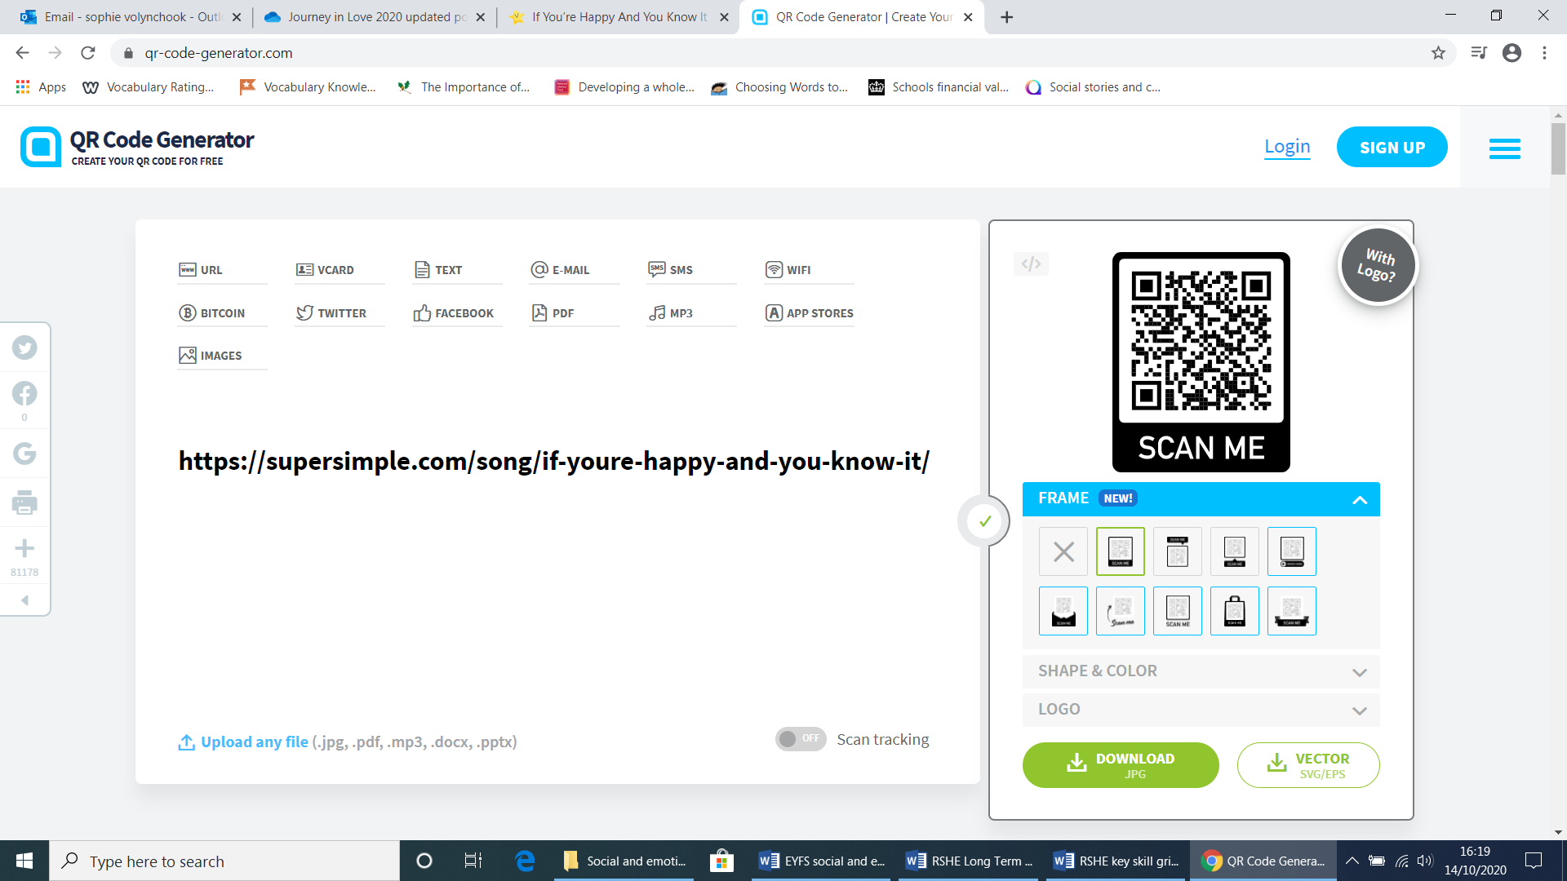
different | Things that are not the same.
special | A quality that is treasured.
friends | People who we have a relationship with who aren’t members of our family.
generous | How we give ourselves; time and sharing.
worried | A negative feeling.

Scripture and prayers that we will use: | Images I may see:
Loving God,  thank you for making me special and unique,  with my own name.  Bless my family and friends.  Amen | 