Year: | 1 | Aim | To focus on families and specially growing up in a loving, secure and stable home.
Strand | Physical | Learning intention | To recognise how I am cared for and kept safe in my family.

What should I already know? | What will I learn?
The signs that I am loved in my family. | Who is in my family and how families shoe love and care for one another.  What are some of the characteristics of a happy family.  How we should act with adults who are not in our family and that we do not know.  In what ways are we made in the image and likeness of God.  How our family helps keep us healthy, including physical, mental and spiritual health.

Key words I will need to understand: |  | 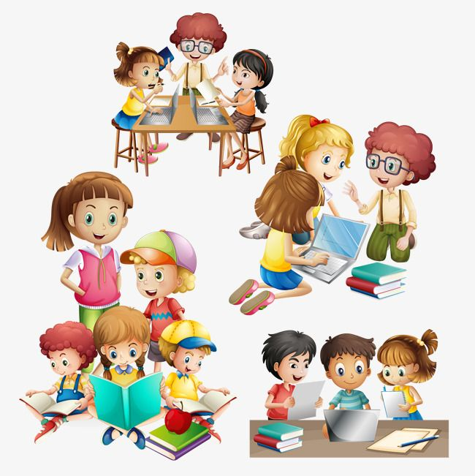Key skills I will need to use: | Songs I will hear during reflection time:
healthy | To be free from illness | 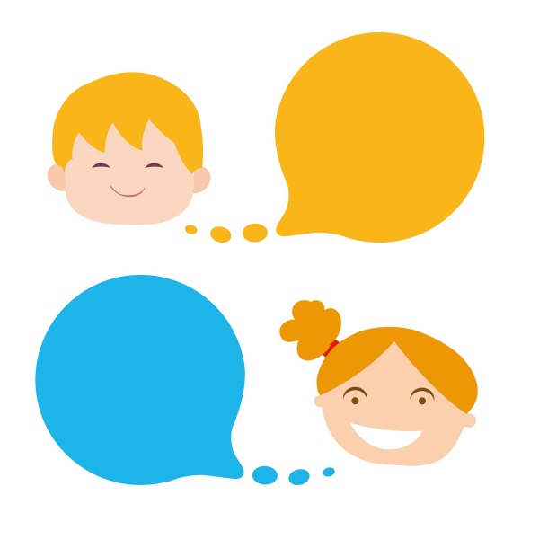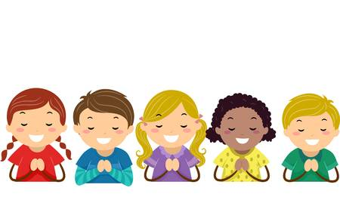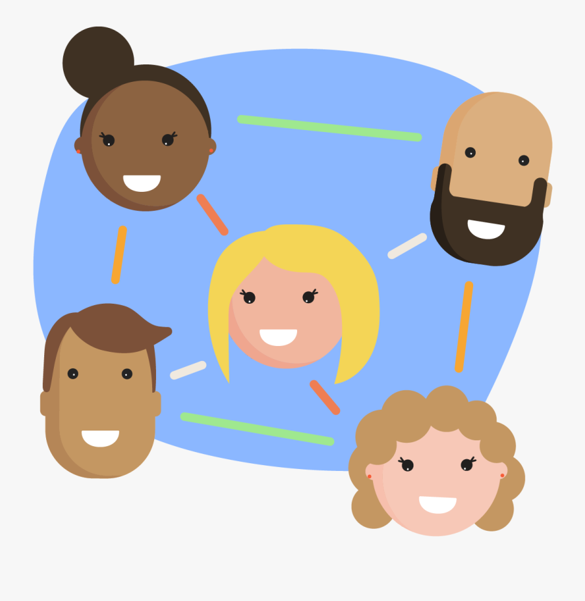 | 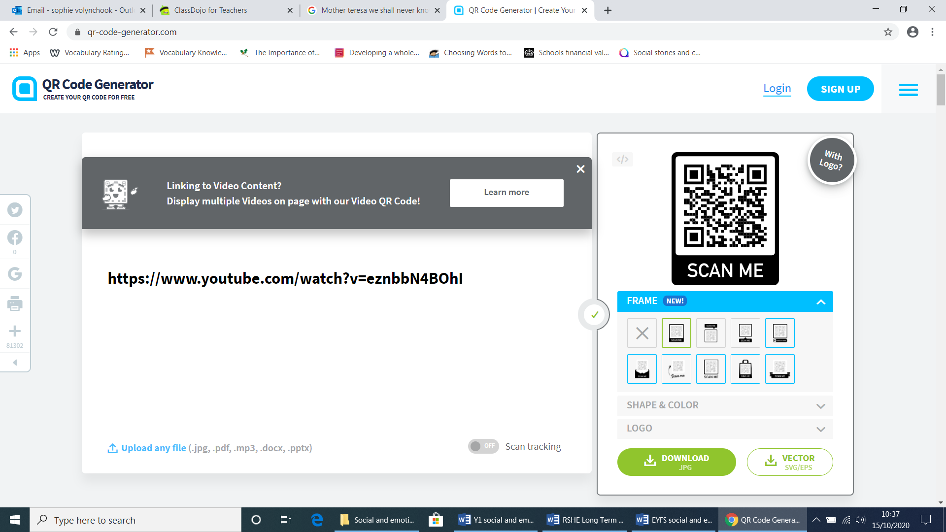
safe | To be free from harm
boundaries | Rules that we keep so that we are safe.
Names of body parts | Penis, vagina, bottom, breasts

Scripture and prayers that we will use: | Images I may see:
Loving Father,  Thank you for my mum, dad, brothers and sisters  Who all love and care for me.  You love me so much that you have my name  Carved on the palm of your hand.  Amen  Isaiah 49: 16 | 