Year: | 2 | Aim | To describe how we are growing and developing in diverse communities that are God-given.
Strand | Physical | Learning intention | To describe ways of being safe in communities.

What should I already know? | What will I learn?
The joy of friendship and what it feels like to belong to a diverse community. | What makes us feel safe in our families, in our friendships and in our wider communities.  What could make you feel unsafe and when is it not right to keep a secret.  Who I can go to if I feel worried about another person who you think is unsafe.  Knowing how to ask for help and who we should talk to.  How we can keep safe when we use the internet and digital devices.  Online safety – knowing what is true and how we can check.  What are the things harming our world and how we can try and stop them.

Key words I will need to understand: |  | Key skills I will need to use: | Songs I will hear during reflection time:
harm | When we are in danger of being hurt, physically or emotionally. | 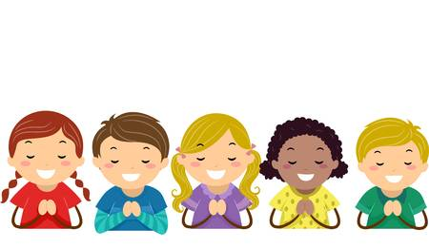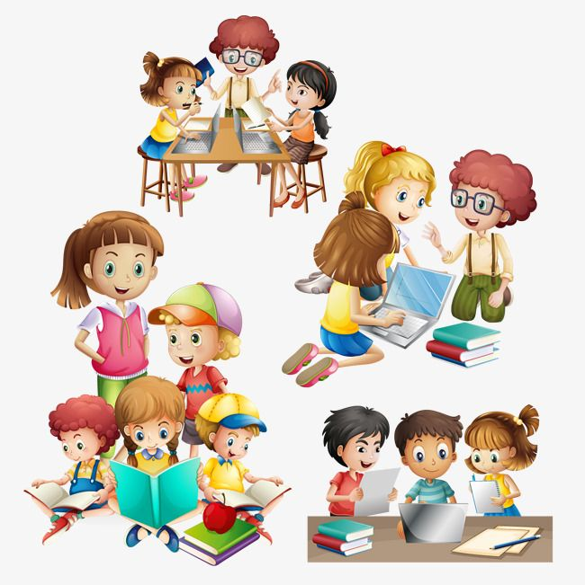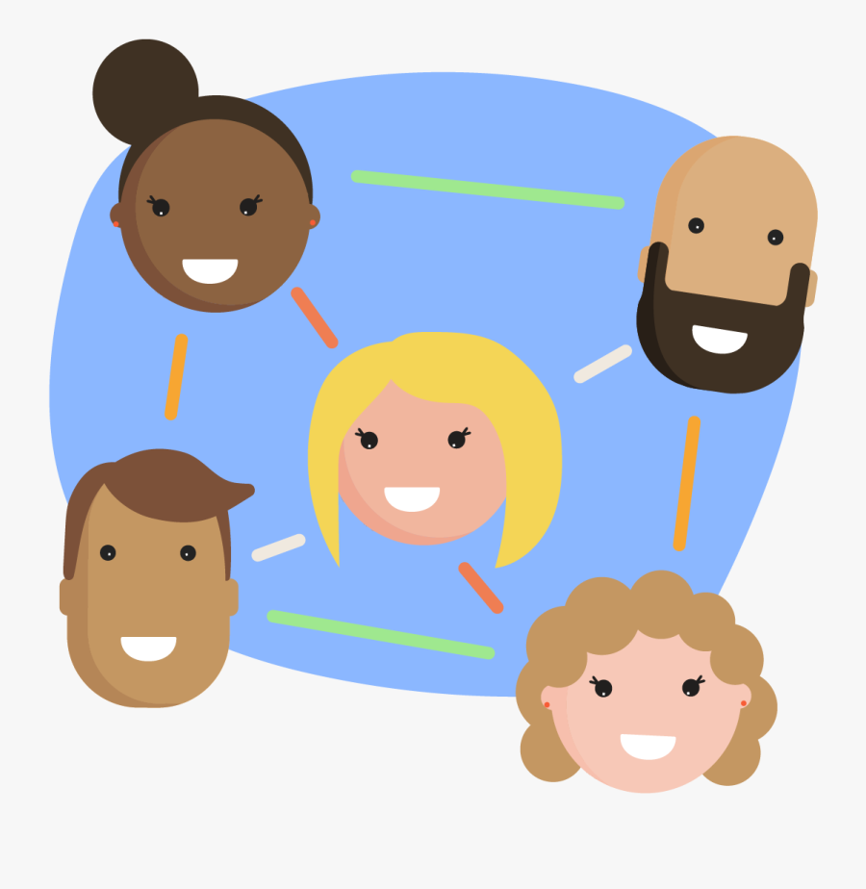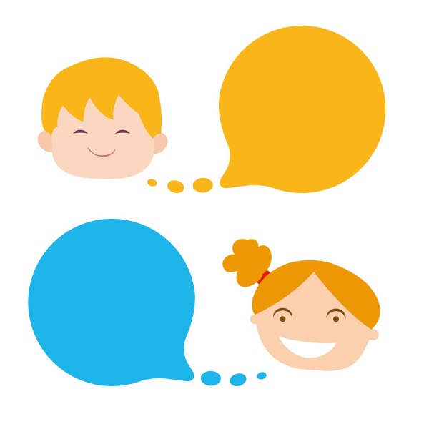 | 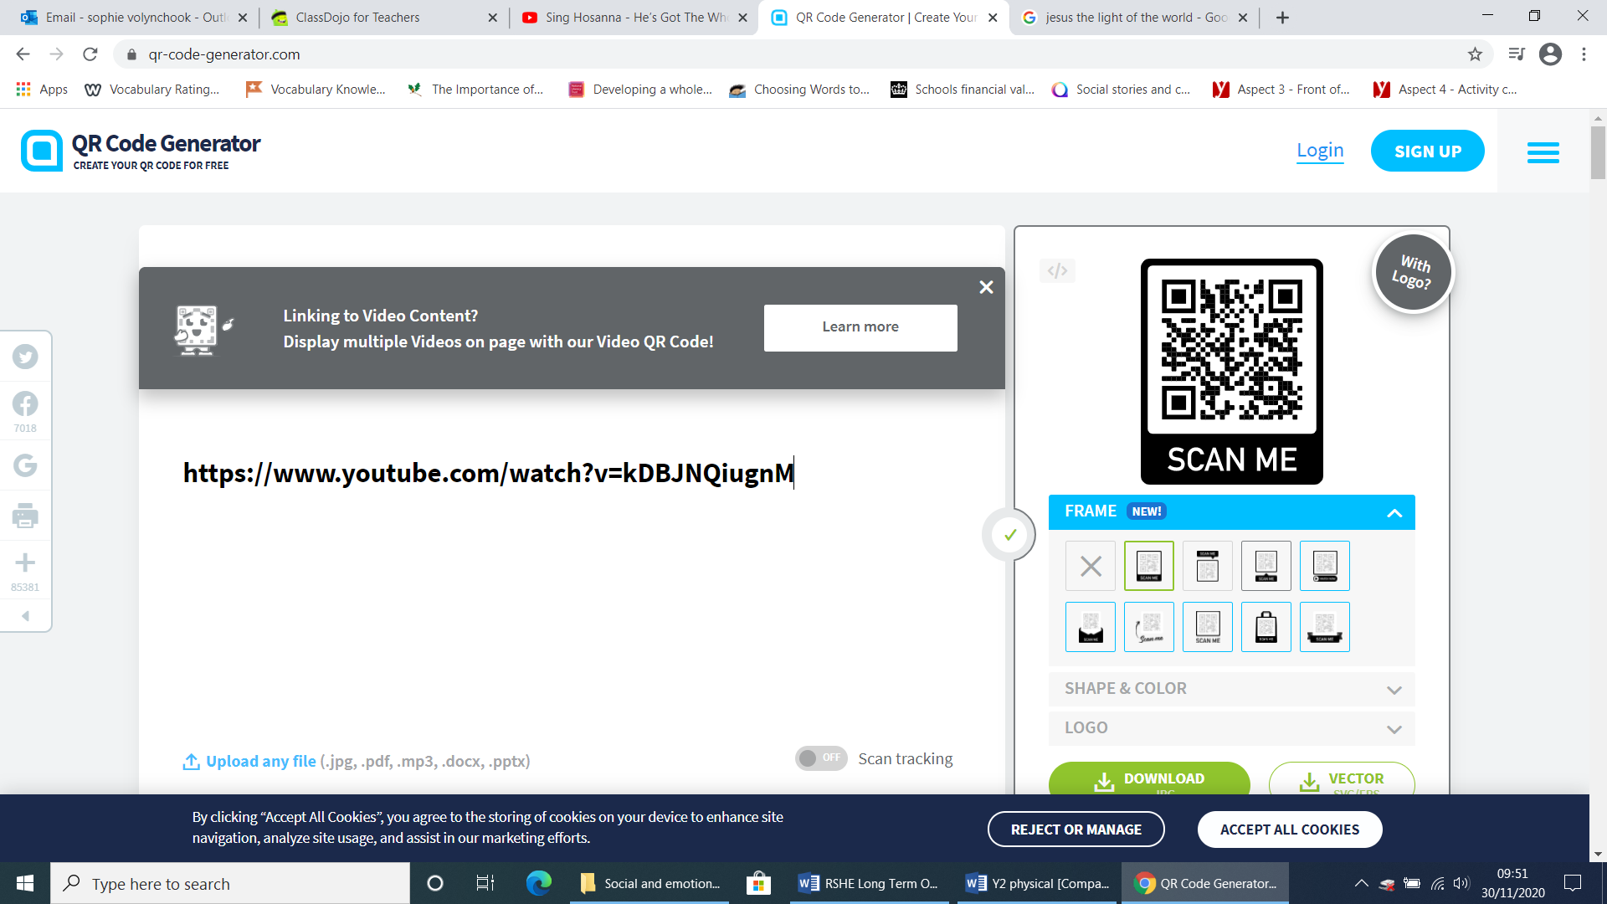
secrets | Something that we don’t tell others.
respect | Treating others in a positive way.
equal | The same
safety | How we keep ourselves from being hurt, physically or emotionally.

Scripture and prayers that we will use: | Images I may see:
Loving Father,  Creator of all people and all of creation.  Help us to see others as you see them,  Brothers and sisters in Jesus,  To be loved and respected at all times.  Amen | 