Year: | 3 | Aim | To describe and give reasons for how we grow in love, in caring and happy friendships where we are secure and safe.
Strand | Physical | Learning intention | To describe and give reasons why friendships break down, how they can be repaired and strengthened.

What should I already know? | What will I learn?
How friendships can make us feel happy and safe. | What can trigger disagreements between friends and within friendship groups.  Feelings we might experience when we have been a part of a disagreement.  How to resolve conflict in friendships.  How healthy friendships can make people feel included and how we should react if others feel lonely or excluded.  Why violence is never the answer.

Key words I will need to understand: |  | Key skills I will need to use: | Songs I will hear during reflection time:
Kindness | The act of being kind |  | 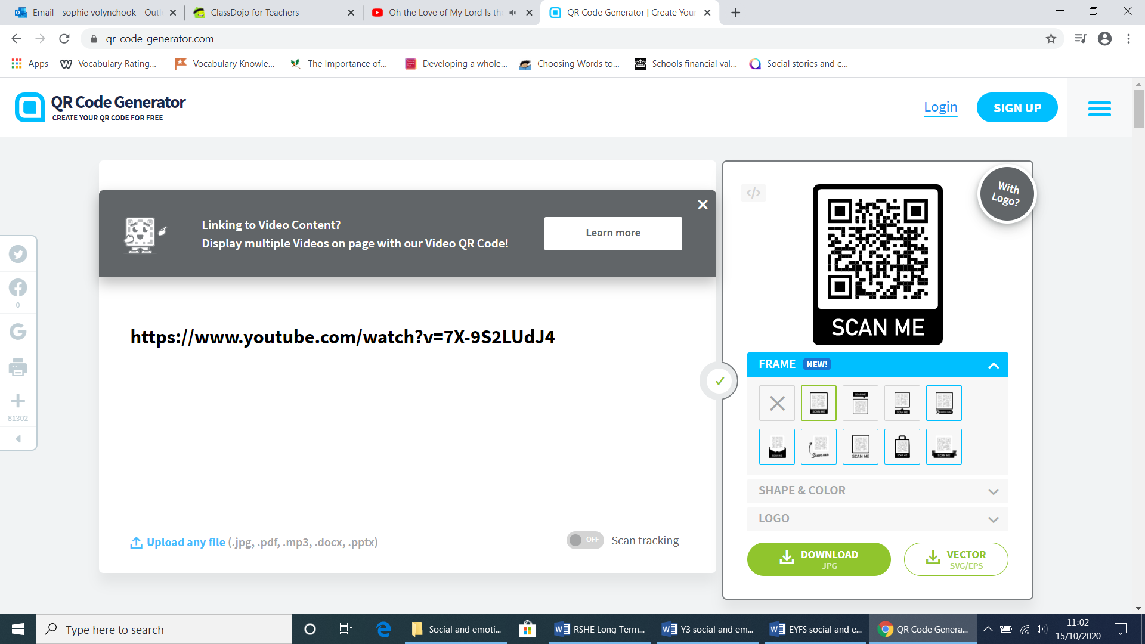
Trust | A person or thing in which confidence is placed.
Difficulties | When we find something hard.
Conflict | A strong disagreement or bad feeling between people.
violence | The use of force to harm a person or damage property.
resolve | To find an answer to a problem.

Scripture and prayers that we will use: | Images I may see:
Peter came to Jesus and asked, “Lord, if my brother keeps on sinning against me, how many times do I have to forgive him? Seven times?”  “No, not seven times,” answered Jesus, “but seventy times seven, because the kingdom of heaven is like this.”  Matthew 18: 21-22 | 

