Year: | 5 | Aim | To show a knowledge and understanding of how we grow in awareness of the physical and emotional changes that accompany puberty, sensitivity, mood swings, anger, boredom et., and grow further in God’s presence in our daily lives.
Strand | Physical | Learning intention | To show knowledge and understanding of the physical changes in puberty.

What should I already know? | What will I learn?
The emotional changes that happen as we grow and develop. | Recognising the emotional, internal and external changes that happen during puberty.  Hygiene routines during puberty and why this is needed to maintain a good personal hygiene.  What physical contact is appropriate, inappropriate or unsafe.  How we can recognise the God of love who journeys with us.

Key words I will need to understand: |  | Key skills I will need to use: | Songs I will hear during reflection time:
puberty | The time when your body begins to develop and change. | 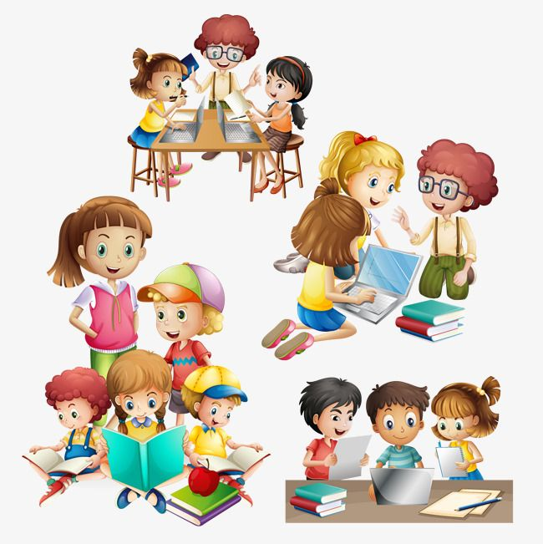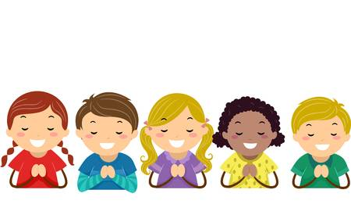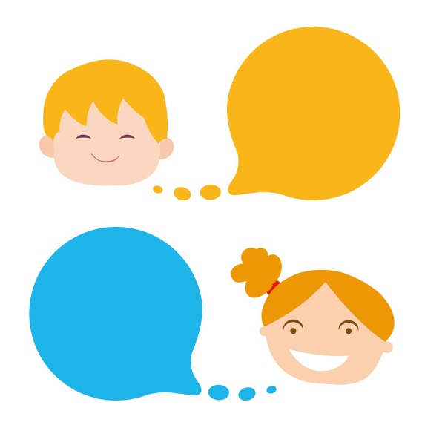 | 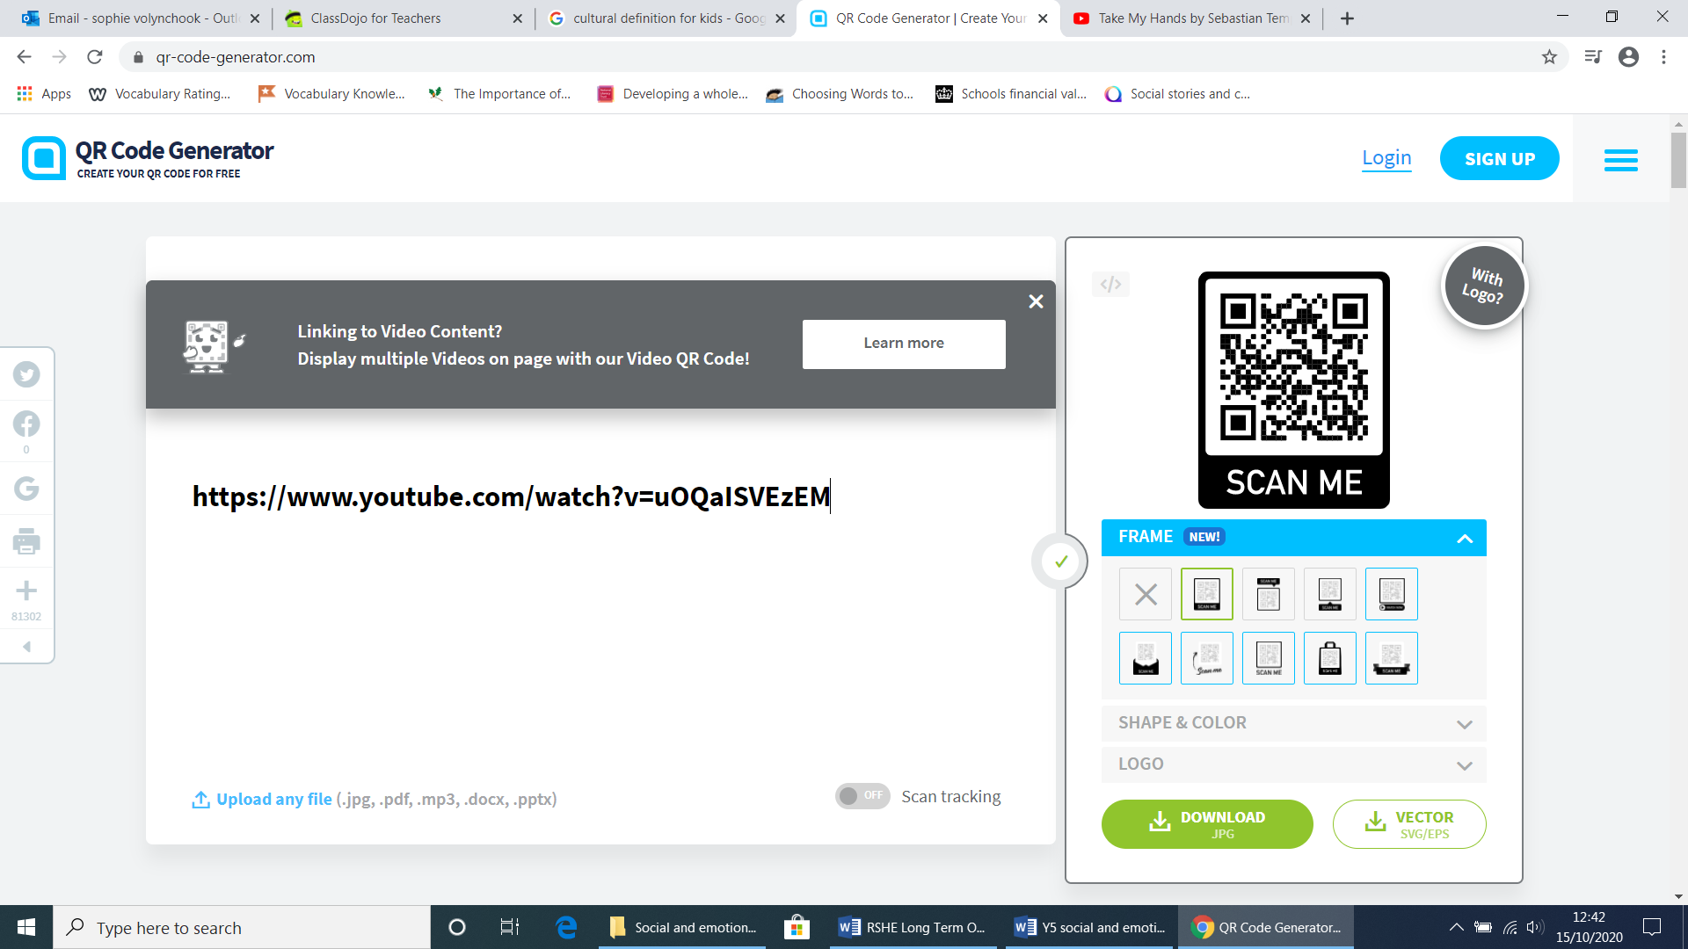
hormones | Chemicals in the body that control cells or organs.
Body parts | Pituitary gland, uterus, fertilised ovum, fallopian tube, vagina, vulva, cervix, womb, breasts, penis, scrotum, sperm, testosterone
Menstruation or period | From the Latin word meaning month. A time during the month where the uterus sheds its lining.
appropriate | Something that is suitable for a person’s age and understanding.

Scripture and prayers that we will use: | Images I may see:
You created every part of me;  You put me together in my Mother’s womb.  When my bones were being formed, carefully put together in my Mother’s womb, when I was growing there in secret, you knew that I was there. You saw me before I was born. Psalm 139: 13-18  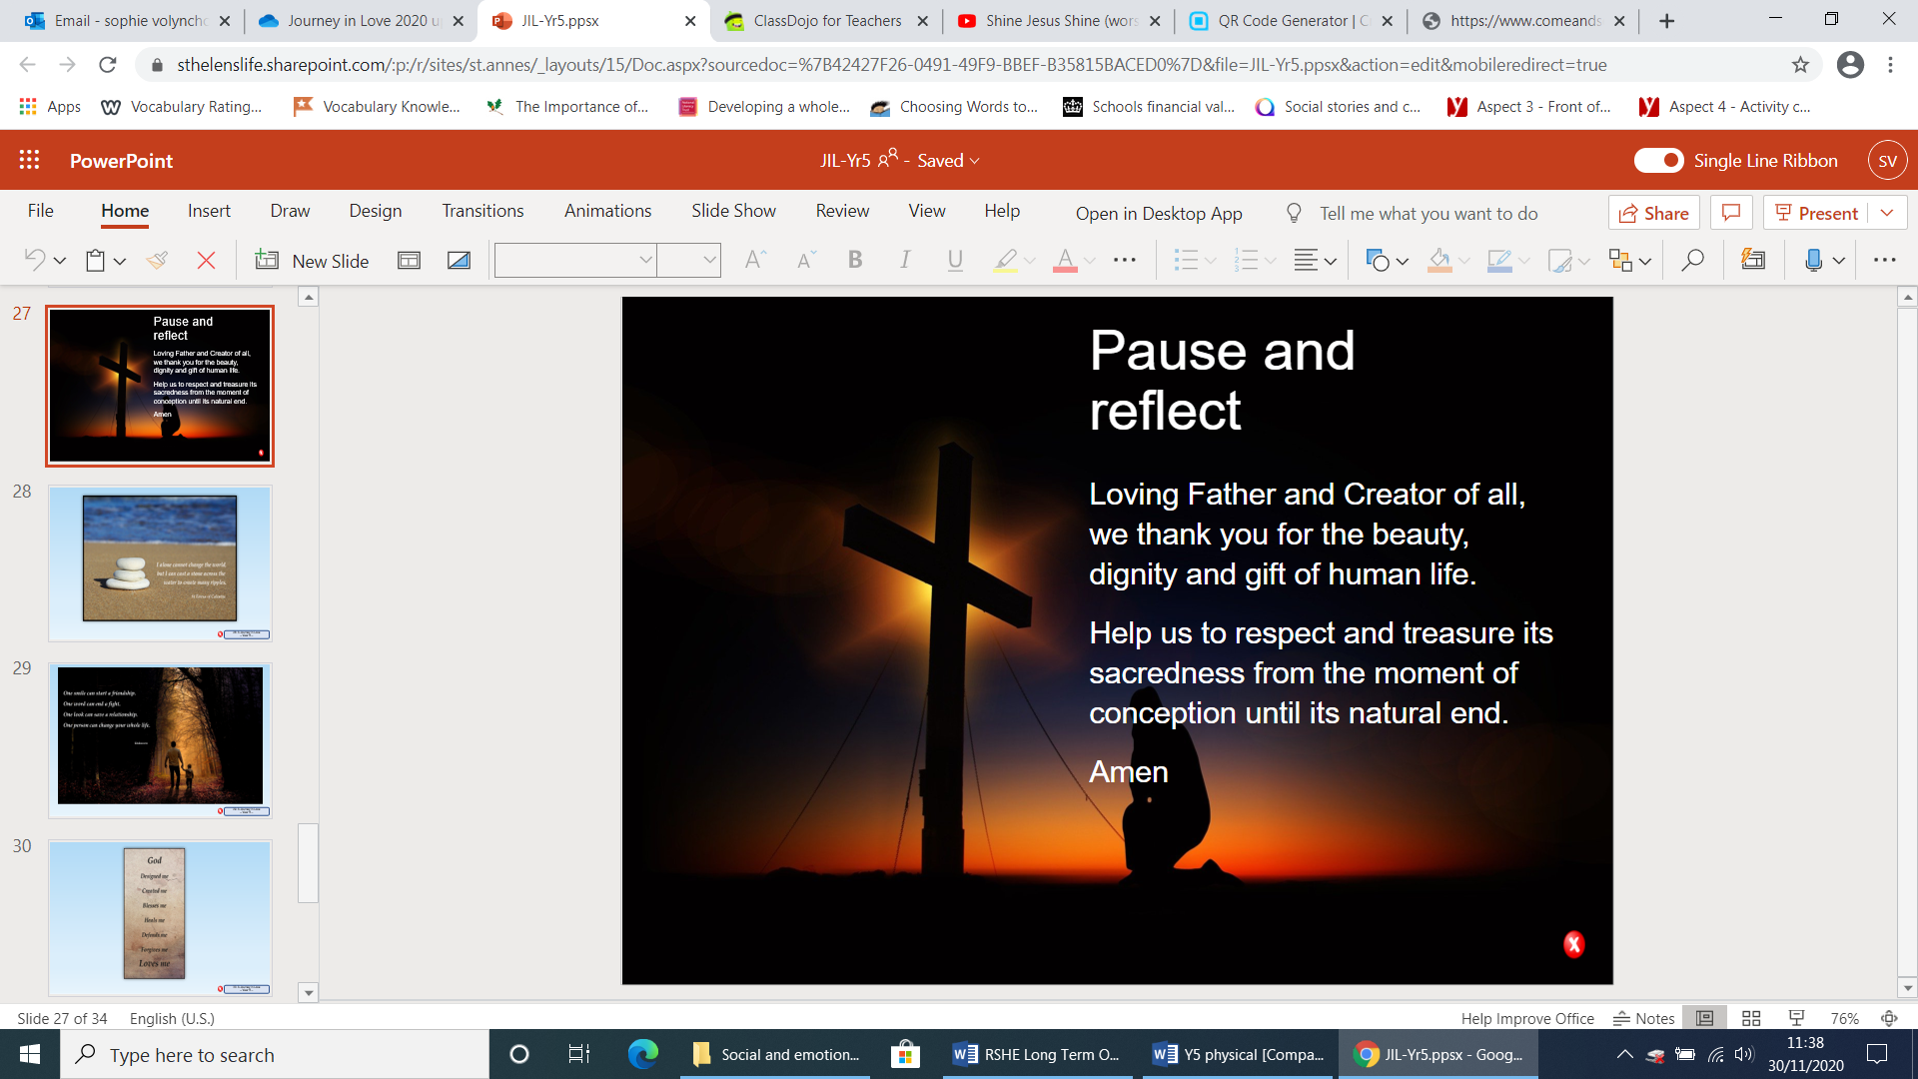 | 