Year: | 6 | Aim | To develop a secure understanding of what stable, caring relationships are and the different kinds there may be. Focussing on Catholic teaching, children will also know and understand about the conception of a child within Marriage.
Strand | Physical | Learning intention | To develop a secure understanding that stable and caring relationships, which may be of difference types, are at the heart of happy families.

What should I already know? | What will I learn?
That there are different types of stable and caring relationships that are at the heart of happy families. | What the key building blocks for a loving relationship are.  How conception takes place.  How a baby develops in a mother’s womb.

Key words I will need to understand: |  | Key skills I will need to use: | Songs I will hear during reflection time:
intercourse | A physical act of love between a husband and wife. | 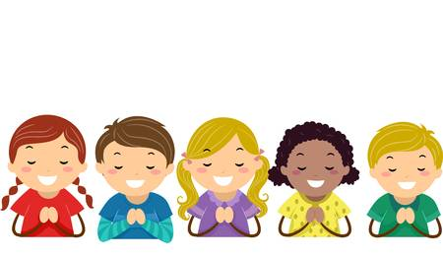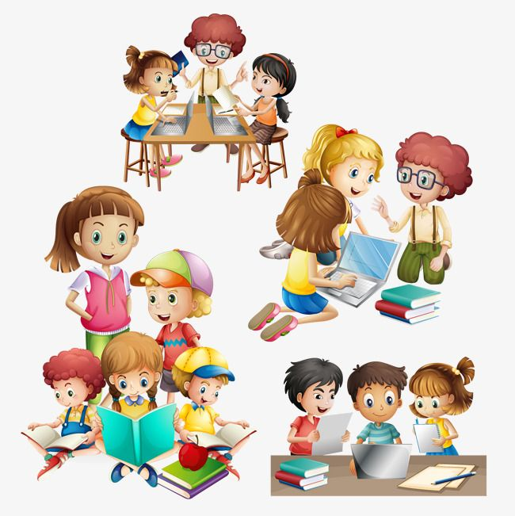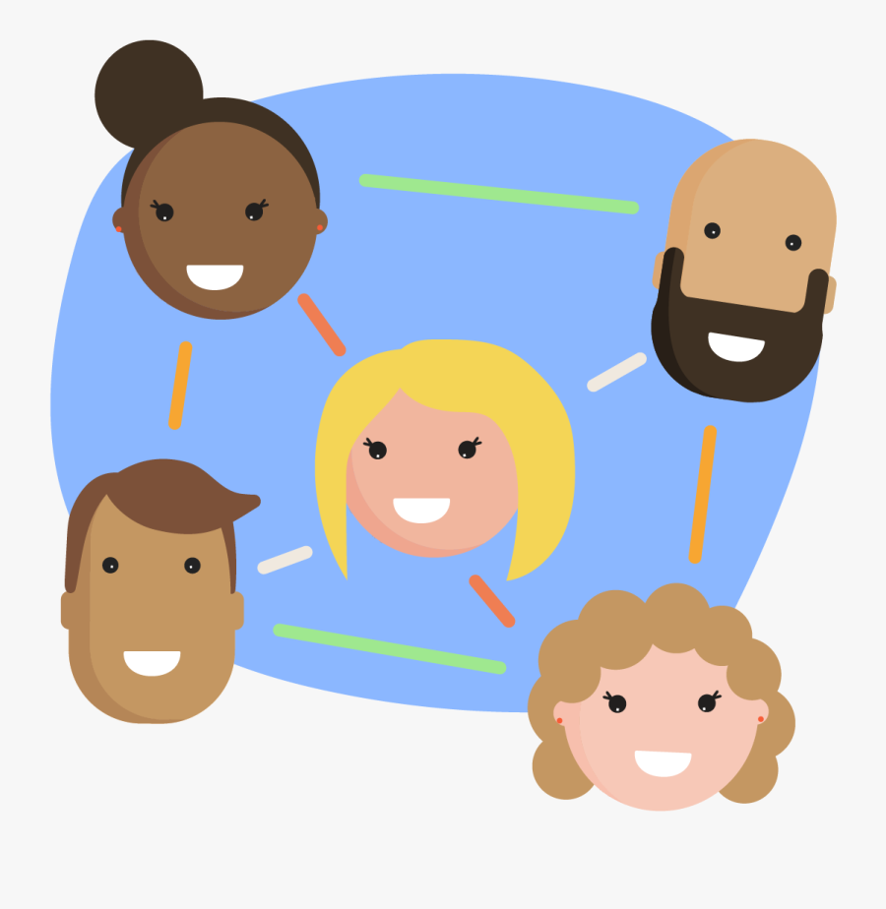 | 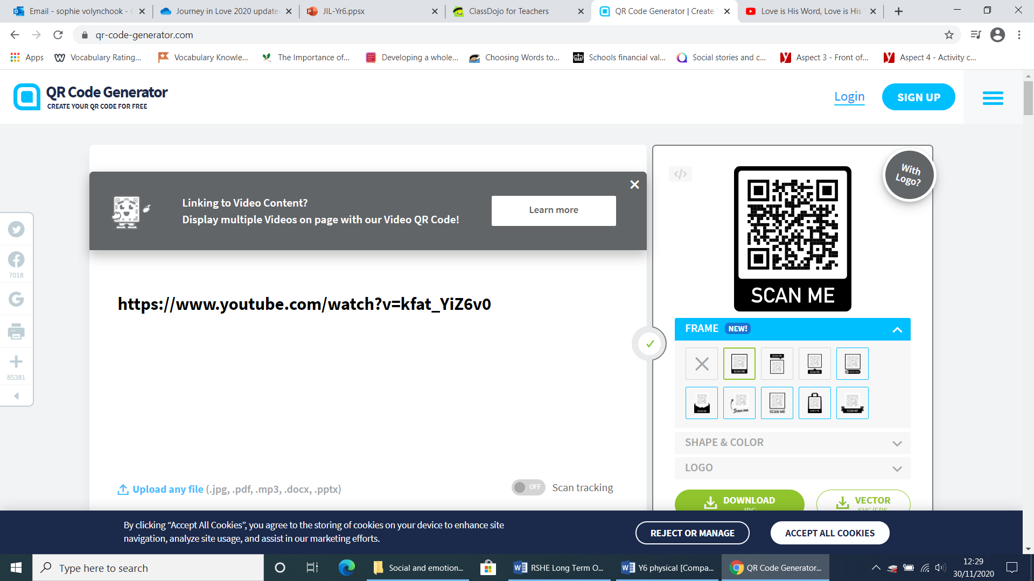
conceive | The moment a sperm cell fertilises an egg cell to create a human life.
Body parts | Uterus, cervix, fallopian tube, ovary, vagina, penis, scrotum, testicle

Scripture and prayers that we will use: | Images I may see:
You saw me before I was born. Every day of my life was recorded in your book. Every moment was laid out before a single day had passed. How precious are your thoughts about me, O God? They cannot be numbered.  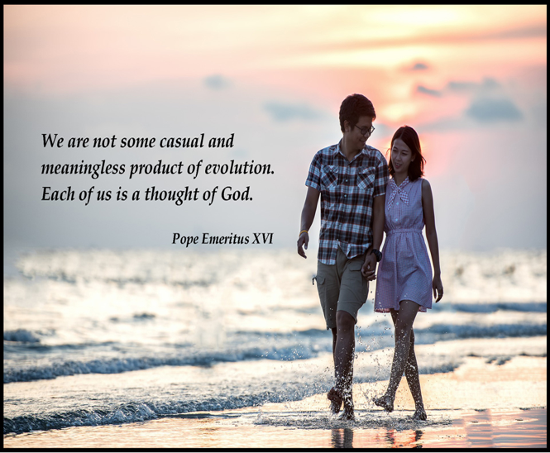Psalm 139: 16-17 | 