Art and Design Curriculum – Cycle B



Upper Key Stage 2 – Year 5 & 6
- to create sketch books to record their observations and use them to review and revisit ideas
- to improve their mastery of art and design techniques, including drawing, painting and sculpture with a range of materials [for example, pencil, charcoal, paint, clay]
- about great artists, architects and designers in history.

Autumn | Spring | Summer
Unit Title: Drawing and Colour - abstract |  | Unit Title: - sculpture
Artist: Wassily Kandinsky 1866 – 1944  Movement: Expressionism  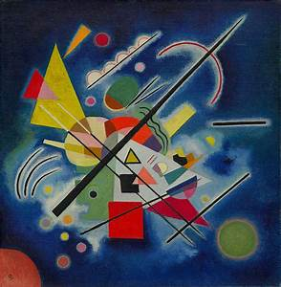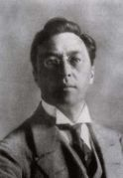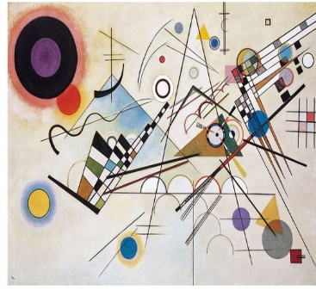  https://www.bbc.co.uk/teach/class-clips-video/art-and-design-ks2-kandinskys-schaukeln/zv7g7nb  https://www.slideshare.net/nivaca2/wassily-kandinsky-for-kids  Compare with the work of:  Artist: Christine Ay Tjoe 1973 -  Movement: Contemporary  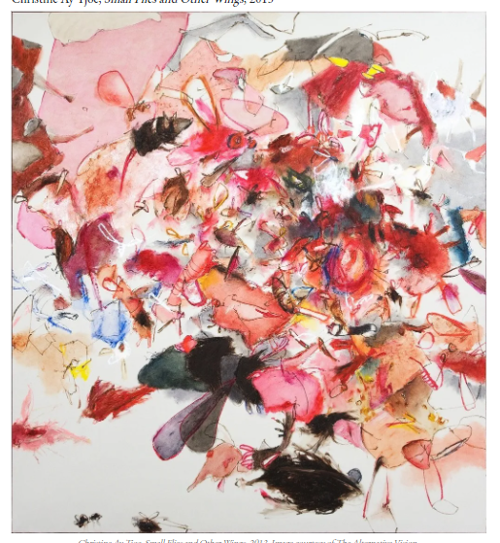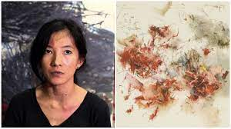  https://www.artsy.net/artist/christine-ay-tjoe |  | Artist: Barbara Hepworth 1903 - 1975  Movement: Modernism  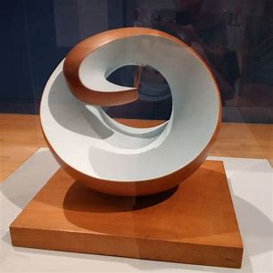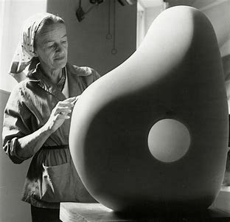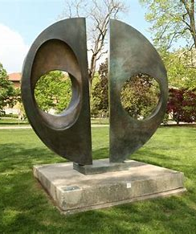  https://www.tate.org.uk/art/artists/dame-barbara-hepworth-1274  https://en.wikipedia.org/wiki/Barbara_Hepworth  http://barbarahepworth.org.uk/  Compare with the work of:  Artist: Antony Gormley 1950 -  Movement: Contemporary  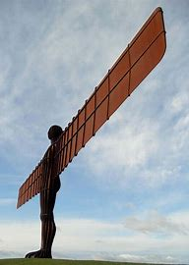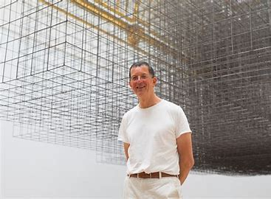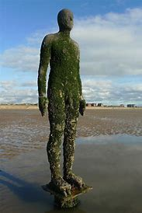  https://www.antonygormley.com/  https://www.britannica.com/biography/Antony-Gormley
Prior Knowledge:  - Use a sketchbook for recording observations, for experimenting with techniques or planning out ideas. (3)  - Experiment with different materials to create a range of effects and use these techniques in the completed piece of work. (3)  - Explain what he/she likes or dislikes about their work. (3)  - Know about some of the great artists, architects and designers in history and describe their work. (3)  - Understand and identify key aspects such as complementary colours, colour as tone, warm and cold colours. (3)  - Use a sketchbook for collecting ideas and developing a plan for a  completed piece of artwork. (4)  - Use taught technical skills to adapt and improve his/her work. (4)  - Articulate how he/she might improve their work using technical terms and reasons as a matter of routine. (4)  - Describe some of the key ideas, techniques and working practices of artists, architects and designers who he/she has studied. (4)  - Create different effects by using a variety of tools and techniques such as bleeds, washes, scratches and splashes. (4)  - Experiment with creating mood, feeling, movement and areas of interest by selecting appropriate materials and learnt techniques. (4)  Prior Vocabulary:  Bleeds, washes, scratches, splashes  Mood, feeling, movement  Complementary colours, tone, warm and cold colours  Artists, designers, architects |  | Prior Knowledge:  - Use a sketchbook for recording observations, for experimenting with techniques or planning out ideas. (3)  - Experiment with different materials to create a range of effects and use these techniques in the completed piece of work. (3)  - Explain what he/she likes or dislikes about their work. (3)  - Know about some of the great artists, architects and designers in history and describe their work. (3)  - Use a sketchbook for collecting ideas and developing a plan for a  completed piece of artwork. (4)  - Articulate how he/she might improve their work using technical terms and reasons as a matter of routine. (4)  - Describe some of the key ideas, techniques and working practices of artists, architects and designers who he/she has studied. (4)  - Compare and recreate form of natural and manmade objects. (3)  - Create a collage using overlapping and layering. (3)  - Plan a sculpture through drawing and other preparatory work. (4)  - Experiment with creating mood, feeling, movement and areas of interest by selecting appropriate materials and learnt techniques. (4)  Prior Vocabulary:  Mood, feeling, movement  Natural/manmade  Form  Artists, designers, architects  Sculpture  Overlapping/layering techniques
Skills:  - Mix colours to express mood or demonstrate tones. (5)  - Return to work over longer periods of time and use a wider range of materials. (5)  - Use different techniques, colours and textures when designing and making pieces of work and explain his/her choices. (6) |  | Skills:
Knowledge:  - Develop different ideas which can be used and explain his/her choices for the materials and techniques used. (5)  - Confidently and systematically investigate the potential of new and unfamiliar materials and use these learnt techniques within his/her work. (5)  - Evaluate his/her work against their intended outcome. (5)  - Research and discuss various artists, architects and designers and discuss their processes and explain how these were used in the finished product. (5)  - Select ideas based on first hand observations, experience or imagination and develop these through open ended research. (6)  - Refine his/her use of learnt techniques. (6)  - Adapt his/her own final work following feedback or discussion based on their preparatory ideas. (6)  - Describe the work and ideas of various artists, architects and designers, using appropriate vocabulary and referring to historical and cultural contexts. (6)  - Explain and justify preferences towards different styles and artists. (6) |  | Knowledge:
Key moments in sketchbook:  - Artist research (Kandinsky)  - Experiment with different techniques, colours and textures to express mood or demonstrate tones.  - Annotations to show reflections on their work and that of others. |  | Key moments in sketchbook:  - Artist research (Barbara Hepworth)  - Experiment with different materials, techniques, colours and textures to express mood or demonstrate tones.  - Photos of temporary art instillations.  - Annotations to show reflections on their work and that of others.
Final artwork:  Kandinksy inspired abstract, music-inspired work of art |  | Final artwork:  Goldsworthy inspired art sculpture using natural materials
Key Vocabulary:  Abstract  Warm/cool colours  Primary/secondary colours  Tints/shades  Line, shape, tone  Mood/feeling  Expressionism |  | Key Vocabulary:  Sculpture  Instillation  Temporary/permanent  Environmentalist  Land/environmental art  Form, space, texture
Curriculum links:  Music, History |  | Curriculum links:  Geography
Jobs in Art & Design:  Fashion, textile designers  Architect  Interior designer  Animator  Illustrator  Web designer  Graphic designer  Photographer  Computer aided designer |  | Jobs in Art & Design:  Fashion, textile designers  Architect  Interior designer  Animator  Illustrator  Web designer  Graphic designer  Photographer  Computer aided designer

