Art and Design Curriculum – Cycle B
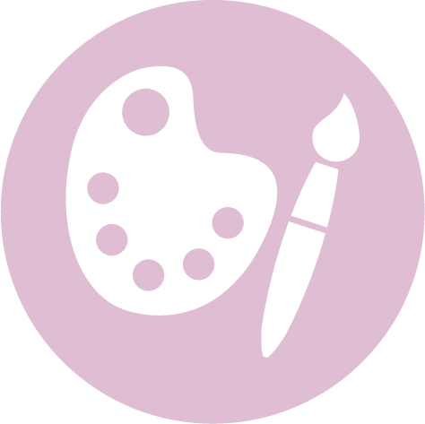
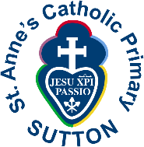

Key Stage 1 – Year 1 & 2
- to use a range of materials creatively to design and make products
- to use drawing, painting and sculpture to develop and share their ideas, experiences and imagination
- to develop a wide range of art and design techniques in using colour, pattern, texture, line, shape, form and space
- about the work of a range of artists, craft makers and designers, describing the differences and similarities between different practices and disciplines, and making links to their own work.

Autumn | Spring | Summer
Unit Title: Drawing and Colour - abstract |  | Unit Title: Collage – visual art
Artist: Paul Klee 1879 – 1940  Movement: Expressionism, Cubism, and Surrealism  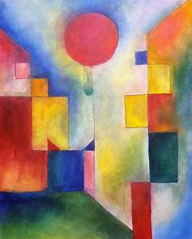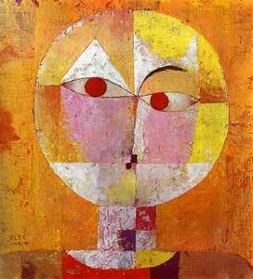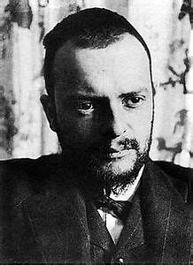  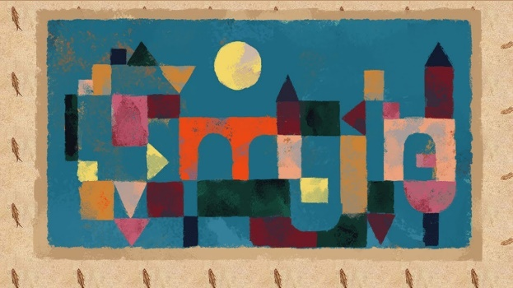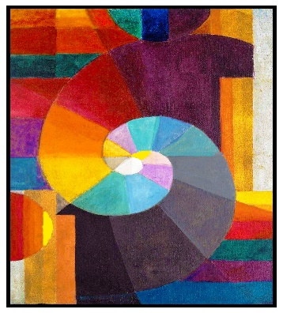  Art with Mati & Dada https://www.youtube.com/watch?v=eqHJ9gDLkL8  https://www.teachingcave.com/the-arts/ks1/art/artist-paul-klee/  Compare with the work of:  Artist: Paul Delaunay 1885 - 1941  Movement: Neo Impressionism  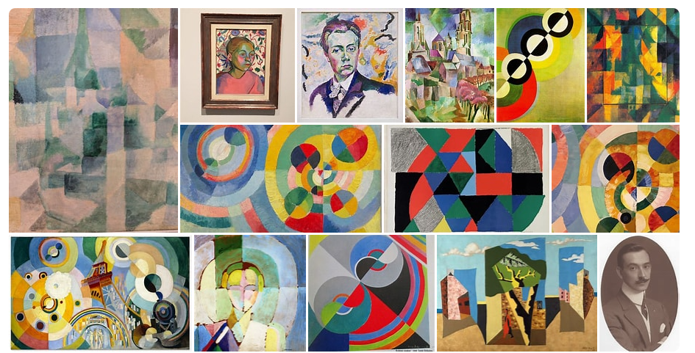  https://www.tate.org.uk/art/artists/robert-delaunay-992  https://www.beaumarisartgroup.org.au/p-artist/paul-delaunay-artist.html |  | Artist: Nancy Standlee 1935 –  Movement: Contemporary  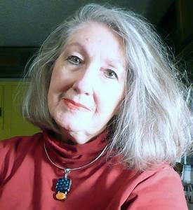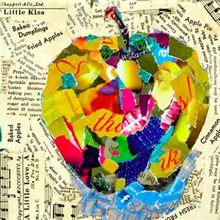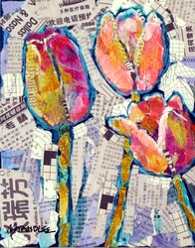  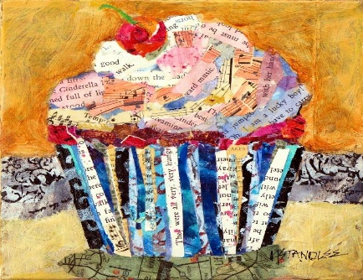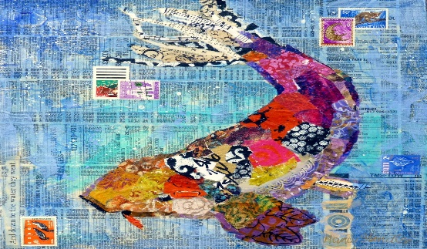  http://www.nancystandlee.com/collage-mixed-media.html  Compare with the work of:  Artist: Deborah Shapiro –  Movement: Contemporary  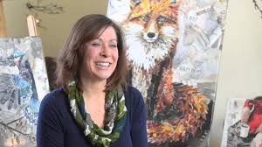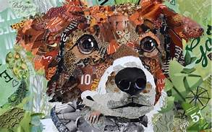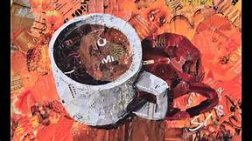  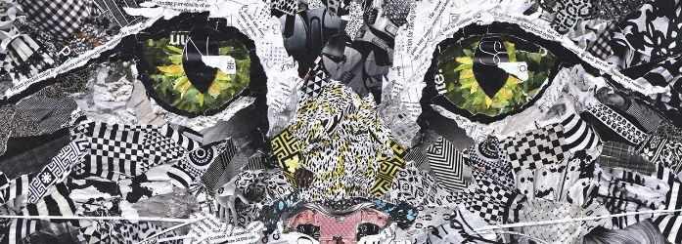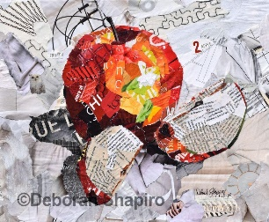  https://www.deborahshapiroart.com/pages/about  https://www.youtube.com/watch?v=IEQFWf8RSSw
Prior Knowledge: EYFS  - Safely use and explore a variety of materials, tools and techniques, experimenting with colour, design, texture, form and function.  - Use what they have learnt about media and materials in original ways, thinking about uses and purposes.  - Represent ideas, thoughts and feelings through art.  Prior Vocabulary:  Colours  Shapes  Paint, draw, colour |  | Prior Knowledge: EYFS  - Safely use and explore a variety of materials, tools and techniques, experimenting with colour, design, texture, form and function.  - Use what they have learnt about media and materials in original ways, thinking about uses and purposes.  - Represent ideas, thoughts and feelings through art.  Prior Vocabulary:  Colours  Shapes  Paint, draw, cut, stick, glue, fold, colour, pattern
Skills:  - Use a variety of tools including pencils, rubbers, crayons, pastels, felt tips, charcoal, ballpoints, chalk and other dry media to represent objects in lines (1)  - Explore mark-making using a variety of tools. (1)  - Experiment with tones using pencils, chalk or charcoal. (2)  - Represent things observed, remembered or imagined using colour/tools in two and three dimensions. (2) |  | Skills:  - Cut, glue and trim material to create images from a variety of media e.g. photocopies, fabric, crepe paper, magazines. (1)  - Represent things observed, remembered or imagined using colour/tools in two and three dimensions. (2)  - Make textured collages from a variety of media and by folding, crumpling and tearing materials. (2)
Knowledge:  - Use artwork to record ideas, observations and experiences. (1)  - Explain what he/she likes about the work of others. (1)  - Know the names of tools, techniques and elements that he/she uses. (1)  - Try out different activities and make sensible choices about what to do next. (2)  - Select particular techniques to create a chosen product and develop some care and control over materials and their use. (2)  - Give reasons for his/her preferences when looking at art/craft or design work. (2)  - Know that different artistic works are made by craftspeople from different cultures and times. (2) |  | Knowledge:  - Use artwork to record ideas, observations and experiences. (1)  - Experiment with different materials to design and make products in two and three dimensions. (1)  - Explain what he/she likes about the work of others. (1)  - Know the names of tools, techniques and elements that he/she uses (1)  - Try out different activities and make sensible choices about what to do next. (2)  - Select particular techniques to create a chosen product and develop some care and control over materials and their use. (2)  - Give reasons for his/her preferences when looking at art/craft or design work. (2)  - Know that different artistic works are made by craftspeople from different cultures and times. (2)
Key moments in sketchbook:  - Artist research (Paul Klee)  - Experiment with a range of materials.  - Experiment with colour, pattern, texture, line, shape and space.  - Annotations to show reflections on their work and that of others. |  | Key moments in sketchbook:  - Artist research (Nancy Standlee)  - Experiment with a range of materials.  - Experiment with colour, pattern, texture, shape and space.  - Experiment with different layering techniques.  - Annotations to show reflections on their work and that of others.
Final artwork:  Self portrait in the style of Paul Klee. |  | Final artwork:  Collage incorporating the ideas and style of Nancy Standlee.
Key Vocabulary:  Elements of art – colour, line, shape, space  Artist, designer, design  Media, materials  Warm/cool colours  Primary/secondary colours  Tints/shades |  | Key Vocabulary:  Elements of art – colour, form, line, space, texture, pattern  Artist, designer, design  Collage, media, materials  Cut, tear
Curriculum links:  History - artist  Maths – shape, space |  | Curriculum links:  Geography – reduce, reuse, recycle
Jobs in Art & Design:  Fashion, textile designers  Architect  Interior designer  Animator  Illustrator  Web designer  Graphic designer  Photographer  Computer aided designer |  | Jobs in Art & Design:  Fashion, textile designers  Architect  Interior designer  Animator  Illustrator  Web designer  Graphic designer  Photographer  Computer aided designer

