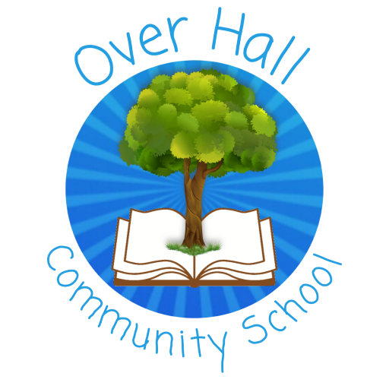
Oracy Policy

Date policy last reviewed: | November 2025

Signed by:
 | Headteacher | Date:
 | Chair of governors | Date:

Last updated: November 2025

Contents:
Statement of intent
- National framework
- Teaching and Learning, personal and social development
- How to plan for oracy sessions
- Purpose
- Guidelines and Protocols
- Discussion Roles
- A talk framework
- Vocabulary and sentence stems
- Resources
- Opportunities to talk
- Monitoring and review

Statement of intent
Oracy plays a prominent role in both wellbeing and teaching and learning. The ability to listen actively, speak clearly and communicate articulately is seen as a fundamental part of the learning process.
Oracy can be described as a combination of learning to talk and learning through talk. It is the ability to articulate ideas, develop understanding and engage with others through spoken language.
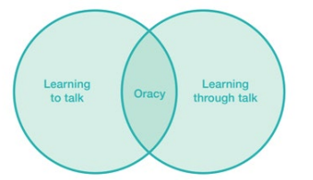
At Over Hall Community Primary School there is a shared understanding of how talk supports children’s personal and social development. We believe that developing Oracy throughout primary education provides our pupils with vital life skills.
We aim to encourage fluent speakers, who are confident to communicate, debate and present in a wide range of situations.

National framework
We ensure all children are taught spoken language as outlined in the National Curriculum 2014.
Spoken language – years 1 to 6
Pupils should be taught to:
- listen and respond appropriately to adults and their peers
- ask relevant questions to extend their understanding and knowledge
- use relevant strategies to build their vocabulary
- articulate and justify answers, arguments and opinions
- give well-structured descriptions, explanations and narratives for different purposes, including for expressing feelings
- maintain attention and participate actively in collaborative conversations, staying on topic and initiating and responding to comments
- use spoken language to develop understanding through speculating, hypothesising, imagining and exploring ideas
- speak audibly and fluently with an increasing command of Standard English
- participate in discussions, presentations, performances, role play/improvisations and debates
- gain, maintain and monitor the interest of the listener(s)
- consider and evaluate different viewpoints, attending to and building on the contributions of others
- select and use appropriate registers for effective communication

Teaching and Learning, personal and social development
At Over Hall Community Primary School, we have developed learning behaviours that support Oracy.
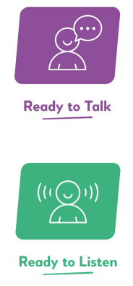
Ready to Talk and Ready to Listen
To engage pupils in valuable talk teachers, need to:
- model responses using a wide range emotional vocabulary
- ensure our pupils have enough opportunities to use it (engaging stimuli/ planned sessions)
- create the right culture for pupils to talk and listen to each other (discussion guidelines/ class community/ connection)

To engage pupils in valuable discussions teachers, need to:
- know what good listening looks like
- teach what good listening is
- model good listening ourselves (see appendix 1 for visuals to support this)
Meaningful talking and listening needs to be taught. For Oracy to be successful, these sessions need to be planned for. During these lessons pupils need to be taught listening skills, vocabulary and discussion techniques. They have the opportunity to experience a range of talking styles – from exploratory talk to presentational talk and then apply these to a whole range of activities that helps them develop confidence.

How to plan for Oracy sessions
Meaningful talk has:
- a purpose (taken from the 4 strands of Oracy)
- clear guidelines and protocols so everyone knows the rules for all speakers/ listeners
- a group configuration
- a framework (clear roles, timings and small tasks for each person in the group)
- the right vocabulary and sentence stems to support that talk
- a bank of different resources to ensure participation and engagement
- a range of opportunities in which pupils can express themselves.

Purpose
This framework allows both staff and pupils to understand what makes good spoken communication. The four strands enable successful discussion, inspiring speech and effective communication. The framework can be used by staff to give feedback and assess progress. Pupils use the framework to self-assess, peer-assess and talk about talk.
• Physical • Cognitive • Linguistic • Social and Emotional
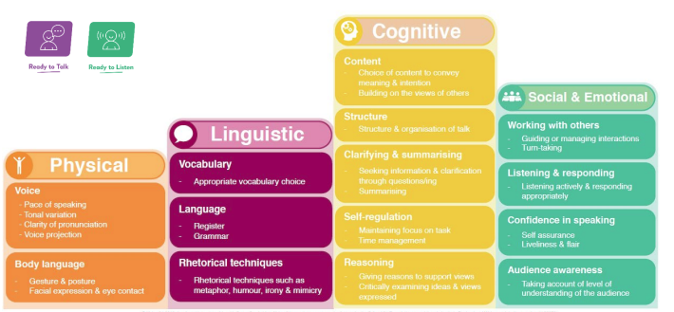

Guidelines and Protocols
Create a set of guidelines appropriate for your setting or groups for partner and group discussion that help to maintain a safe, effective and respectful environment for talk. Use visuals, actions, photographs etc to help embed the guidelines and protocols.
Your guidelines and protocol posters will be visible in every area used for talk. Share them at the beginning of any Oracy session – model them and refer to them throughout any Oracy sessions.
Here are some examples:
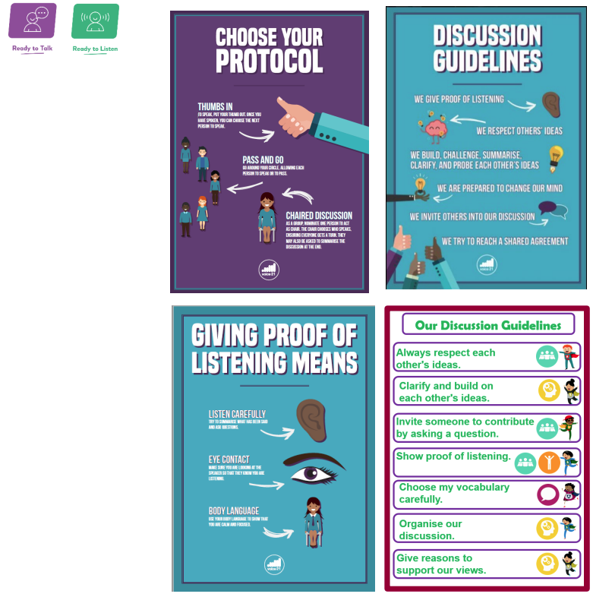

Discussion Roles
These discussion roles can help to manage and support group discussions. They also help to develop speaking and listening skills.
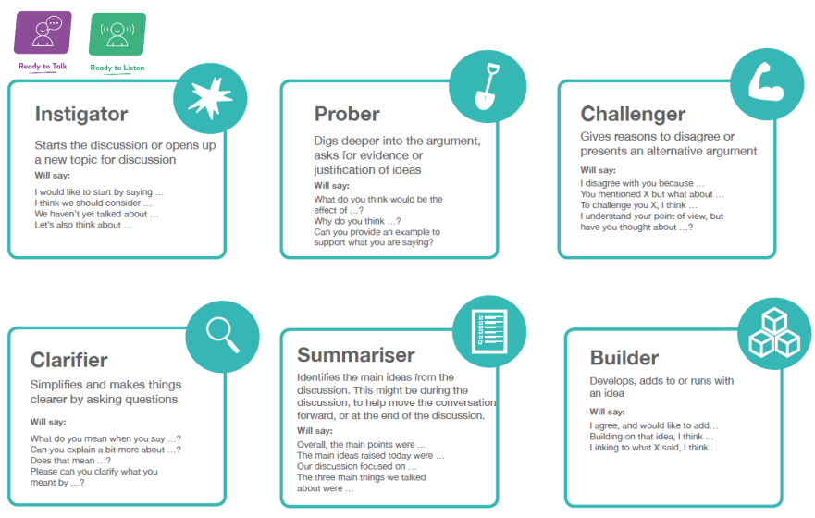
In EYFS and early KS1 you could pick one or two roles to start off with a build up – provide sentence stems in the roles for children and provide more visuals to help pupils understand the role.
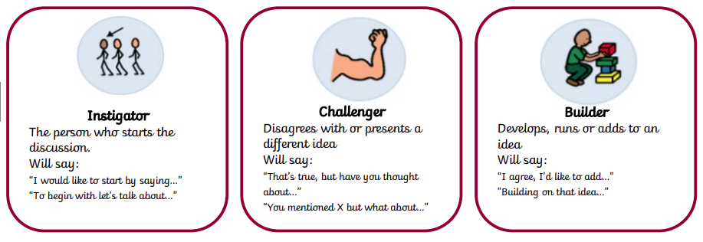

A talk framework
All talk sessions need to have a clear framework so pupils know the direction the talk is heading and what the purpose of their talking or listening is.
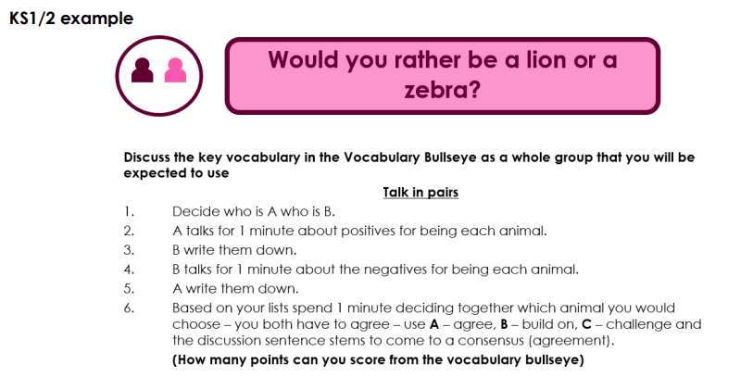
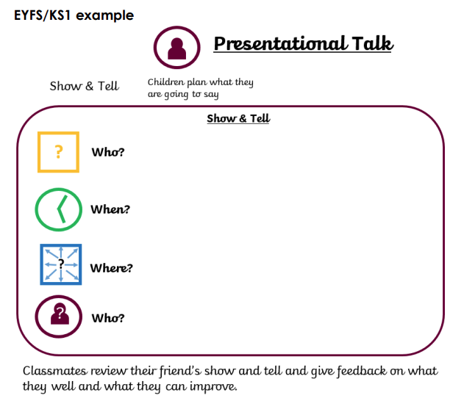

Vocabulary and sentence stems
In order for knowledge to be woven into talk sessions an understanding of the correct vocabulary needs to be present. Without it meaning is lost and children will not be as well understood. Different subject matter involves the need for different words. A mixture of tier 2 (goldilocks words/ wide ranging) and tier 3 words (subject specific) should be taught along with sentence stems and visuals to support to use. Vocabulary Bullseye is a great example of gamifying the use of the correct terminology.
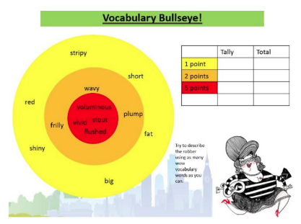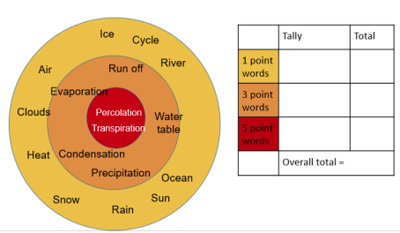
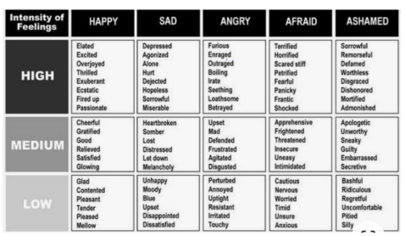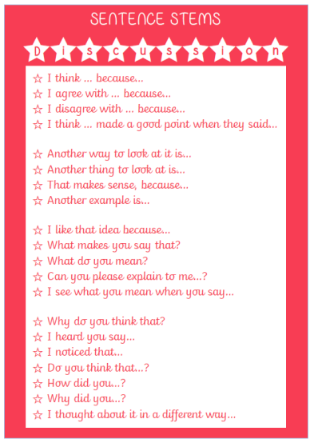

Resources
Resources that provide opportunities to promote Oracy within your classrooms – they can be applied to many curriculum subjects. All credit to Voice21
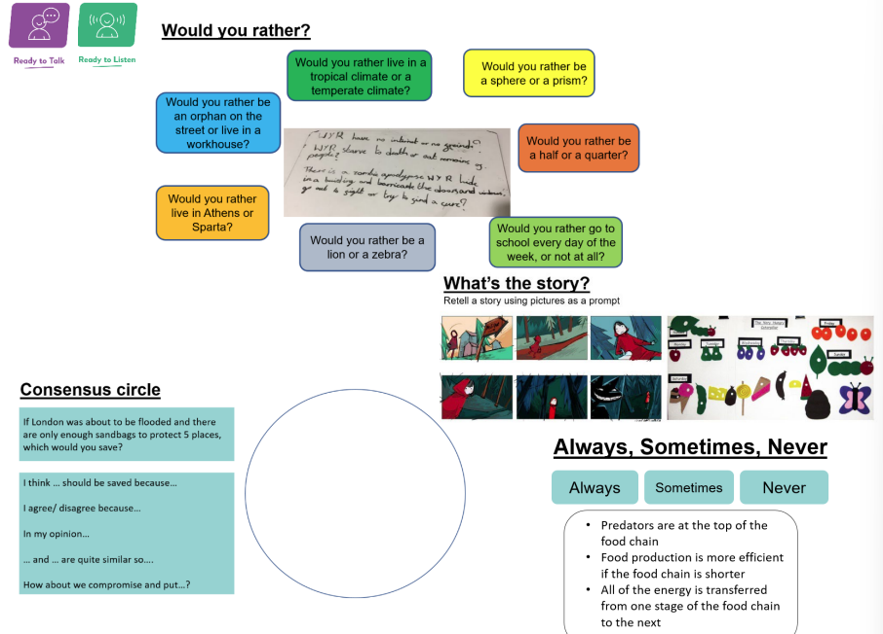
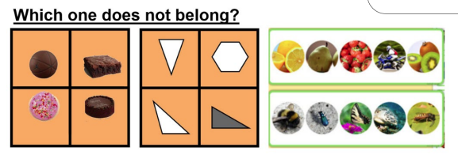
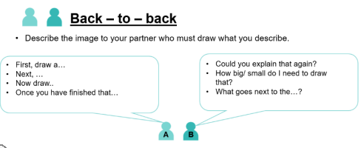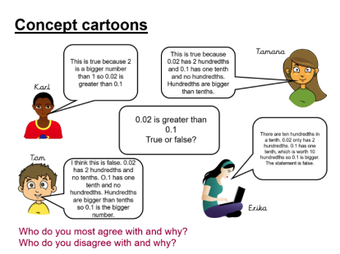

Opportunities to talk
There are a range of Oracy activities and opportunities within the curriculum for pupils to participate in which help them to develop confidence in spoken language.
- Collaborative work and problem solving
- Debate
- Role play
- Drama
- Presentations
There could be opportunities for pupils to develop their Oracy skills outside of the curriculum. This could be achieved through pupil voice groups, year group productions, assemblies, visiting speakers, topic events and participation in local events.

Monitoring and review
This policy will be reviewed on an bi-annual basis by the subject leader.
Any changes made to this policy will be communicated to all teaching staff.

