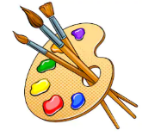
Year 1 Art Textiles
KNOWLEDGE ORGANISER
What should I already know? |  |  |  |  | What skills will I learn? |  |  | Key Vocabulary  Match  Sort  Fabric  Thread  Colour  Texture  Length  Size  Shape  Twisting  Stitching  Gluing  Printing  Dipping  Dyes  Weaving  Fringing  Fraying  Knotting
- In the night sky, you see stars and sometimes the moon and the brighter planets.  - Rockets and astronauts go into space.  - There are lots of different, brightly coloured planets.  - I can create closed shapes with continuous lines, and begin to use these shapes to represent objects.  - I can use drawing to represent ideas like movement or loud noises.  - There are lots of different colours and you can mix these to make new colours.  - Artwork can be printed onto different materials like rugs, wallpaper, curtains, cushions. |  |  | 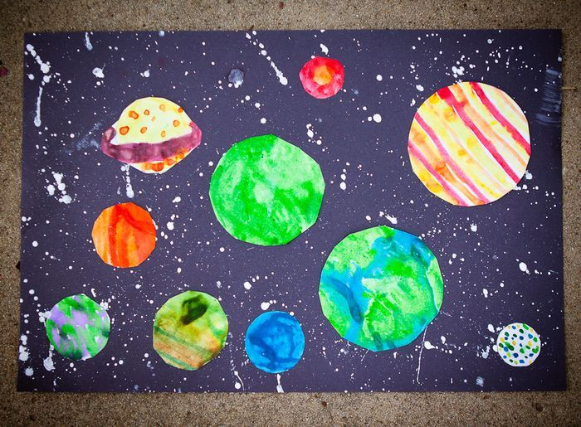 |  | - Match and sort fabrics and threads for colour, texture, length, size and shape.  - Change and modify threads and fabrics, knotting, fraying, fringing, pulling threads, twisting, plaiting.  - Cut and shape fabric using scissors/snips.  - Apply shapes with glue or by stitching.  - Apply decoration using beads, buttons, feathers etc.  - Colour  - Apply colour with printing , dipping , fabric crayons  - Create and use dyes i.e. onion skins, tea, coffee  - Texture  - Create fabrics by weaving materials i.e. grass through twigs, carrier bags on a wheel
What will I know by the end of the unit?
Splatter  Dye | 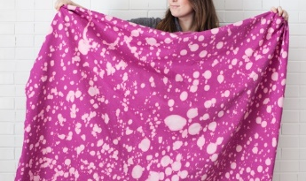 | Splatter dyes can be created with lots of different tools.  You could use a paintbrush, a twig, a stick and even other material to dip into dye. |  |  | How to tie dye fabric | How to thread a needle
 |  |  |  |  | You will need: Fabric dye, Rubber bands, Rubber gloves and apron, Clean cotton material, Two large containers (one for water, one for dye).  - Bind sections of the t-shirt tightly with rubber bands – these areas won’t be dyed and will create rings or starburst patterns.  - Prepare dye according to the packet instructions.  - Add a cup of salt to the mixture to boost the dye colour.  - Fill a large bucket with hot water and dunk your shirt in. Wring out excess water.  - Plunge the wet t-shirt into the dye bath and stir regularly with a long spoon for 10-30 minutes, depending on how dark you want the colour.  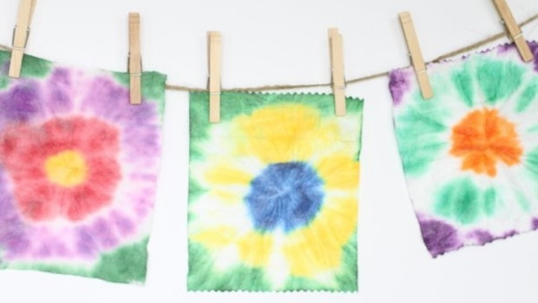  - Remove the t-shirt, rinse under warm, then cool water until the liquid runs clear and lay flat to dry. | 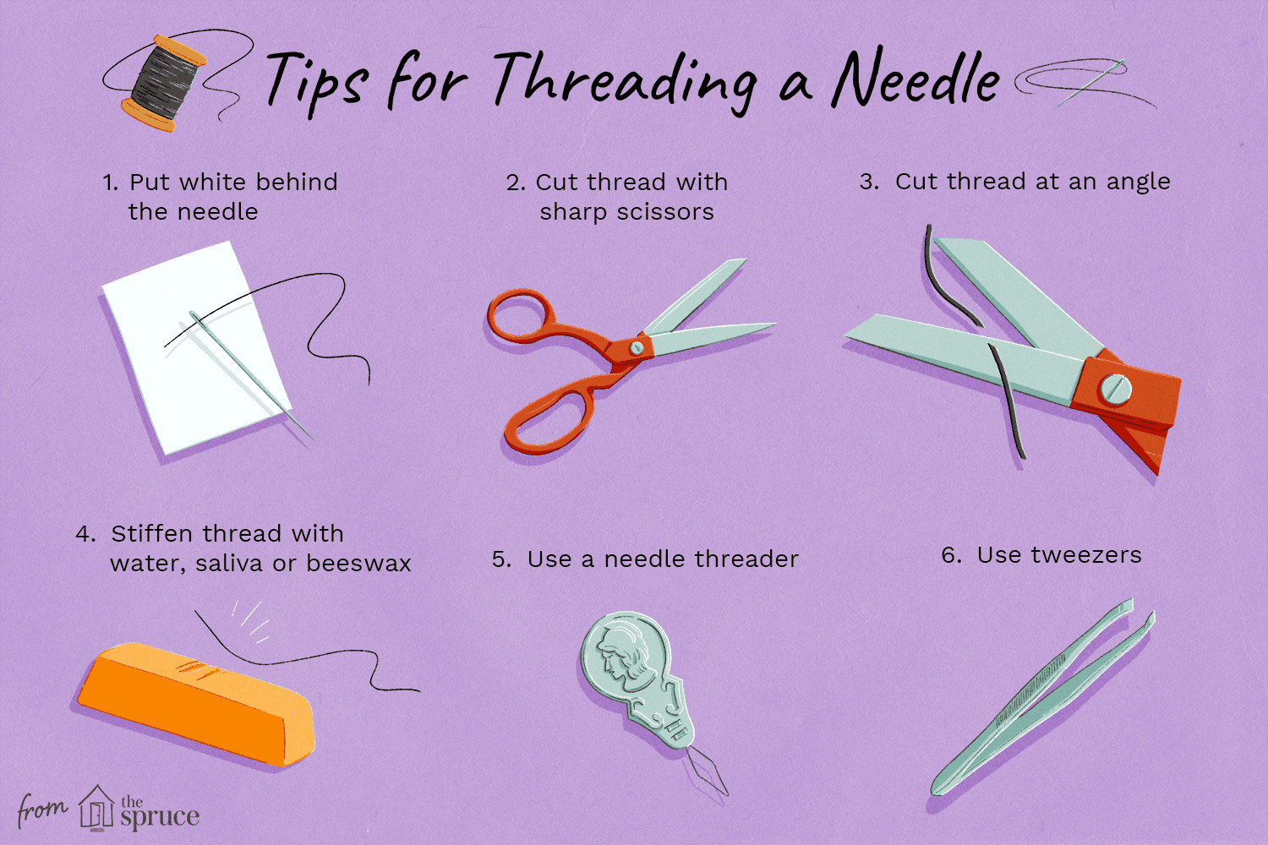
Natural Dye | 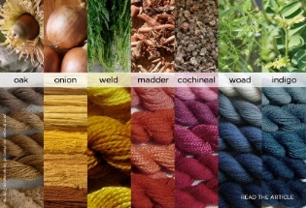 | Natural dye is created by using things that can be found in nature. This has been used for thousands of years!  You could use fruit, vegetables or plants.
Tie Dye | 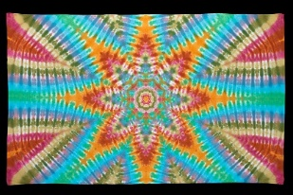 | There are lots of ways to create tie-dye.  It works by covering or blocking the colour to specific areas. This then blocks the dye from reaching it.
Weaving | 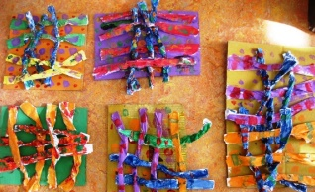 | This is a way of making fabric, by interlacing threads is called weaving. There are two different parts to remember with weaving.  - Warp – These are the threads that run from top to bottom.  - Weft – These are the threads that run from side to side. The strips in the weft must be alternated when weaving.  Under – Over – Under – Over  Over – Under – Over - Under

