

Mathematics Curriculum
Overview
2024-2026

EYFS

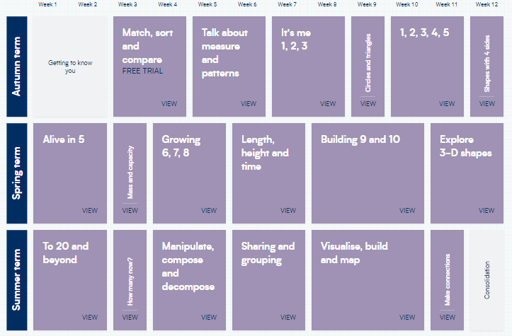
YEAR ONE
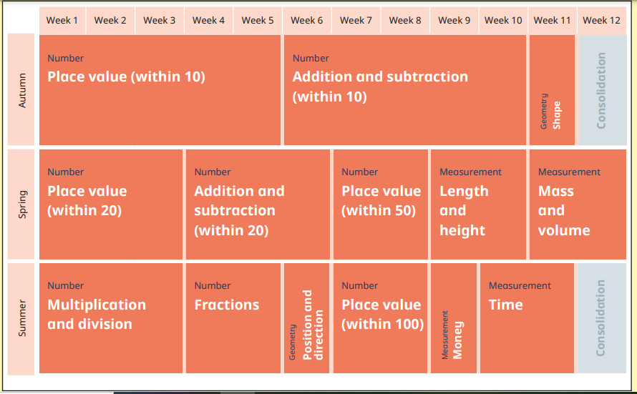

YEAR TWO
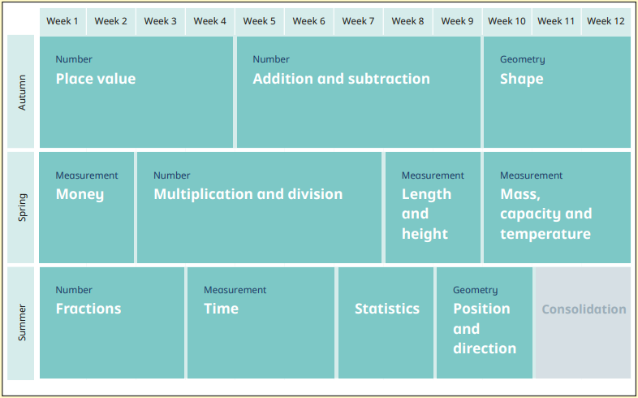

YEAR THREE
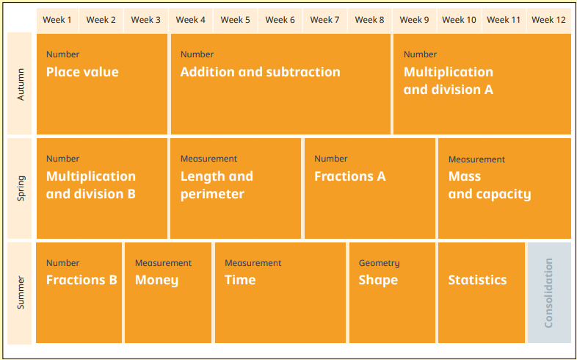

YEAR FOUR
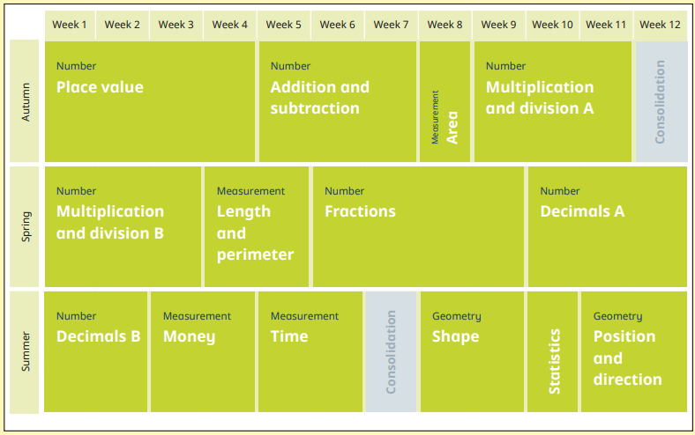

YEAR FIVE
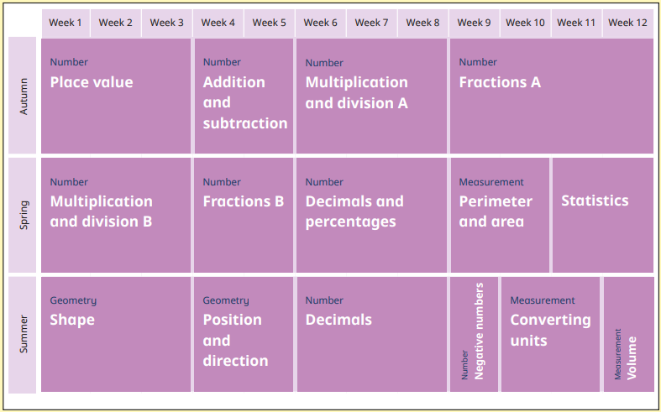

YEAR SIX
 | Week 1 | Week 2 | Week 3 | Week 4 | Week 5 | Week 6 |  | Week 7 | Week 8 | Week 9 | Week 10 | Week 11 | Week 12
Autumn Term | Number  Place Value |  | Number  Addition/Subtraction  Multiplication/Division |  |  | Geometry  Shape |  | Geometry  Shape | Number  Fractions  A |  | Statistics |  | Measurement  Area and Perimeter
Spring Term | Number  Decimals |  | Number  Addition/Subtraction  Multiplication/Division |  | Number  Ratio | Number  Algebra |  | Geometry  Position and Direction | Number  Fractions  B |  | Measurement  Converting Units of Measure | Number  Fractions, Decimals and Percentages
Summer Term | Number  Calculations | Number  Fractions  C |  | SATs | Investigations and Problem Solving |  |  | Investigations and Problem Solving

