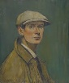
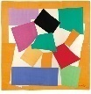
KNOWLEDGE ORGANISER

What should I know already?  Year 1 Art Collage |  |  | What skills will I learn? |  | Key Vocabulary  Media  Backgrounds  Sort  Group  Material  Colour  Shape  Texture  Tearing  Overlapping  Layering  Collecting  Rubbing  Pattern  Composition  Proportion  Foreground  Middle ground  Background
- There are different types of materials.  - Paper can be different sizes and colour.  - Scissors can be used to cut things out.  - Glue can be used to stick two things together.  - You can cut and stick objects together to create a piece of art. | 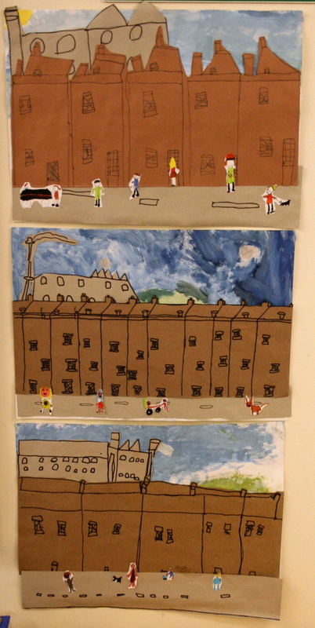  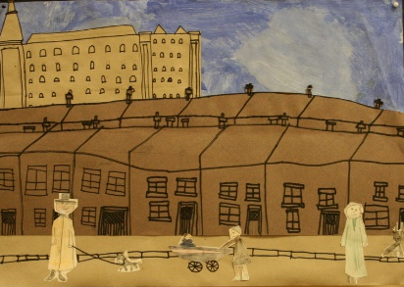 |  | - Create images form a variety of media e.g. photocopies material, fabric, crepe paper, magazines etc.  - Arrange and glue materials to different backgrounds.  - Sort and group materials for different purposes e.g. colour texture.  - Fold, crumple, tear and overlap papers.  - Work on different scales.  - Colour - Collect, sort , name match colours appropriate for an image.  - Shape - Create and arranges shapes appropriately.  - Texture - Create, select and use textured paper for an image.
What will I know by the end of this unit?
- Collage is a type of artwork where an image created by sticking materials, (usually torn or cut paper) on to a surface.  - Collage has been around for a very long time.  - The process of creating a collage including choosing materials, textures, colour and shape. Cutting out objects or materials, gluing and layering them onto a background.  - L.S. Lowry is an artist who drew lots of landscapes with ‘matchstick men’ in them.  - Looking at other artists work can inspire us to create our own artwork in their style. We can choose to replicate the colours, style, technique, or subject of the artwork.  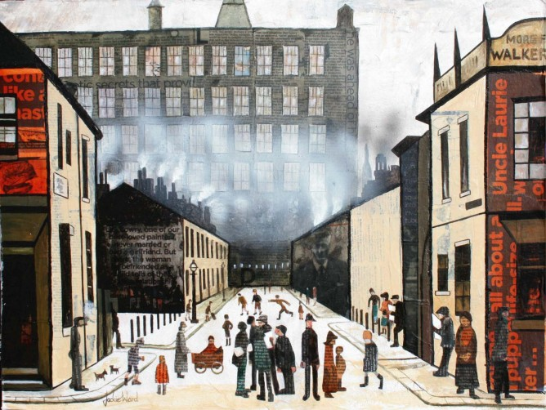  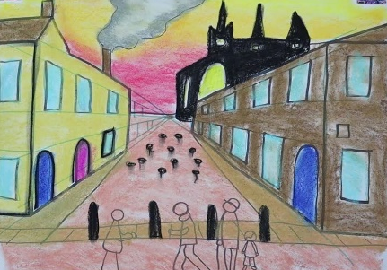  - How to create a landscape piece of art, using collage and inspired by the work of L.S. Lowry. |  |  | Artist Study – L.S. Lowry
Lowry was born on 1st November 1887 and died on 23rd February 1976. He was an English artist who mostly created drawings and paintings.

Lowry is famous for painting landscapes with lots of human figures. These people were often called “matchstick men”. His work did not usually show shadows or weather effects.

In Salford Quays, Manchester, there is an art gallery called The Lowry. Inside here is a collection of his work which anyone can go in to see.

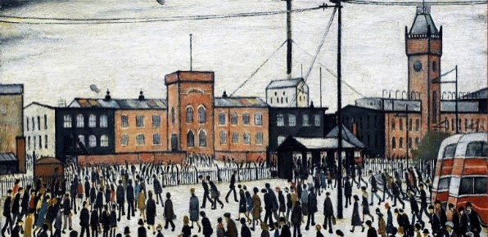
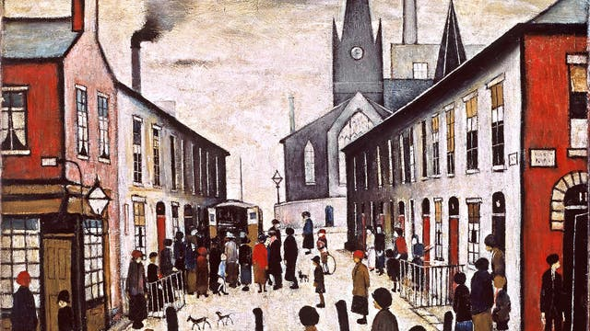
What can you see? What do you like? What do you not like?
How could you create a piece of artwork in the style of Lowry?

