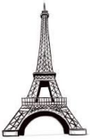

KNOWLEDGE ORGANISER
Overview |  |  |  |  | Designing – What makes a strong, stable, rigid structure?  YEAR 1 D.T: FREESTANDING STRUCTURES |  |  |  |  | Key Vocabulary  Structures  Freestanding  Support  Weight  Strong  Rigid  Stable  Base  Materials  Layering  Design  Make  Evaluate
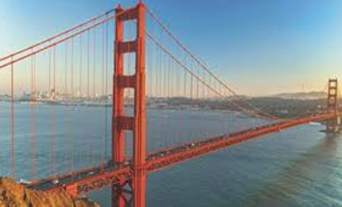  Freestanding Structures  Structures are things that are built for a purpose.  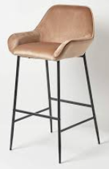  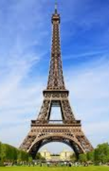  -Structures can be large (e.g. buildings and bridges) or small (e.g. chairs and tables).  -Freestanding structures are structures that can stand up without being attached to something else.  -Freestanding structures need to support their own weight and also the weight of the things/people using them.  So that they can do this, freestanding structures need to be well-designed: strong, rigid and stable. |  |  |  |  | A structure that is stable is less likely to fall over.  -Structures are more stable when they have a wider base.  -Buttresses can also make a structure more stable. A buttress is something that is built against a structure to give it more stability.  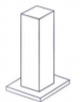  The buttress adds width to the base, making the structure more stable.  A structure that is strong and rigid is able to support more weight.  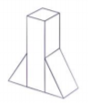  -Some materials are stronger and more rigid (stiffer) than others, e.g. card is stronger and more rigid than paper.  -Structures can also be made stronger and more rigid by making sure that parts and materials are properly joined together, e.g. with glue or tape.  -Folding and layering (adding an extra layer) of materials can also be used to strengthen and stiffen structures.
Example Structures
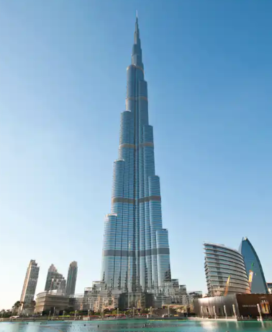 | Name: Burj Khalifa  Location: Dubai, United Arab Emirates  Height: 828m  Floors: 163  Built in: 2010 |  | -The Burj Khalifa is the tallest freestanding structure in the world.  -It has an extremely wide base, and is very narrow at the top.  -The steps down the sides help to protect the structure from the wind.  -It has deep foundations in the ground.  -It is made of strong, rigid materials – over 330,000m³ of concrete and 40,000 tonnes of steel reinforcement!
 |  |  |  |  | Making & Evaluating
 |  |  |  |  | 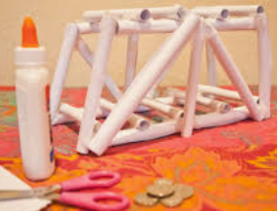  Making  -Read your plan carefully. Make sure that you are prepared.  -Think about the skills you will need to use (e.g. cutting, assembling sticking) and the tools that you will need for them (e.g. scissors, glue).  -Think about finishing techniques (e.g. adding buttresses/extra layers for strength, or colour to make your structure look well presented!)  -Remember your purpose – does it work? |  |  | Evaluating  -How well does your structure work? Does it meet its purpose?  -How did you make your structure stable? How could you make it more stable?    -How did you make your structure strong and rigid? How could you make it more strong and rigid?
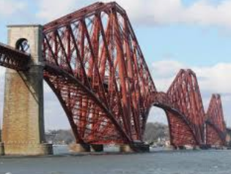 | Name: Forth Bridge  Type: Railway Bridge  Location: Scotland  Length: 2,528m  Built in: 1890 |  | -The Forth Bridge is a long railway bridge in Scotland, across the Firth of Forth.  -It is made of strong materials: it was one of the first bridges made of steel. The steel frame is built into triangles (a wide base and narrow top. It also has strong, stable concrete arms supporting on either side.

If you need to move around with scissors, hold around the closed blades, facing down.
Report all spillages & clean up properly after yourself.
Make sure that you are wearing the correct equipment for tasks.
Follow the teacher’s cutting instructions carefully.
Keep your work area and floor area clear – keep your belongings well clear.
-Walk safely and calmly around the classroom/ workshop.
-Wear an apron and roll up your sleeves.
-Remove any jewellery and tie back long hair.
Health and Safety

