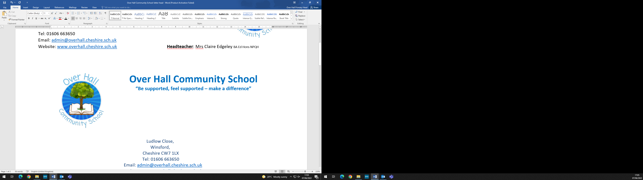

Accessibility Plan

At Over Hall Community School we are committed to providing a fully accessible environment to all pupils, staff, parents and visitors regardless of their needs.
Definition
“A person has a disability if he or she has a physical or mental impairment which has a substantial and long-term adverse effect on his or her ability to carry out normal day-to-day activities.”
Equality Act 2010
AIMS
- To ensure that all our pupils, including those with disability or sensory impairment, have equal access to the curriculum;
- To improve and maintain access to the physical environment of the school, adding specialist facilities as necessary to enable disabled pupils to take better advantage of education, benefits, facilities and services provided;
- To improve the availability of accessible information to disabled pupils.

This policy should be read in conjunction with the following policies:
- SEN Policy
- SEN Information Report
- Health & Safety Policy
- Teaching & Learning Policy
- Antibullying Policy
- Intimate Care Policy
- Safeguarding Policy

Tracking and Monitoring of Accessibility
Possible Accessibility issue | Actions in place | Frequency of actions | Monitoring of actions
Attainment of pupils | Data analysis and regular monitoring carried out to track pupil progress | Termly pupil progress reviews | SLT monitor progress reviews termly
Meeting the needs of SEN children | Differentiated curriculum where appropriate; individual pupil profiles identifying support and targets following “assess-plan-do-review” cycle. | Termly review of pupil profiles | SENCO monitors pupil profiles and interventions at least termly or more often if required
Resources | Appropriate resources to support access (including visual timetables, now and next cards, feelings cards, etc)  Sensory Room & Zen Den available for children with social/communication/emotional needs. | Ongoing throughout year in line with pupil needs | Class Teacher to monitor resources in place in liaison with SENCo/SLT
Access to the Curriculum | The school curriculum is accessible to all pupils via extra adult support during class sessions, residential visits or out of class interventions.  Strong relationship with outside agencies providing further support and training to enable access to the curriculum | Ongoing tracking of pupil needs throughout the school year | Monitored by Head Teacher, SLT and individual adults who give support. Pupil needs are reassessed regularly and support adapted to suit needs.
Access through the school building | School has wide doors/corridors for accessibility; ramps outside for wheelchair access; disabled toilet; disabled parking spaces.  All classrooms can accommodate pupil with mobility needs.  Equipment provided to accommodate pupil with mobility needs.  Additional disabled parking spaces positioned near front of building. | Ongoing in line with pupil needs | Monitored regularly by SLT and Site maintenance officer.

MONITORING & REVIEW

It is the responsibility of the Head Teacher and Governing Body to monitor the effectiveness of this Accessibility Plan by:
- Monitoring the progress of children with disability, comparing them with the progress made by able bodied children.
- Assess the impact of this plan through regular review of the action plan above.
- Provide training for staff in accessibility needs and raising awareness of disability discrimination.

The Trustees and Head Teacher will review this policy every three years, or earlier if considered necessary.
Reviewed March 2023

