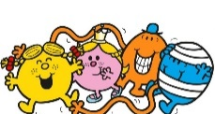
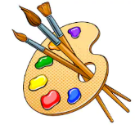
Year 1 Art Digital Media and Drawing
KNOWLEDGE ORGANISER
What should I know already? |  | Colour wheel |  |  | What skills will I learn? |  | Key Vocabulary  Author  Illustrator  Line  Straight  Zigzag  Wavy  Curved  Character  Landscape  Horizon  Primary colours  Stop Motion Animation  Tripod  Film
- Continuous lines can be used to draw shapes and represent objects.  - A face can be drawn with a circle and adding detail.  - Different emotions can be shown in drawings, like happiness, sadness, fear.  - It is important to return to and build on previous work to make it even better. |  | 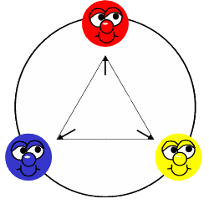  Colour wheels show us how colours are related. They remind artists how to mix and think about colours.  The primary colours are:  - red  - blue  - yellow  Primary colours cannot be made from other colours. Artists create all the other colours of the rainbow by mixing together the primary colours. What other colours do you know? How do you think those colours are made? |  |  | Drawing  - Experiment with a variety of media pencils, rubbers, crayons, pastels, felt tips, charcoal, ballpoints, chalk.  - Control the types of marks made with the range of media.  - Observe and draw shapes from observations.  - Draw shapes in between objects.  - Invent new shapes  Digital Media  - Explore ideas using digital sources i.e. internet.  - Record visual information using digital cameras, video recorders.  - Use a simple graphics package to create images and effects with lines, brush size, shapes, eraser and fill tools.  - Add/ change colours and texture using simple filters to manipulate and create images.  - Use basic selection and cropping tools.
What will I know by the end of this unit?
Mark Making | 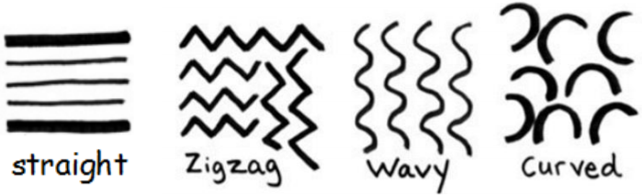  There are lots of different types of lines that can be used in drawing. Knowing when is best to use which line depending on its purpose. |  |  |  | Artist Study – Roger Hargreaves
Mark Making |  |  |  |  | 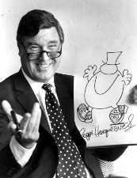  Born in 1935 in Cleckheaton, West Yorkshire, Charles Roger Hargreaves is Britain's third best-selling author of all time having sold more than 100 million books, including all the familiar Mr. Men and Little Miss characters. Roger Hargreaves followed a career in advertising before becoming an author and illustrator.  He wrote the first Mr. Men book in 1971 when his 8 year old son, Adam Hargreaves, asked 'What does a tickle look like?' In response, Roger drew a figure with a round orange body and long, rubbery arms and Mr. Tickle was born.  He initially had difficulty finding a publisher, but once he did, the books became an instant success, selling over one million copies within three years and spawning a BBC animated television series, narrated and voiced by Arthur Lowe.  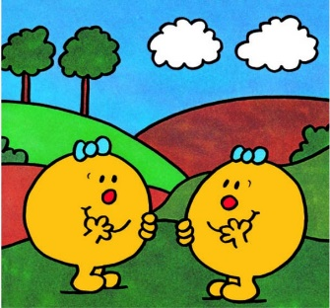
Drawing a character and a landscape | 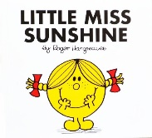  It is important to observe closely when drawing to make sure that you include detail to represent what it is that you are trying to achieve. It might take some planning, a couple of attempts and some more practice until you are happy with your outcome.  Landscape Art is a drawing or a painting of nature. They usually have mountains, valleys, trees, rivers or forests in them. Start with drawing the horizon line. This can be staight, curved, wavy or zigzagged. Add detail by drawing the objects and shapes that  you can see on the land. Then draw what  you can see in the sky. |  | 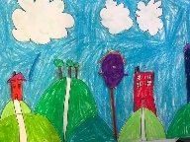
Incorporating drawing into digital media | Photographs can be taken of artwork and uploaded onto a digital media platform (e.g. Ipads, computers, tablets, laptops.  These pieces of artwork can then be changed by adding more detail, changing the size, colour, layering another image on top.  Several images can also be added together to make a stop frame animation video. This can be made on an app called Stop Motion.  Digital media can also be used to draw images from a blank canvas. There are lots of tools to help you to do this like brush size and colour, fill buttons, shapes, etc.

