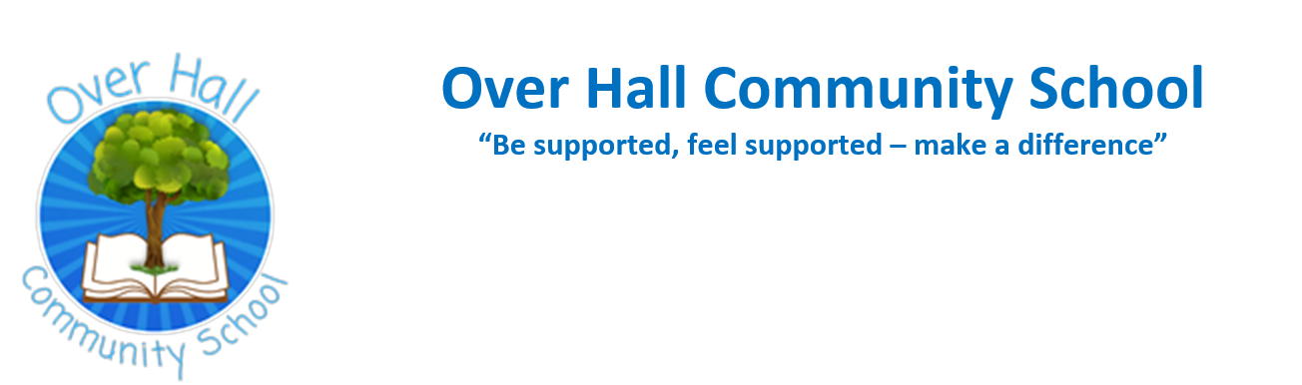
Proposed: Opening and closing times
For the following six weeks we are consulting parents/carers regarding the proposed changes to the official school day to ensure our offer is in line with Government guidelines.
Last academic year, there was an initial poll with both staff and parents regarding the additional 15 minutes added to either the start or the end of the school day. Responses were equally balanced in both groups with approximately 50% of both staff and parents preferring the earlier start and the remaining 50% preferring a later end.
Taking this into consideration the following has been proposed …
Please see the information below detailing the proposed offer of official hours within the school day at Over Hall Community School. These will amount to the expected 6 hours and 30 minutes per day, totalling 32½ hours per week. Parents are encouraged to bring their children into school for doors opening at 8:40am, playground bagels are on offer from 8:30 until 8:40am.
Start of day
7:30 onwards | Breakfast Club availability at a charge (48 hours notice required)
8 – 8:40am | Breakfast Club availability at a charge
8:30am | Gates open & (Magic Breakfast) playground bagels
8:40am | Classroom doors open – morning task
8:50am | Morning register – Official start to the school day
End of day
3:20pm | End of day – official end to school day – children may be collected or in agreement between home and school allowed to walk home
3:15-4:15pm | Treetops After School Club availability at a cost of only £2
Until 6pm | Treetops After School Club availability (48 hours notice required)

The changes made include:
- An earlier start of 10 minutes
- A later finish of 5 minutes

