

Mickle Trafford Village School
Number Formation Policy

This policy is to ensure consistency of number presentation throughout the school and to avoid ambiguity between which number is which. Children will begin to explore number formation in the Foundation Stage, through mark making. The formal teaching of number formation begins in the spring term of Reception and continues throughout school.
Correct modelling of number formation from all adults in school is expected. The correct models of formation will be displayed in all Key Stage One classes. Number formation and recognition is covered as part of the day-to-day coverage of the maths curriculum.
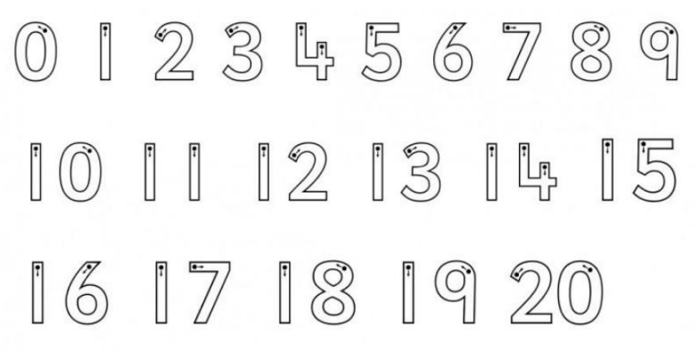
Where number formation is found to be incorrect, this will be identified in teacher marking and followed up with the children.
Additional support on number formation in KS1 and KS2 will be supplemental and part of individual support programs.
When the formal teaching of number formation begins in Reception, the following phrases are used to support children in the correct formation.
0 – around and around and around we go, when we get home, we have a zero
1 - is like a stick, a straight line really quick
2 - around and back on the rail road track, two, two, two
3 - around a tree, around a tree, that’s the way to make a three
4 – down and across and down one more, that’s the way to make a four
5 – down and around and a hat on top
6 – a curve and a loop, number 6 makes a hoop
7 – across the sky and down from heaven, that’s the way we make a seven
8 – draw an s but do not wait, loop back round to make an eight
9 – around and down

