Year 5 Autumn Term Newsletter

Welcome Back!

I hope you have had a lovely summer holiday and a good rest. We have a fun and exciting term to look forward to, details of which you will find below. Our weekly routine should hopefully begin without a hitch, with Mr Waring teaching full time and Mrs Hayes covering his PPA on a Wednesday afternoon. Below, you will find information useful to you, but please do let me know if you require any more information and I will get back to you as soon as possible.

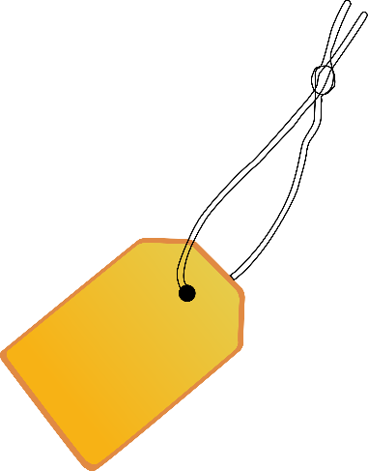
Uniform
Although summer holidays are over, September is an odd month for the weather. Some days, it may be warm and sunny, but other days may bring torrential rain. Please check and keep an eye on the weather to make sure children are dressed appropriately, including coats if needed! Please could children have their hair tied back fully if they have long hair. Earrings and watches are permitted but children are reminded that other jewellery is not.
Please label all clothing clearly.

PE
PE in Year 5 will take place on Tuesday and Fridays.
Children will need to come into school in their uniform every day. They will require a PE kit to be kept in school at all times. The kit will need to consist of: a plain (or logoed) light blue PE top, plain navy shorts, a pair of trainers or pumps. Depending on the time of year children may also need a pair of joggers to be brought in for outdoor PE. On PE days, children will be able to wear their sports hoodies instead of their jumpers if they have them.

Snacks and Water Bottles
It’s important that children bring their water bottles in to stay hydrated throughout the day. They will be kept at desks, so those with sports lids are most appropriate to reduce spills!
Remember that snacks provided must be a healthy snack – fruit or other healthy options please. Snacks are still available to purchase from the kitchen too.


I will aim to set homework on Fridays and with it being due by the following Thursday. The work will link to what we are covering in class. On some occasions, homework will be set on Google Classrooms. I expect that activities take no more than an hour and should be completed fairly independently. If you have found that your child has had difficulty doing the task or has completed it really easily, please let me know. It is important that children take pride in their presentation in homework tasks, in the same way they would in school.
Children will be focusing on spelling patterns within school across the week. Children may want to practise spellings at home.

Reading
Alongside your homework, your child should also read very regularly at home (either independently or to you depending on their ability). We have a great selection of books in school but please don’t hesitate to visit the library or bookshop with your child to select new books. I also strive to read our class novel as much as possible to the class. I aim to closely monitor the children’s reading material so that they do not spend too long reading the same book, change their book daily without completing it or read the same sort of book continuously! I will speak to the children about not regularly choosing books that they find really challenging – they are welcome to give a book a go, if they really feel they are able, but with the commitment that they read as often as possible. I have pointed out that as adults we do not choose really difficult books time after time and may choose to read a familiar story or a quick read depending on how we feel. Children will be completing a weekly task within their Reading and Homework Diaries. This is to be completed in school, not at home.

Times Tables
The children have worked so hard on their times tables last year, but please can this be continued this year? We will continue to use them within our maths lessons so it’s vital that children keep practising.

And finally …
I hope the children will enjoy settling into Year 5. Please remember that if you have any concerns, I am always here, by email, phone call or at the end of the day. I can then arrange longer meetings if necessary. The year 5 email is: year5@mickletrafford.cheshire.sch.uk. This is checked most days, but please give myself 48 hours to respond. If there is an urgent matter, please email or call the office.

Thank you for your continued support,

Mr Waring
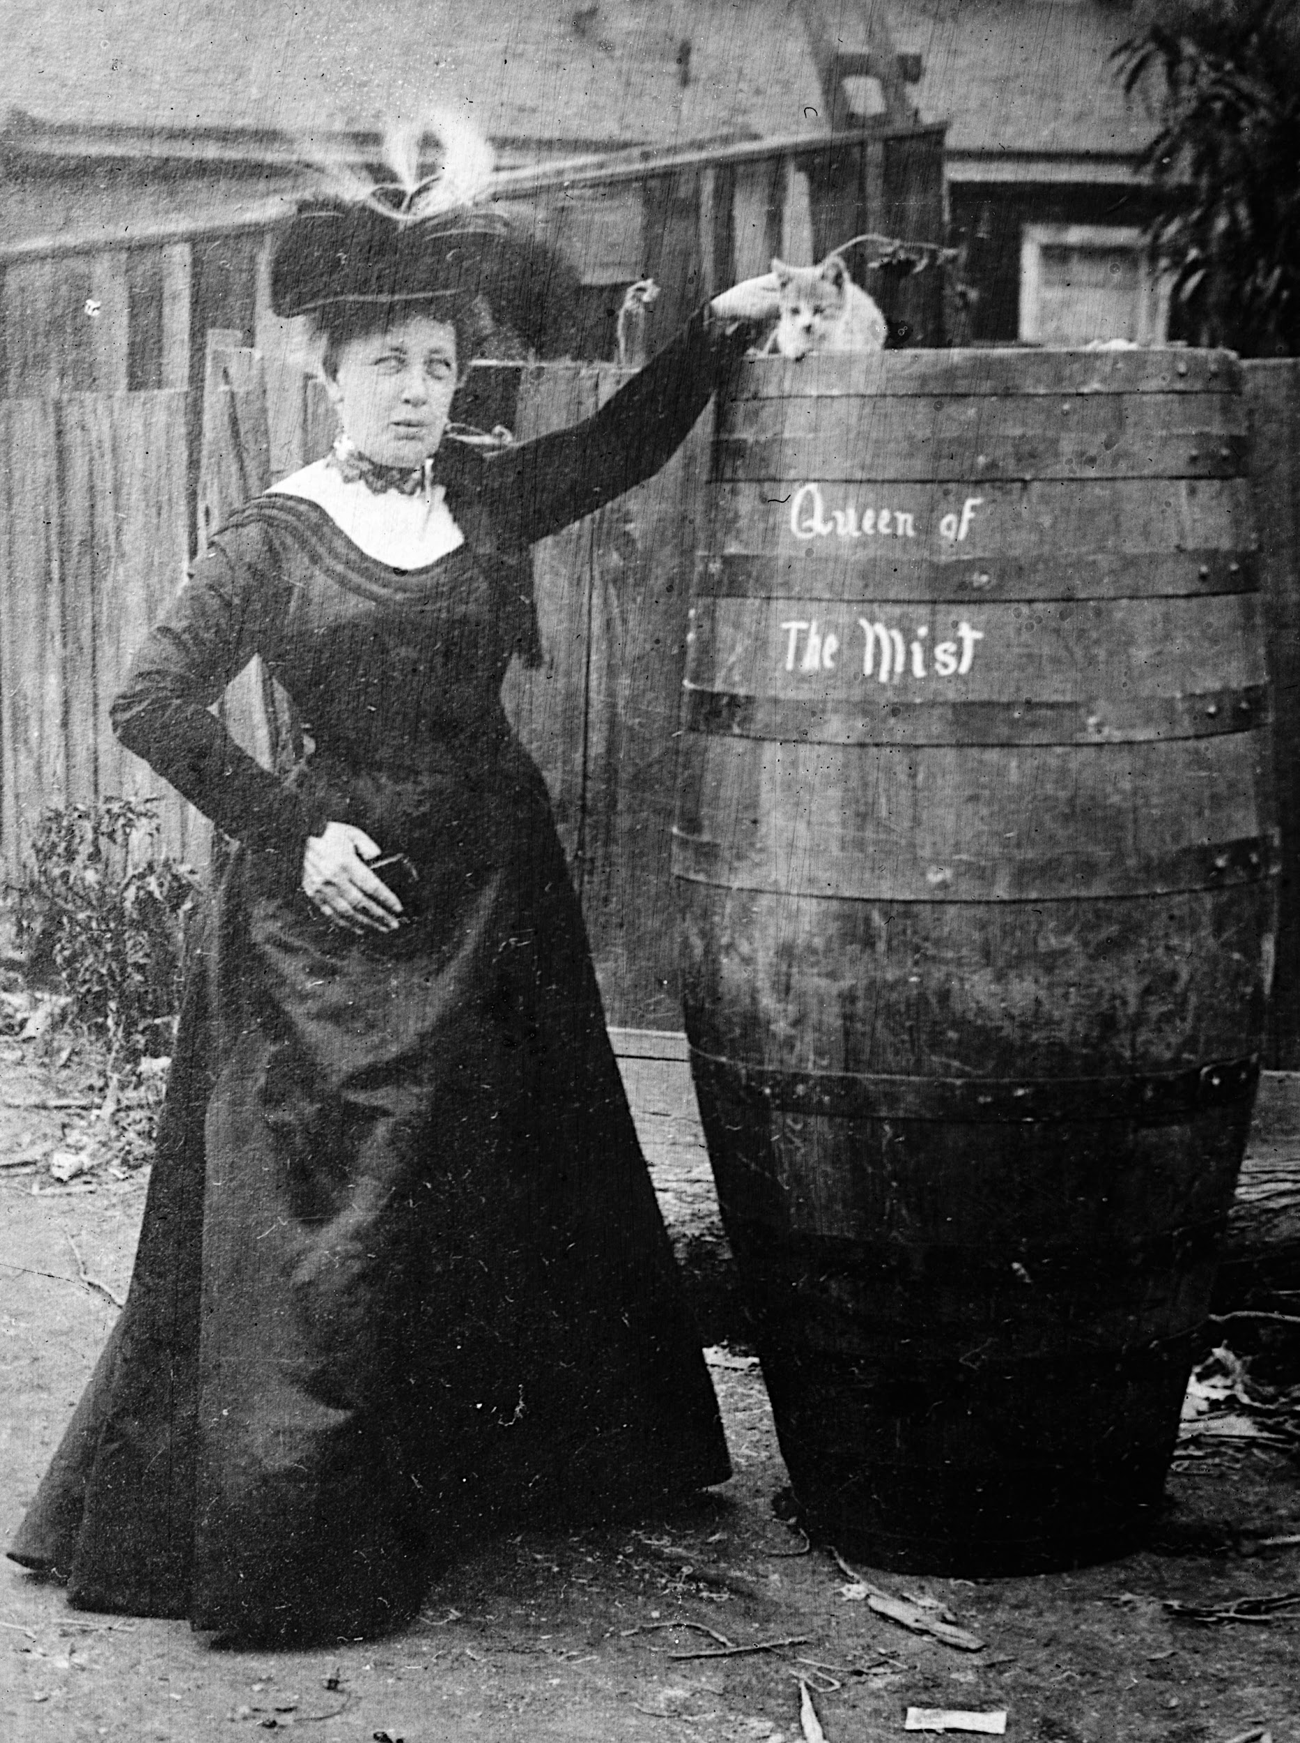
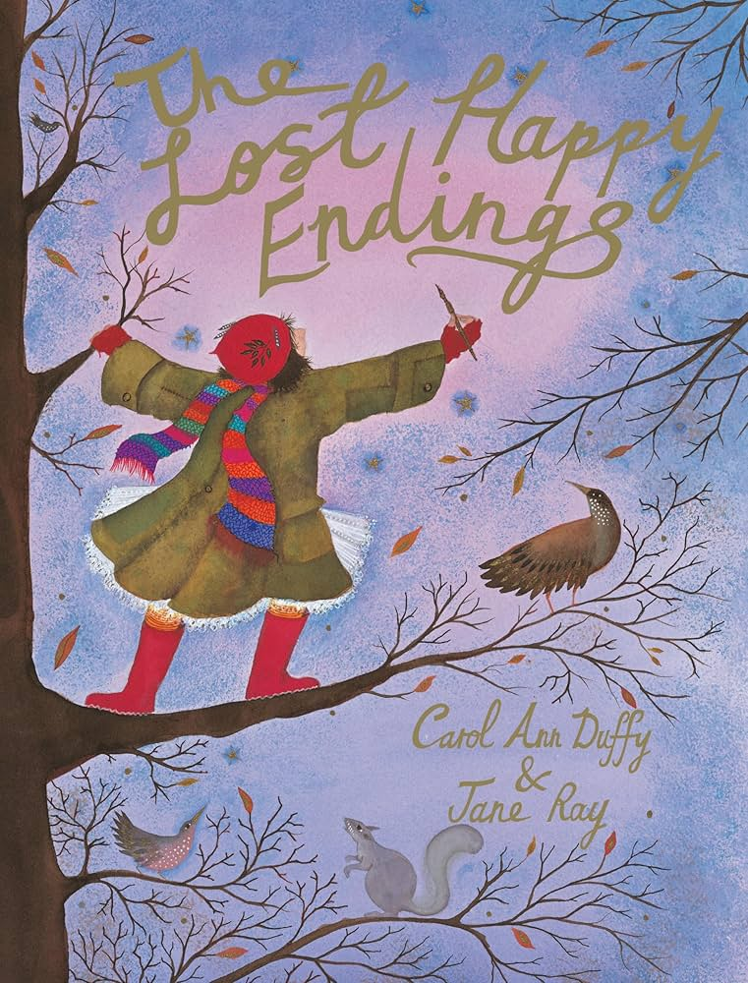
Year 5 Autumn Term 2026-2027
English
In English this term, we will dive straight into our book ‘Queen of the Falls’ – the story of Annie Edson Taylor. The children will be writing a variety of genres to retell key parts of her life. Our Wednesday lessons with Mr Gough will focus mainly on grammar and punctuation which children will be asked to apply to their independent writing.

Maths
In Maths, we will begin with an intensive 2-3 weeks securing our knowledge and understanding of Place Value. This is the basis of our number system and will underpin all future calculations. In Year 5 we will be working with numbers up to 1 000 000, so a confident understanding of the value of each digits is vital – eg in the number 1, 245, 673 the digit 2 has a value of 200,000. The four operations: adding, subtracting, multiplying and dividing come next, we will work on complex calculations, developing our skills at formal written methods – this will mean working in columns, which should be underpinned by our place value work (our calculation policy is on the website if you are unsure of the methods we teach).
We will be looking for the first time at square and cube numbers. Key vocabulary in multiplication and division will be multiples and factors. We will also introduce some fractions earlier than usual, to give children a head start with the huge fractions unit in Year 5.
Science
Our Science work during this term will be on Changes of Materials. We will be looking at reversible and irreversible changes, evaporation, dissolving and filtration. Children will develop their own investigative skills through hands on, practical experiments where they will have the chance to make predictions and discuss fair testing. Where appropriate, they will also link with their statistics work to show their results.
History
We are going back in time to the Industrial Revolution to learn all about its impact on the local area, the UK and the world this term. Children are going to focus on the impact of the Industrial Revolution, life and roles as a child, schooling, crime and punishment, and many more interesting things.
PE
This term, we will be taking part in a variety of sports. We will begin the term with Tag Rugby and Basketball, learning key skills of invasion sports and teamwork.
Following this, after half term, we will be focusing on gymnastics and netball. The children will be taking part in swimming sessions later on this academic year.

Art and DT
Art this term is going to focus on line, shading and patterns through pencil drawings and experimenting with pastels and inks. We will also study Islamic pattern art and create our own versions.

Modern Foreign Languages
In French this year, we will recap counting of larger numbers up to 100, and knowledge of European countries.
To introduce our unit of work on ‘The Family’, we will play ‘Qui est-ce?’ (‘Guess Who’) in French to learn the vocabulary to be able to describe our own families in French.

RE
For the first term, we will learn all about Islam. Children will learn about the five pillars of Islam and their importance to Muslims. They will find out how Muslim faith is expressed through family life.

Music
After an exciting year of music in Year 4, the children will be building upon their learning from their Music for Life lessons.

Computing
This term, we will be finding out how search engines are best used and how children can maximise their potential. Further on in the term, we will be starting a video editing project, using storyboards and editing software on computers.

