PE
Athletics
Can they run at different speeds?
Can they jump from a standing and running position and land safely?
We will be practising a variety of Sports Day games.
Maths
Multiplication and Division
To count forwards and backwards in 2s, 5s and 10s.
To group in 2s, 5s and 10s
To make arrays
Fractions
Halves and quarters
Position and Direction
Turns and positional language
Place Value within 50 and 100
Partitioning, counting, one more one less, comparing
Money
Recognising coins and notes, counting in coins
Time
Time to the hour/half an hour, comparing time
Geography/ History
The history of Chester Zoo
Can I describe what Chester Zoo is like today?
Can I explain how Chester Zoo has changed over the years?
Can I look at how George Mottershead has made significant changes to Chester Zoo?
Can I look at changes within living memory?
Art/ DT
Architect-Sir Christopher Wren
Link images of light and dark within the own environment.
Draw lines of different shapes and thickness.
Draw from the imagination to represent ideas and thoughts.
Use digital imagery to record sculptures and annotate ideas and thoughts.
Develop cooking skills and apply the principles of nutrition and healthy eating. Learn that cooking is a crucial life skill for themselves and others.
RE
Talk about who Muslims say Allah and Muhammad (pbuh) are e.g. 99 names of Allah / Prophet of God.
Explain that the Qu’ran is the holy book of Islam and say how it should be treated.
Show an understanding of at least two Muslim artefacts and explain how they are used.
Describe at least three things that might happen at a Muslim baby’s naming ceremony.
Computing
Can I combine words and images to create word art?
Can I create a visual plan using images and text to tell a story?
Can I create a simple presentation using slides?
Can I combine images, text and voice recordings to retell a story?
Can I combine images and edit text to create front covers, posters and invitations?
Music
The children will be exploring pitch and tempo which they will use to compose their own short superhero theme tunes. musical patterns. In the second half of the year, we will also explore dynamics and write down our compositions using musical symbols.

Science – Materials
Can I tell the difference between an object and a material?
Can I describe materials using my senses and scientific language?
Can I explain what material objects are made from and why a material might be useful for a specific job?
Can I name materials and sort them according to different criteria?
Can I change the shape of an object by squashing, twisting and stretching them?

Year 1 – Summer Term 2026
Go with the Flow
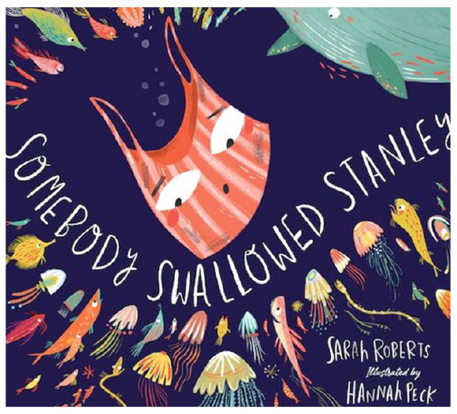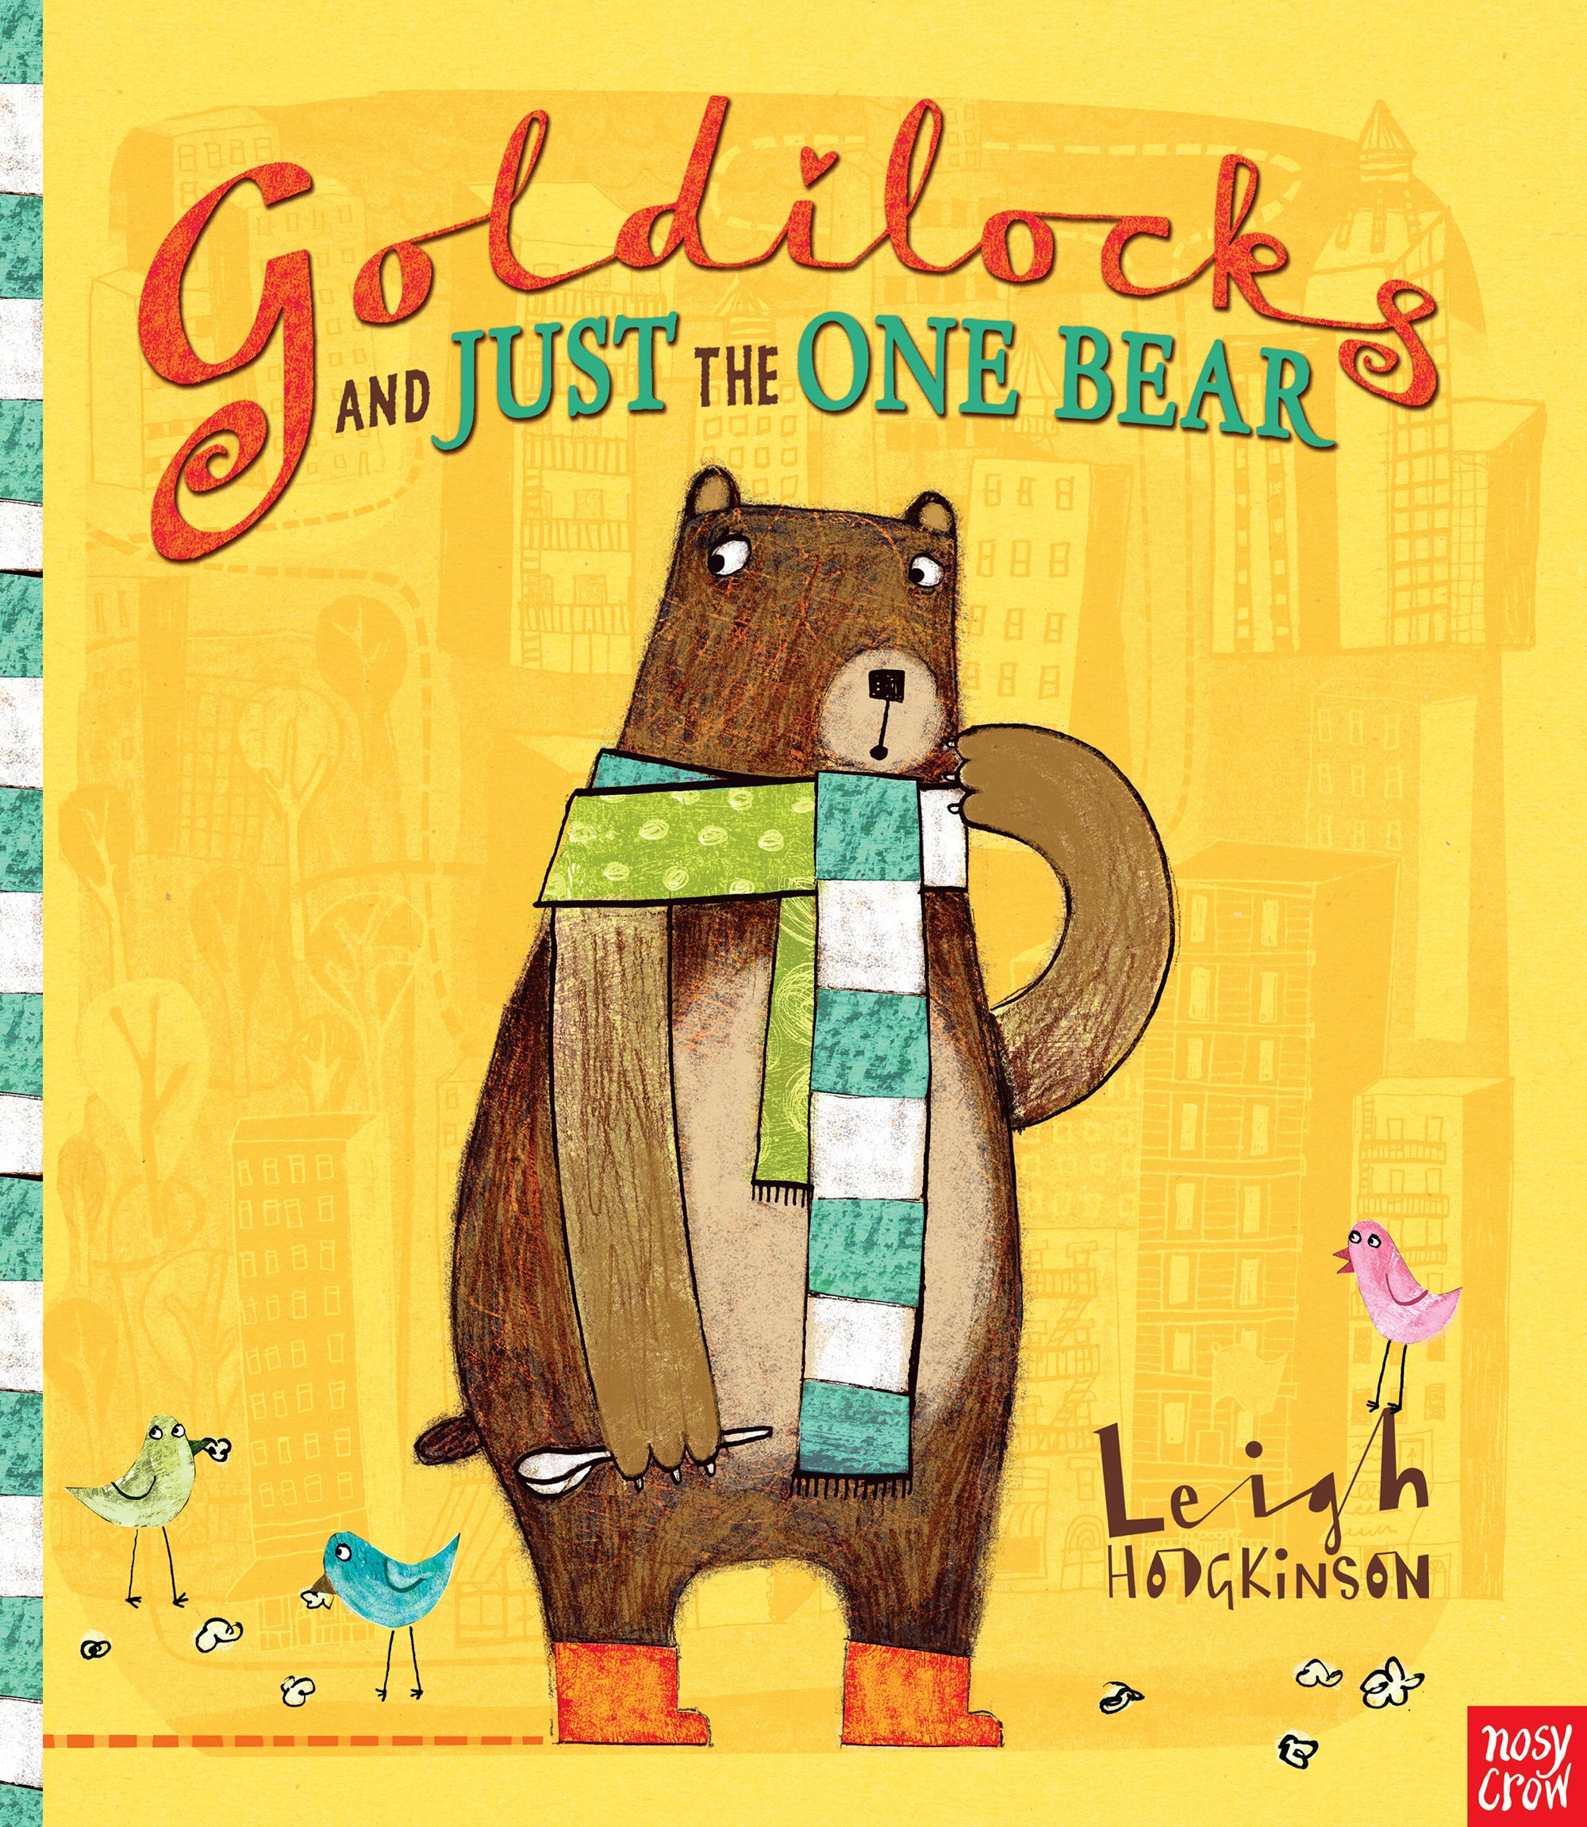

Literacy
This term we will be ensuring we have mastered letter formation, heights and placement on the line as well as the KS1 high frequency spellings. The books we will be reading and working from will be Somebody Swallowed Stanley and Goldilocks and Just The One Bear. The children will give well-structured descriptions, explanations and narratives and make inferences on the basis of what is being said and done. The children will change the meaning of verbs and adjectives by adding the prefix un- and join words and clauses using and. They will continue to punctuate sentences using a capital letter and a full stop, question mark or exclamation mark. We will continue to add suffixes to verbs where no change is needed to the root e.g. –ed, -er, -ing, -est.
Reading
We will be using our new scheme of reading books from Read Write Inc. These books will link to our reading, phonics, writing and spelling and the children will be sent home books that they have been reading in school. They will be able to read these books and we will give ideas on how you can continue to supports your child’s reading at home.
Year 1 – Summer Newsletter 2026
Welcome back parents and children. I hope you enjoyed the Spring break. We are going to have a wonderful, sunny summer term in school. The children have come back full of energy and ready to finish Year 1 on a high!

Summer Term information:

Uniform – We are all hoping that the weather gets warmer and the sun begins to shine daily! Children will need to make sure they are dressed appropriately for the weather. We will be trying to get outside as much as possible. Children will need hats and suncream on brighter, sunny days. If possible, please apply suncream before the school day. Please make sure all clothing is named, especially jumpers!

P.E - PE for Year 1 will take place on Tuesday and Friday. All P.E this term will be outside (weather permitting), please ensure they have a named PE Kit in a named bag which should include the following: t-shirt, joggers/leggings, shorts on warmer days, a sports hoodie or fleece and a suitable pair of trainers. Please be aware that if you are sending your children in trainers with laces, they need to be able to re-tie them independently. Any earrings will need to be removed/taped up for these sessions.

Snacks and water bottles - Please send your child to school daily with a fresh water bottle. We have healthy fruit snacks in school daily for the children to choose from. These alternate between oranges, pears, apples, carrots and bananas. Please ensure any snacks or packed lunch brought from home are entirely nut-free.

Reading & phonics – Please make sure reading diaries are in bags every day, if we have a spare minute for reading, we will use it! Children should be reading at home as much as possible. This could be with an adult or a sibling. Please record any reading your child does. The phonics screening check will take place in the week beginning 8th June. There is no need to share this with the children. They will be used to reading real and nonsense words with us in a 1:1 situation and it will not feel like a ‘test’ to them.

Homework - Homework will continue to be sent out on Fridays, along with new reading books. All homework is there to support and consolidate school learning. Please continue to return your homework and school books every Thursday so that we can have their new books prepared to be sent out on Friday.

Thank you all for your support,

Year 1 Team

