
Year 4 Summer Term Newsletter
Welcome back to the Summer Term!

I hope the children have had a lovely, well earnt relaxing Easter break. We are all really looking forward to welcoming them back and continuing to see them grow and flourish in Year 4!

The Year 4 Team
The Year 4 team will remain the same as it was during the Spring Term. We are once again lucky to be supported by a range of experienced support staff throughout the week. Mrs Barlow will work with the class on Monday. Mrs Davies will support on Wednesday and Friday, with Miss Connah working with us on Tuesdays, Wednesdays and Thursdays.

The week will usually look something like this:
 | Monday | Tuesday | Wednesday | Thursday | Friday
AM | Mr Gough | Forest Schools | Mr Gough | Mr Gough | Mr Gough
PM | Mr Gough  Music for Life | Mr Gough | Mr Gough | Mr Gough  PE | Mr Gough

Uniform and Equipment
As we move into the summer months we are crossing our fingers for warmer weather. This inevitably leads to children taking off their cardigans and jumpers in the sunshine. To avoid losing clothing, please put your child’s name inside their clothes where possible. It is important that the children are hydrated as the temperature rises so please ensure your child continues to come to school with a water bottle. Please could you keep an eye on the weather to see if your child will require suncream on the day, but also if they will need a coat due to rain! Children are required to have their hair tied back fully if they have long hair. Earrings and watches are permitted but children are reminded that other jewellery is not (including necklaces).

Times Tables
The children have been really improving their knowledge and speed, so please continue to practise with them as much as possible. We will be continuing to take part in Mastering Number sessions every day, with times tables activities to start the day.
At the beginning of June, we will take part in the Multiplication Tables Check as we have mentioned throughout the year. For more information, please see https://www.gov.uk/government/publications/multiplication-tables-check-information-for-parents

Reading

It is extremely important that children continue to read on a daily basis and that some of these sessions are with an adult. We’d be grateful if you could listen to your child read as often as possible. It would be great if you could ask them questions about the text as they are reading. This develops confidence and reading comprehension.
Children will continue to come home with their Reading and Homework Diaries which will contain their homework and spelling patterns that they will be learning in school. Please ensure their Reading and Homework Diaries come into school every day.

Homework
Homework will continue to be set on Fridays and should be handed in by the following Thursday. As usual, for larger projects, you will be notified on School Spider for additional details.
PE
PE this term will change slightly. One of our PE slots will be taken up by Forest School on Tuesday and our other slot will be delivered on Thursday afternoon. Please see the School Spider message with an attached letter for further details.

Please make sure your child has their indoor PE kit, clearly labelled, in school. Please remember that earrings will need to be removed for PE. Trainers can be left in school or brought in on the day if you do not have any spares. It is important that suitable footwear is worn for PE to avoid injury.

Finally, we hope your children are looking forward to another amazing term in Year 4. As always, please do get in touch if you have any questions or concerns. You can catch us after school or send us an email year4@mickletrafford.cheshire.sch.uk.
For urgent enquiries, please contact admin@mickletrafford.cheshire.sch.uk or telephone school.

Thank you for your continued support throughout the year, it is much appreciated.

Mr Gough

Literacy | Maths | Science
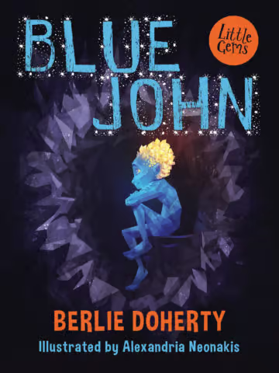  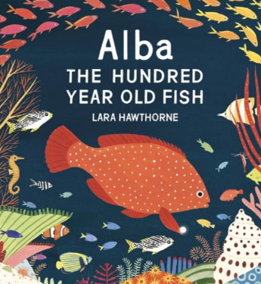  Our Summer term in literacy will begin with the book Alba: The Hundred Year Old Fish. We will be working towards creating our own non-information text that could be presented in an aquarium.  Later in the term, we will be studying a text called ‘Blue John’ by Berlie Dogherty. Through this text, the children will learn about caves through explanation texts and have the opportunity for letter writing. | Our maths work this term will focus on mastering skills and using and applying techniques through problem solving.  To begin with, we will continue working decimals that we started before Easter.    Our work on decimals will support our understanding as we begin to focus on money. This topic will see us convert different values, estimate and problem solve using various amounts. We would be grateful for your support in helping children by talking about money and encouraging your children to use coins to pay for things whenever possible.  Following this, we will work on position and direction and shape. |   After Easter, we will begin our science topic of electricity. We will take a first look at electrical circuits, learning the names of the components and making a simple circuit with a switch. We will use this knowledge in a DT project, making a pyramid linked to our history learning.  Sound: This is a very practical (and noisy!) unit where the children explore how sounds are made by vibrations and how these vibrations travel to our ear to be heard. We look at a range of musical instruments and learn lots about the different parts of the ear.
Humanities | Year 4 Curriculum  Summer 2026 | Art & DT
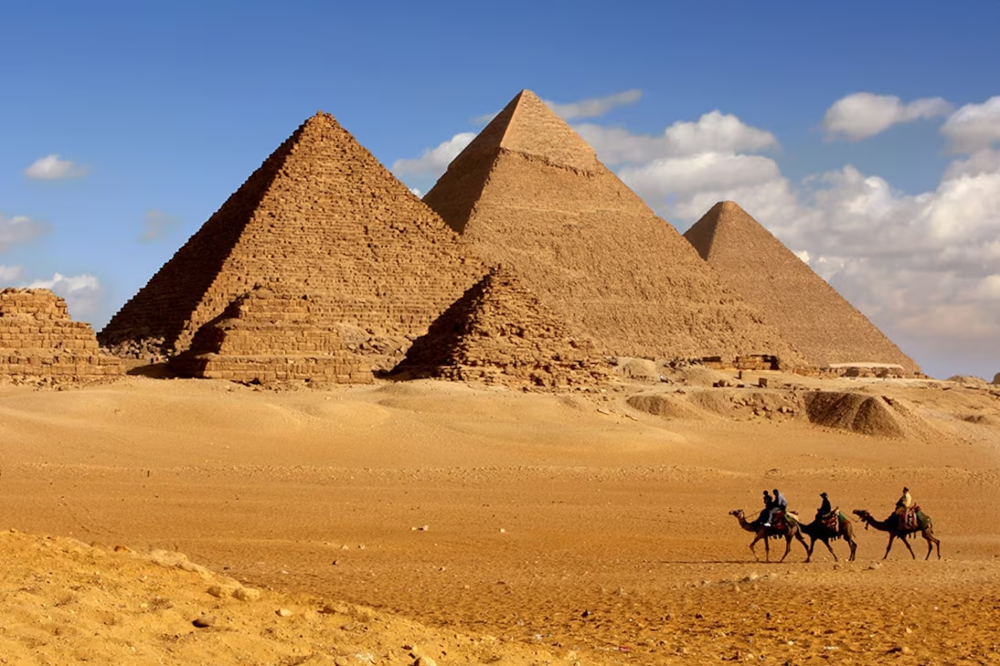  Once we have completed our current topic, we will begin our unit about The Egyptians.  We will learn where the Egyptians are placed in history and create a timeline of key events. We will find out all about Egyptian life and the amazing discovery of Tutankhanmun’s tomb. We are excited for our school trip to the World Museum to further our understanding! | Year 4 Curriculum  Summer 2026 | This term’s art will involve using printing techniques to produce work on different materials. We will also investigate textiles as a medium for art and look at how fabric and fashion link to art movements.  In DT, as well as our electricity project, we will be investigating mechanisms and learning how CAM mechanisms change the movement of a product. The children will have the opportunity to design and make their own mechanism.
RE | PE | Computing
  This term, the children will be learning about Buddhism for the first time!  We will begin our topic by learning what Buddhism is, its core beliefs and who the Buddha was.  We will continue our journey by discovering how Buddhists celebrate, how symbolism is used and what community looks like for Buddhists. |   This term our PE sessions will be on Tuesday and Thursday. As stated above, our Tuesday PE will be taken up by forest schools.  In the first half term, our PE will be tennis. After half term, we will begin to develop our rounders skills. | We will begin by linking work in art to the use of digital images, exploring how to recolour, clone and combine images to create art.    We will then be turning our attention to programming. Using Scratch, we will be designing and creating simple games.

