Computing – Technology Around Us
We will:
- Be introduced to programming and algorithms.
- Create commands for a robot.
- Labelling, grouping and searching for data.
- Assign labels to data to demonstrate how computers group and present data.

Problem Solving, Reasoning and Numeracy
This term we will focus on working with numbers up to 50. We will learn to:
- Count, order and compare numbers up to 50.
- Partition numbers into tens and ones.
- Add and subtract numbers up to 20.
- Find and make number bonds to 20.
- Know our doubles and near doubles facts.
- Begin to compare and measure length, height, weight and capacity.
- Mass and Volume
- Geometry
PE

Emotional Wellbeing – Jigsaw

Dreams and Goals

Can they talk about what makes them special?

Can they discuss differences and similarities?

Can I stay motivated when completing a task?

Can I work well with a partner and group?

Can I help others to achieve their goals?

Healthy Me

Can I identify ways to stay healthy and make healthy lifestyle choices?

Can I identify ways to keep myself clean and healthy?

Can I understand how germs can cause disease and illness?

Can I understand how household items can be dangerous to health if not used properly?

Can I understand that medicines can help us when feeling poorly and know how to use them safely?

Can I understand road safety?

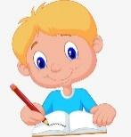
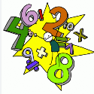
RE
Can I celebrate beauty around me?
Can I understand how Christians believe the world began?
Can I understand others' views about creation?
Can I demonstrate stewardship?
Communication, language and literacy
We will read a wide variety of stories, books and poems across the curriculum. In our writing lessons we will be focusing on writing:
- Adventure stories (The Lion Inside)
- Stories in the first person (Beegu)

Using these books as our focus, we will:
- Use capital letters, full stops, question marks and exclamation marks.
- Join words and sentences using ‘and’.
- Include a beginning, middle and end.
- Describe characters and settings.
- Add suffixes to the ends of words (-er, -ing, -est, -ed).
- Begin to use the -un prefix to change the meaning of a word.

Creative development
Music
- To understand the musical term dynamics
- To identify, describe and recreate different sounds within a musical piece
- To use instruments to create loud and soft sounds.
- To read, clap and play simple rhythmic patterns that include one beat sounds and rests.

PE Fundamental Movement Skills and Gymnastics

History – The history of Chester Zoo
We will:
Begin to investigate what Chester Zoo is like today using a variety of sources.
Look at how Chester Zoo has changed and developed over time.
Look at the influence George Mottershead has had on Chester zoo.
Investigate how the zoo has changed within living memory.
Geography - Study of the local area.
We will:
Look at maps looking into the 4 compass points and some simple symbols.
Look at the importance of our addresses and postcode.
Investigate the features of our school grounds.
Look into the human and physical features in the local area.

Science - Animals (including humans)
We will:
- Identify and label external human body parts.
- Know the 5 human senses and recognise which body parts are linked to these.
- Name and identify the features of mammals, birds, reptiles, amphibians and fish.
- Group animals according to their diet (carnivores, herbivores and omnivores).
- Explore animals in their natural habitats and learn to care for them.

Design Technology - Mechanisms
We will:
- Create a moving picture based on a storybook.
- Explore, select and create their own sliders and levers to create movement within their picture.

Year 1: I wonder what’s out there?
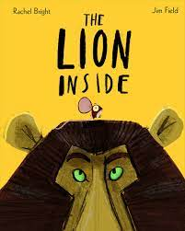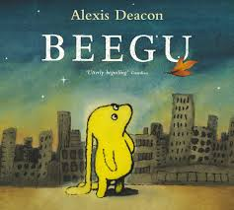

Mickle Trafford Village School
Spring Term 2025 Year One
Happy New Year!

Welcome back! We hope you have had a fantastic Christmas break.

This half term is packed full of exciting and fun opportunities as we ask the question ‘What is out there?’. The topic plan above highlights the areas that we will cover in the specific subjects.

Phonics/ Spellings
Daily phonics sessions will continue and we will continue to assess the children every 6 weeks. Each Friday, children will be given their new RWI reading book and an additional story to read at home. Please ensure reading wallets are returned to school on Thursday so that we can issue your child with their new reading books.

In June the children will be given a statutory phonics screening check. This includes twenty real words and twenty alien words using the set 1, 2 and 3 sounds that the children are learning in school. If you would like to find out more information yourself, then please visit the government website on https://www.gov.uk/government/publications/phonics-screening-check-2022-materials.

Homework
Homework will continue to be issued on a Friday and will be due the following Thursday. All homework will link to our learning from that week, or will be a task to support learning for the following week.

PE
Our Forest school sessions have now ended for this year so we will have two PE sessions per week. These will take place on Tuesdays and Thursdays.
Please ensure your child has an indoor and outdoor PE kit in school for these sessions.

Thank you,

Mrs Bamford, Mrs Taylor, Mrs Cox and Mrs Sykes

