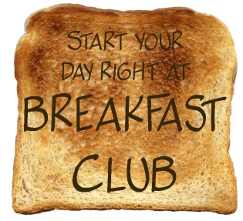

Chestnuts Primary School
Black Boy Lane
London N15 3AS
Tel: 020 8800 2362
Email: clubs@chestnutsprimary.com

BREAKFAST CLUB REGISTRATION

Requests to change club days will need to be made on a half termly basis. All requests to be sent to the above email before the second week of the new term.

1. CHILD’S DETAILS
Date of Application:
Child’s Full Name:
Date of Birth: / / Current School Year: Class:

2. EMERGENCY CONTACT DETAILS:
1. Name: Mobile No:
NOTE: If any of this information changes during the period of the agreement it is imperative that you inform the school office.

3. MEDICAL INFORMATION
Any known Allergies:
Specific Dietary Requirements:
Medical Conditions:
I give permission for first aid to be administered should my child require it and to seek medical assistance should it be required YES / NO

4. BREAKFAST CLUB REQUIREMENTS
Monday | Tuesday | Wednesday | Thursday | Friday
Breakfast Club is £4.00/day or £20.00/week
NOTE: All fees for the half term must be paid in advance via Parent Pay or a credit/debit card. We do accept Childcare Vouchers (Scheme reference: EY348142) and bank transfers.
Bank: RBS
Sort code: 16-19-18
Account no: 10113553
Ref: BC First initial and Surname, e.g. BC J.Bloggs

If a space could not be provided your child’s name will be placed on a waiting list.

5. DECLARATION
I undertake to abide by the conditions laid down by Chestnuts Breakfast Club and I understand that my child’s place could be removed if I fail to pay the required fees on time. I agree to pay for the days my child has been allocated regardless of whether they attend.
Signed: Date
Print Name:

