
Maths:
You will notice that under each challenge there is a star. This star relates to the difficulty of the question. All children should be able to complete all the although some may still need support. Other children who find it easier, must make their way through the questions and continue until they reach . If the children find these questions hard they can then stop there. They do not need to continue.
It is really important for children to be able to explain why they have done certain things, so if you can make sure that after each maths challenge ( each lesson, not each question ) they can reason a chosen question. This is something the children do every day in class, so it should be relatively easy for them.

Lessons:
Adding 4 digit numbers
Children need to think about what the 1 at the bottom of the column signifies. What does it mean? It means there was a renaming/exchange of 10 ones for 1 ten. What could the missing digit possibly be? They need to remember that that missing digit + the 1 = a number with 2 digits. This number has to have 1 ten. If it was a number ie 21 the number exchanged over with be 2 because in 21 we have 2 tens and 1 ones.
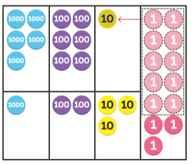
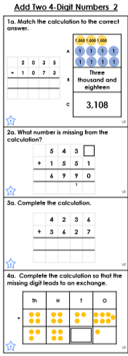
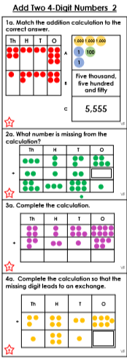
Remind the children of what happens when we exchange. Ask them whether you can have more than 1 digit in a place value? No. So what do they need to do? They need to exchange 10 ones for how many tens? 1 ten
For questions where there is a missing number children need to remember to do the opposite. Ask them to remind you what the opposite of each operation is. Add = Subtract
For pictorial questions you should encourage the children to write ALL the numbers on the question in concrete form ( using numbers)

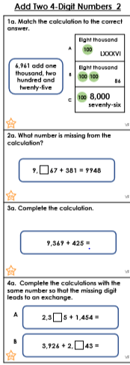
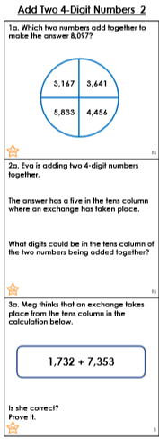
Make sure the children do these questions bit by bit. For questions like this it would be helpful if the children place 6,961 onto a place value grid and from here they add the other amounts. They should then make sure that the answers A,B AND C are all of the same representation. Whichever the child finds easiest.
For example I would change them all into digits.

Questions where is says prove it make sure the children are reasoning their answers with a short explanation.
I know this because..
I solved this by doing..
NOT: I just did it in my head

INVERSE operations.Children need to work backwards.What is the inverse of addition? Subtraction.
If they struggle ask them whether you can subtract 9948 from 381, why not? They should be able to tell you because the number will go into negatives and therefore won’t give you the correct answer.
9948 – 381 = Will give you the answer.

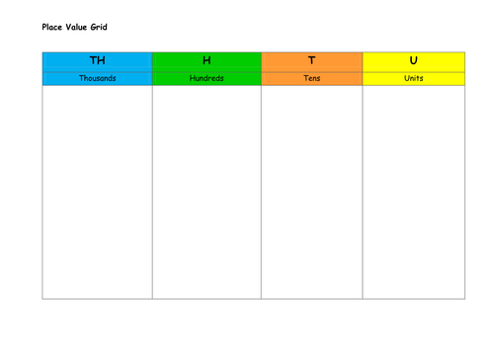
WARNING: Both missing numbers MUST be the same.
Children should place the number sentences into a place value do its visually easier for them to see. They will need to do this for both number sentences.
WARNING: The exchange has been ADDED FOR YOU ALREADY. (therefore you don’t know how many 10’s 100’s 1000’s have been exchanged - tricky)
Children to use their renaming/exchanging knowledge. What can we add to 5 that would lead to an exchange? Anything that would make a 2 digit number.
5

3
2
4
5
4
1
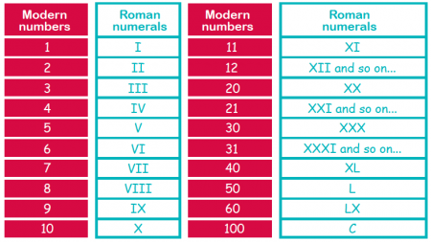

Rounding to the nearest 1,000

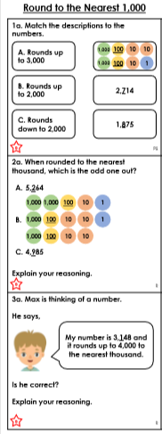
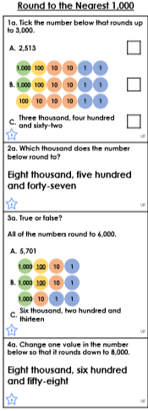
Sentence starters:
I solved this problem by..
The strategy I used was..
I discovered that…
I noticed that..
The first thing I did was
First,next,then,after that…
I agree with.. because..
I disagree because..
I got a different answer because…

Make all the answers the same representation to help with the answer.
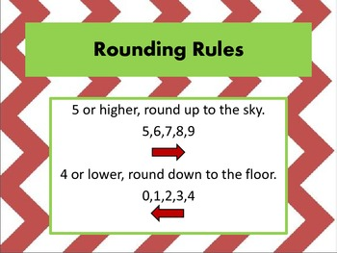
5 TO THE SKY
4 TO THE FLOOR
If the second digit is 4 of less you round down. If it is 5 or more you round up.
6000
5000
5678
Rounded nearest hundred the children need to focus on the TH value and the H value. IE:
5678 - When rounding to TH they need to identify the thousands on each end of a number. For : 5678 it would be 5000 and 6000.
The children then need to look at the digit to the right 5678 and if this digit is above 5 we round up. If it is 4 or less. We round down.
Doing rounding on a numberline really helps those who find it difficult.

CO ORDINATES
We havn’t done coordinates as a class so this may be challenging.
The children should know where the x and y axis is. From here they need to label their graph. Remind them that is always down the corridor THEN up the stairs.

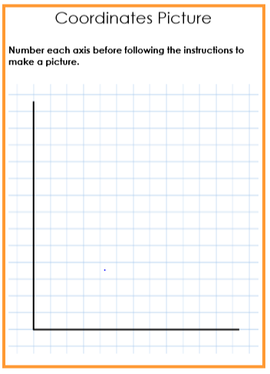

Y AXIS
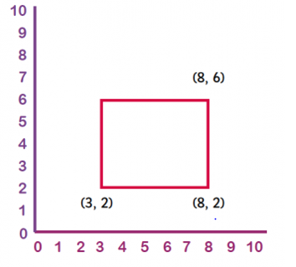

X AXIS

Coordinates are always written in brackets, with the two numbers separated by a comma. Coordinates are ordered pairs of numbers; the first number indicates the point on the x axis and the second the point on the y axis.
When reading or plotting coordinates you always go across first and then up (a good way to remember this is: 'across the landing and up the stairs').

TIME
1h = 60m
Children should be reminded what the difference between a 12h and 24h clock is. If children know they can continue with the task but for those who do not, it would be beneficial if they could draw they own clock face and add the 12h and 24h clock to help them when adding the time to the task.
1m = 60s
1/2h = 30m
1/2m = 30s
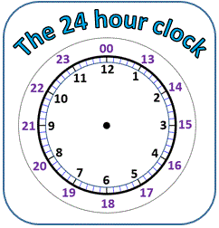
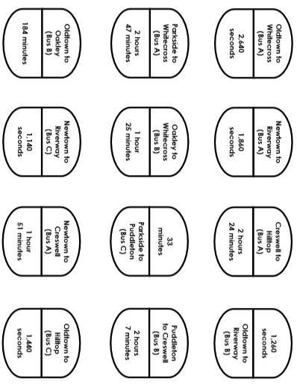
To start the children need to decide what time is best to convert ALL the stops into.
They should be able to decide that converting them into hours would be the best decision.
SECOND TO MINUTES: you divide the amount of seconds by 60. They can use long division for this.
MINUTES TO HOURS: you convert the amount of minutes by 60.
OPPOSITE: If the children decide to onvert hours in minutes you simply do the opposite and multiply the amount by 60. If they decide to convert minutes into seconds they also multiply by 60

English
Direct speech:
The general rules of direct speech are:
- Each new character's speech starts on a new line.
- Speech is opened with speech marks.
- Each line of speech starts with a capital.
- The line of speech ends with a comma, exclamation mark or question mark.
- A reporting clause is used at the end (said Jane, shouted Paul, replied Mum).
- A full stop goes after the reporting clause.
4th close speech
2nd Capital letter

“ I cannot believe this is happening to us!” shouted Ms Linares.
Said verb
3rd punctuation.
! ? ,
1s: Open speech marks

Indirect speech:
He said "I'm coming" is direct speech, whereas He said (that) he was coming is indirect speech.
Ie:
Jimmy said he wasn’t feeling too well < INDIRECT
Jimmy said, “ I’m not feeling too well.” < DIRECT

Fronted Adverbials:
Fronted adverbials are words or phrases placed at the beginning of a sentence which are used to describe the action that follows. Here are some examples: Before sunrise, Zack ate his breakfast. After the rain stopped, Sophie went outside to play.
Fronted adverbials are followed by a comma.
