AFTER SCHOOL ACTIVITY CLUBS- Spring 1
There are a wide variety of clubs available for your child this Spring half term. Below you can find the details. Please remember that these activities are not designed to be child care but as an enrichment opportunity for the children.
You can enrol in clubs through Parent Pay from Wednesday 8th January at 10.00pm (please see reverse of letter for instructions). Once the online spaces are filled the club will be full and no one else will be able to enrol.
Clubs will start from the week commencing Monday 13th January 2020 and will run for 5 weeks. The last week of clubs will commence on Monday 10th February.

DAY | CLUB | STAFF MEMBER | AVAILABLE TO | COST PER SESSION | COST FOR HALFTERM
Monday  (3.30-4.30) | Fun Swim | Mr Joe | Y1 – Y6 | £4 | £20
Monday  (3.30 – 4.45) | Fun Activities | Ms Begum | Y1 – Y6 | £4 | £20
Monday (3.30-4.45) | Dodgeball /Tennis | Mr Abdel | Y1 – Y6 | £4 | £20
Tuesday (3.30-4.45) | KS1 Football | Mr Abdel | Y1 – Y2 | £4 | £20
Tuesday  (3.30-4.30) | Fun Swim | Mr Joe | Y1 – Y6 | £4 | £20
Wednesday  (3.30-4.45) | KS2 Football | Mr Joe & Mr Abdel | Y3 - Y6 | £4 | £20
Thursday (3.30-4.45) | Taekwondo | Clive | Y3 – Y6 | £4 | £20
Thursday (3.30-4.45) | Japan Club | Naoko | Y3 – Y6 | £4 | £16
Thursday  (3.30 – 4.45) | Maths Street Dance | Outside Agency | Y3 – Y6 | £4 | £20
Friday  (3.30 – 4.45) | Junk Club | Ms Hen | Y1 – Y6 | £4 | £20
Friday  (3.30 – 4.45) | Netball Team Practice | Ms Ellis | Y3 – Y6 | Free | Free

Japan Club will not start until Thursday 23rd January and will run for 4 weeks

To sign up for an activity club through ParentPay:
- Log in to ParentPay (Details available from the school office if you don’t have a login)
- Once you have logged in, click on “Pay for other items” Pictured below: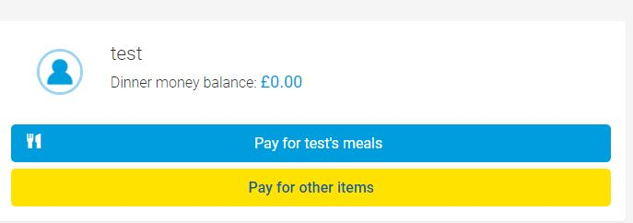
- Find the club you would like to book a place on and click the View button: 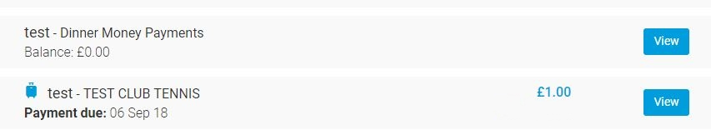
- Under the “Payment” section of the next page, you must tick the consent button and then add to basket. 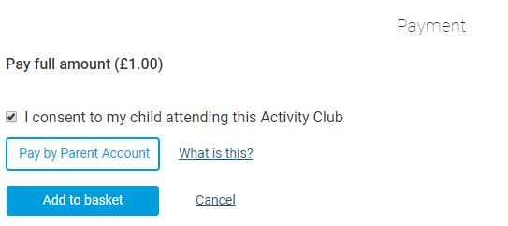
- Once you have consented and made payment, your place will be booked and the payment item will be marked as “Paid” as shown below.