

Flintshire

Healthy School Scheme

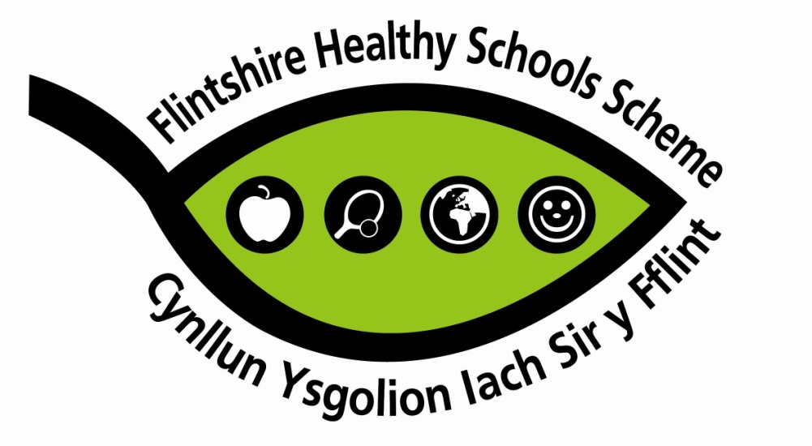
Accreditation Report

School: Ysgol Maes Hyfryd
Head teacher: Helen Millard
Co-ordinator: Emma Keyworth
Phase: 5
Assessor: Marina Carter
Assessment Date: 25.06.2019
With reference to the National Quality Award (NQA), please select which health theme/s have been addressed:

*Emotional Health and Well-being
*Personal relationships
*Safety
Relevant documentation available:

*
*NQA Indicators
*
*Evidence folder
Summary of visit and comments:
On arrival I entered a welcoming, light, spacious and comfortable reception where electronic signing in was extremely secure. The. Coordinator and three pupils from the school council introduced themselves before taking me on a visit of the premises describing everything politely and confidently.
The first thing I was reassured by was the security provided for everyone in the building, the lanyards being the only way of opening doors -some by staff only and others by senior pupils. There are four phases for pupils - sensory phase, Key Stage 3, Key Stage 4 and post 16. I told the pupils I was looking particularly at mental and emotion health and well-being along with safety, so whilst touring the school they pointed out how the school classrooms are organised for pupil welfare as well as age and how the displays along corridors were particularly sensory, eye catching, stimulating, informative and helpful in boosting self-esteem and confidence. The pupils emphasised the caring, supportive staff and environment.
Outdoors there was a range of areas suitably adapted for learning, physical play for all and gardening for senior pupils. The pupils showed good understanding of their environment.
Opportunity for discussion with:
*Coordinator
*Pupils
*Headteacher

Opportunity for observation:
*Inside the school building
*Outdoors

Evidence
Summary of developments:
Provide summary of evidence / developments undertaken for each of the main criteria:

- Emotional Health and Well being
- Policy - all relevant policies are in evidence. Included in the safeguarding policy is clear referral guidance and referral forms including self referral. Notice boards display information about all available services and school based counselling is available through the YMH (youth mental health) family engagement worker. Pupils also have access to ELSA (emotional literacy support workers) and nurses.
- Training - all staff have safeguarding training and have regular reviews and the PSE/Healthy Schools coordinator attends network meetings, self-harm prevention training and regular CAMHS training. ELSA staff attend relevant training. all training is cascaded and influences practice through the curriculum and emotional literacy support.
3. Initiatives - The school is involved with numerous national initiatives including the John Muir Award, D of E award and young enterprise. Locally pupils help at the Buzz cafe, the Sidewalk /castle cafe and the Eco Centre. Photos evidence many activities supporting pupil’s emotional health and wellbeing and assembly themes address local issues such as anti-bullying and safety.
4. Curriculum - The portfolio includes many examples of SOW’s which identify emotional health and wellbeing in PSE and the sensory curriculum and the informal curriculum. Pupils work about feelings, rights and how staff observe pupils feelings and signs of distress in the sensory stage is well evidenced. A range of resources are available for wide range of needs. These may be specific rooms, calm areas, material resources, projects or specialised staff.
5. Out of school hours -pupils are offered opportunities to attend many extra-curricular events and activities such as the Eisteddfod, and residentials at Glan Llyn, farm trust and the Duke of Edinburgh
6. Pupil involvement - school council minutes and a PowerPoint show discussions and feedback from other pupils about how students feel about their school and how they might improve. There is a student council specific notice board providing lots of information. A buddy system is in place, school rules are developed by pupils and visiting agencies’ work is evaluated. A behaviour questionnaire produced data which was included in the SDP.
7. Staff involvement - All staff are trained in team teaching and for physical intervention. Everyone works together very closely as a team and knows pupils needs and emotional as well as physical issues.
8. Environment - The indoor environment is pleasant, tidy with bright, stimulating displays and the outdoor environment offers opportunities for learning and enjoyment and includes a sensory garden and a green area shred with Flint High School. Everywhere has been created and developed specifically for the needs of the pupils. The entrance celebrates whole school achievements displaying awards and certificates and displays class merit star of the week photographs. The mission statement is “Skills, well-being, attitude and knowledge” and the aim is to “provide a caring, supportive and safe learning environment where pupils can develop the skills they need to live happy fulfilling lives” In 2018 Estyn inspection praised this ethos stating “pupils are proud of their achievements and share their work passionately with staff and visitors”. Pupils feel safe and know who to turn to if they feel anxious. Growth mindset displays are all around the school and a young person’s display board outside the school nurse room signpost pupils to a number of counselling services. In school pupils have chess to the county school based counsellor, the family engagement worker, the school nurse and the ELSAs.
For staff there is an NQT induction programme and induction for new staff. Both staff and pupils have opportunities to promote self-esteem including the PSE programme, buddy systems, awards and achievements in numerous events and assemblies celebrating achievements. Pupils have taken part in the NEW dance show at Theatre Clwyd and in the school pantomime to which parents are invited. The school has a communications policy which indicates how pupils are supported to manage their feelings and empathise with others.
9.Parent and community - The school encourages parents to get involved with school events and newsletters invite them to workshops which help them to understand the importance of emotional health and well-being and how to manage behavioural issues. (Eg a sleep workshop, behaviour and communication session) . They are well informed about the school approach to emotional issues and actions in newsletters, text, Twitter, the website and school-home diaries. A parent’s room in the school signposts them to leaflets and policies. investors in Families Sessions are also held for family workshops such as with a nutritionist and events such as a charity pop up shop. Support for the community includes the choir singing at a local nursing home and beach combing at Talacre beach.
10. Outside Agencies - The school engages with a number of outside agencies to support the curriculum, for example: CAMHS, the behaviour support service, Project JIWSI, community police, physiotherapists, Rugby Wales and Kimnel Camp. Examples of pupils evaluating work with outside agencies are in the portfolio
11. Health Promoting Workplace - Staff complete a questionnaire annually, the data collected is fed back to staff and actions taken as necessary. Also, a Professional Development review. Well-being is discussed at staff meetings and activities such as yoga and fitness sessions and nights out have been introduced. Investors in People award was achieved in 2018 Corporate policies made available to staff include Sickness management, leave of absence, grievance and lone working policies. Staff consider there is a good communications system, staff room facilities are good and procedures are in place to address work life balance.

- Personal Relationships

- Policy - Good policies are in place including an SRE policy following welsh guidelines, child protection relationships sections are covered in each stage in the PSE policy. The SRE policy was developed with support from the county and the school council were involved in discussion and developed a child friendly version. There is a Twitter usage policy and clear framework for all staff to provide a safe learning environment in relation to internet use. The policy is on the website and a copy available in the office.

2. Staff training All staff have been trained in child protection and safeguarding. Training has also been given by Stonewall, training on self-harm and train the trainers by JIWSI. The coordinator attends Healthy Schools/ PSE network meetings termly and disseminates relevant information to staff including county lines, so now lessons are included in PSE.

3. Initiatives - the school takes part in safer internet day and PC Debbie delivers personal safety lessons. Sexting, project JIWSI and county lines are examples of addressing issues as the need arises.

4. Curriculum . There are good examples of planning for personal relationships and safety including puberty in KS3. KS4 cover exploitation, diversity and equality with pregnancy in science. Sensory stage covers personal care and independence. Post 16students cover STIs, sexual exploitation, their own health and the health of others. Examples of pupils work in PSE and science is evidenced. Project JIWSI, CEOP, and the school nurse have provided posters and leaflets available for pupils.

6. Pupil Involvement. - Pupils views have been taken into account in relation to the policy and feedback provided on consultation about what is taught.
7. Staff involvement All staff are familiar with safeguarding procedures and SRE policy. Estyn spoke highly of practice regarding safeguarding in the last inspection.
8. Environment - posters, leaflets and information about where to get support is displayed on a notice board outside the nurse’s room, information about Childline is displayed and there is an on-site counsellor for support. (See information above in summary of visit and section 8 of emotional health and well-being)
9. Parents and Community - Letters are sent to parents to inform them of SRE being taught. They can access the policy and the website and the School Prospectus also provides information.
10. Outside Agencies. - Project JIWSI works closely with vulnerable pupils in Years 10 to 14. The school nurse and PC Debbie also support the curriculum. As a matter of course all work delivers by outside agencies is followed up in class. Staff all sit in during lessons delivers by outside agencies. Examples of pupil evaluations are evidenced.

3. Safety
- Policies - A range of policies include covering child protection and safety in the environment include sexting (needs led, staff researched and trained), e-safety, a lockdown policy, extremism and radicalisation and lone working is included in the health and safety policy. Risk assessments, fire drills, and first aid training demonstrates policy implementation
- Training - All staff are appropriately trained in child protection and safeguarding, emergency lockdown, food safety, epi-pen use and first aid.
- Initiatives - School is involved in initiatives such as National Safety Week, Road safety, CEOP, anti bullying week, Project JIWSI.
- Curriculum - schemes of work, plans and pupils work evidence work on safety at all stages including e-safety and environment safety. The school is an e-aware school. Personal safety includes peer pressure and gang culture with appropriate resources from mixed sources
- Out of school hours - all activities and trips away from school are risk assessed thoroughly. A first aider is always present on trips along with first aid kits.
- Pupil involvement - pupils are involved in developing school rules for their safety and risk assessments also involve students both in class and vulnerable individuals. Examples provided.
- Staff - all staff wear badges; they all report any incidents. There is a staff duties list evidenced. Cleaning staff are aware of all safety policies and procedures. The staff handbook and bulletin ensure regular updates are communicated.
- Environment and ethos. - An extremely safe and secure environment ensures pupil and staff safety. There is CCTV outdoors, all staff and visitors wear identity badges and posters in school display safety relating for food, ICT and first aid. All doors in corridors can only be opened by special fobs worn by staff and/or senior students. The business manager keeps records of DBS checks and other confidential records. Lockdown procedures are practiced.
- Family and Community involvement - Parents and carers receive regular newsletters. They are invited to a session on safe behaviours. Letters sent home include safety information such as road safety, facebook, nut allergy, weather, e-cigarettes. Examples provided. The website provides a parent’s guide to technology safety. Pupils visit Dangerpoint for safety education and support is provided by road safety education team and transport officer.
- Outside agencies -Pupils and staff evaluate all curriculum input from outside agencies. Examples of student evaluations for the PLO are evidenced and some from staff.

Particular Strengths:

Emotional Health and Well being
- Staff understanding of pupils needs, the support they provide and signposting to supporting agencies are a great strength.
- Large range of policies all appropriate to needs of the school.
- A variety of resources are available specific to the vast range of emotional needs of pupils.
- Pupils are involved in discussions about their school and how it can be improved. A behaviour questionnaire produced data which was included in the SDP.
- Staff health and wellbeing is well considered and there are many opportunities for them to air their views and take part in activities.

Personal Relationships

- Pupil involvement is extremely good - discussing needs and evaluating lessons and activities.
- The curriculum whilst covering all required aspects, also addresses the specific needs and vulnerability of pupils.
- Plenty of support from outside agencies which is always appropriately evaluated.

Safety
- Safety and providing a secure environment is a great strength of the school. The signing in of visitors’ process is considered crucial and the electronic method which includes a photograph and checking DRB is excellent.

Areas for consideration
- Continue the good work

Sustainability

Schools are asked to demonstrate that the work is sustainable and that health promotion has become an integral part of the daily life of the school.

My observations of the evidence that was available would confirm everything is sustainable. There is very good awareness of need and sufficient evidence that these themes contribute to health promotion and are incorporated into the daily life of the school

Accreditation Status

Do you recommend the school receives Healthy Schools Scheme Accreditation?

Yes
Comments: Ysgol Maes Hyfryd makes health and wellbeing a priority and have some excellent actions and evidence. Strong learner voice and the involvement of all staff will enable the school to sustain the actions and continue to embed health in the life of the school. I was particularly impressed by the well organised files and the range of evidence provided which included ample examples of pupils work and examples of communication with parents. Also, the environment felt safe, showing care and consideration for both staff and pupils. I would like to thank the young people who showed me around the school. It was obvious they were happy with their school, the education provided and the caring attitude of the staff.
Well done to all involved in developing and promoting these themes. Good luck with the NQA!

Report date: 05.07.2019

