

Year 4
Multiplication Tables Workshop
Games and Strategies

Multiplication Tables Check (MTC) The Multiplication Tables Check (MTC) will be administered to children in Year 4. They will take place in June.

The purpose of the MTC is to determine whether Year 4 pupils can recall their multiplication tables up to 12x12 fluently as outlined in the National Curriculum.

Children will be tested using a computer, where they will have to answer multiplication questions against a clock. The test will last no longer than 5 minutes; children will have 6 seconds to answer each question in a series of 25.

A sound recall of times tables will form a strong foundation for all maths learning that follows – especially in the lead up to Year 6 SATS. I’m sure we all remember standing up, chanting tables at school. Learning by rote is one strategy, but there are also other activities we can do with children to help them learn their tables.

The aim of this booklet is to show you some of the strategies we use in school and that you could try at home to help your child with their tables.

These are the national expectations for the recall of times tables.
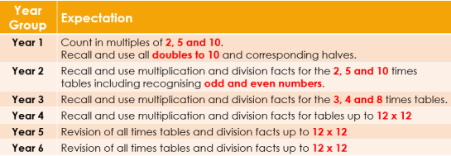

Games and activities to help your child learn at home. Rhyme Time! Silly rhymes and songs can help children to remember these patterns, e.g. ‘0 2 4 6 8, my mum thinks I’m great’ – the sillier the better really!
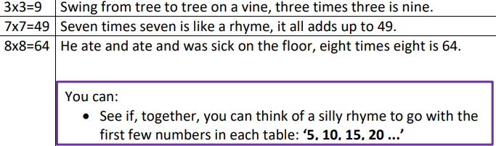

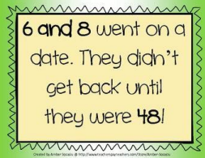

One Less Equals Nine! This is a strategy for learning the 9 x tables. The key to it is that for any answer in the nine times table, both digits add up to 9. Try it and see! 1.

Subtract 1 from the number you are multiplying by. E.g. 7x9, one less than 7 is 6. 2. This number becomes the first number in the answer.

7x9=6__ 3. The two numbers in the answer add up to 9 so the second number must be 3. 7x9=63 9 Times Tables on your Fingers!

1. Hold your hands in front of you with your fingers spread out.
2. For 9 x 8 bend your 8th finger down (like the picture).
3. You have 7 fingers in front of the bent finger (the tens) and 2 after the bent finger (the ones). Thus the answer must be 72!
4. The technique works for the 9 times table up to 10.

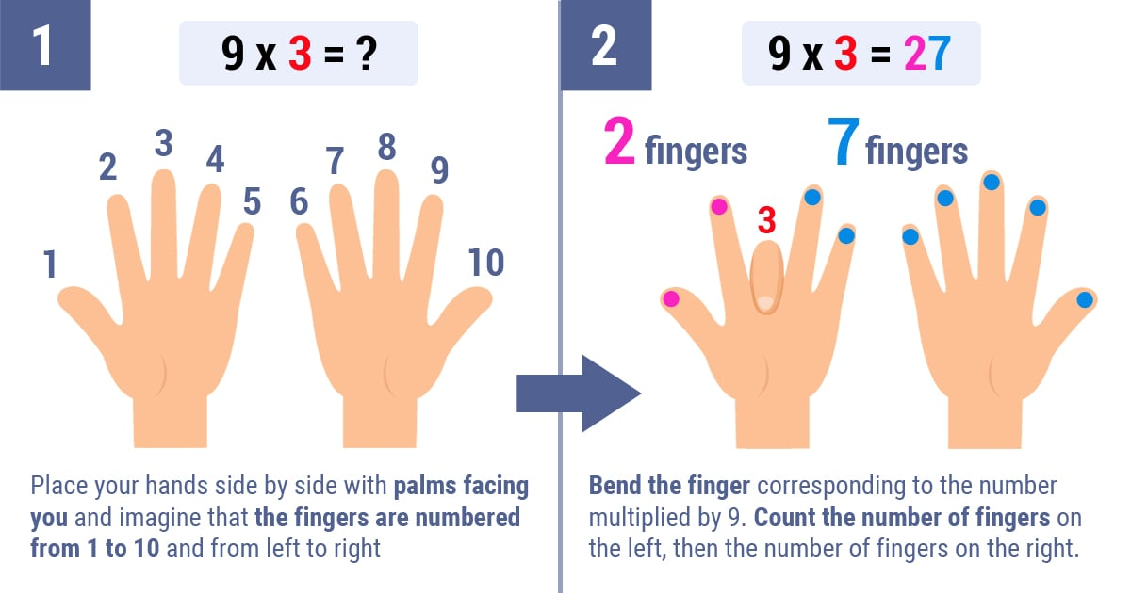

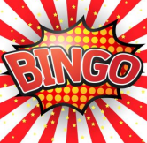
Bingo! This game will need 2 players! Make a grid of six squares on a piece of paper and ask your child to write a number in each square from the target tables. Give them a question and if they have the answer, they mark them off. First one to mark off all their numbers is the winner!

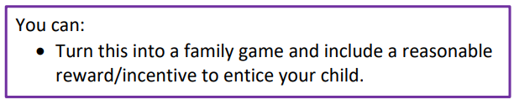

Number Squares When numbers are placed in a number square, highlighted times tables make a visual pattern. Some children find these very visual patterns help them to remember the table.
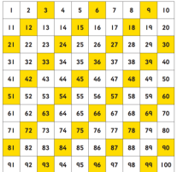

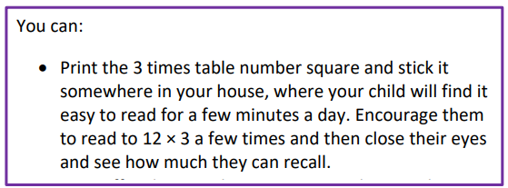

Super Fingers! This is a game for two players! The game is basically a version of rock, paper, scissors but with numbers. Two players count to 3 and then make a number using their fingers.


Both players then have to multiply both numbers together and the quickest wins. You can do it with one or two hands.

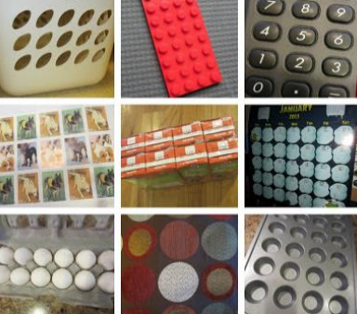
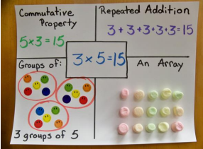
Concrete Pictorial & Abstract Approach (CPA) Manipulation of physical resources and construction of pictorial representations before conquering the abstract understanding of times tables is extremely valuable. Multiplication has a strong presence in our day-to-day life. Look for opportunities to use them when problem-solving when shopping or using recipes. In order for maths experiences to be effective, children need to be able to work with and manipulate practical materials.

Useful Websites
1. Maths Frame Multiplication Tables Check
https://mathsframe.co.uk/en/resources/resource/477/MultiplicationTables-Check

2. Timed tests that mirror the multiplication tables check.
https://ttrockstars.com/

3. Topmarks.co.uk
https://www.topmarks.co.uk/maths-games/7-11-years/times-tables

Various games that can be adjusted to specific times tables.
4. Tablestest.com
https://tablestest.com/

Multiplication grid test that records the time taken for each question.
5. Transum.org
https://www.transum.org/Tables/Square.asp

General Table practise games
6. ictgames - Home Page

