Pets

Biggest Pet
Zeus, a whopping 44-inch tall Great Dane from Michigan, US was officially crowned as world’s tallest dog by the Guinness Book of World record in 2013 beating another Great Dane named Giant George by an inch.
He was named after an ancient Greek God. At over 70 kilograms, he required 12 cups of food every day. He passed away on Sept 3, 2014, aged 5, due to natural causes.
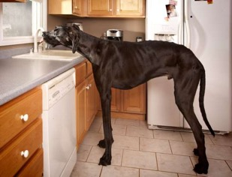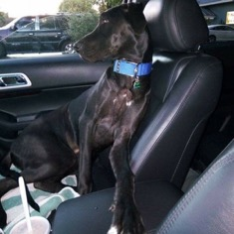

Smallest Pet
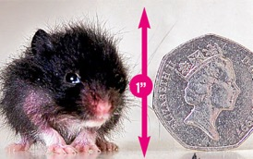
Only slightly bigger than a 50 pence coin, PeeWee is the smallest hamster in the world.
He weighed less than an ounce and stopped growing when he was three weeks old. He was so small, measuring less than one inch and could fit into a matchbox.
His siblings all grew to be over four to six inches said his owner, Mandy Bower, a pet shop owner in Keighley, West Yorkshire.

Weirdest Pet
Micro pigs are one of the weirdest pets you can own. They are very cute and also cheap to maintain. They even eat your leftovers! All you need is some outdoor space.
Even though they are called Micro pigs they do grow pretty large when they are adults. So do be careful while choosing one.
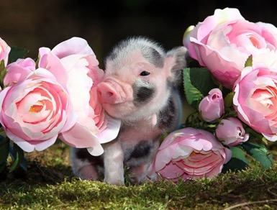

A day in a Cat’s life!
Finally, a vacation where I won’t be annoyed by Rosie, my household mouse.
We were going on a cruise to the West Indies to see all my friends. And I was excitedly dreaming the wonderful time that I would have.
Ouch!!! What was that? Did someone just throw a cup at me?
Oh, it’s that silly old mouse Rosie. How did she manage to get on the ship? I am so annoyed. I am so going to get her this time – it would make a good meal or even better throw her off into the sea. I prefer the yummy cat snacks these days!

I chased Rosie, as she ran into the ship’s cockpit. Got you cornered now Rosie!


Screeching….
What why are there 50 odd mice behind Rosie. Oh no, they seem to be running towards me.
Looks like there is a small change of plan - RUN….
I ran until I saw the swimming pool. Rosie and her friends wouldn’t be able to chase me into the pool. Time to jump in!!
Splash… Gurg… Gurg…
How stupid of me? I can’t swim! I should realised before jumping in.
HELP ME! HELP ME SOMEONE!
What it looks like Rosie and her friends are throwing in some floats to help me. I tried grabbing one and had no option but to be pulled in by the mice.
Rosie said, “Never again but I can’t lose you my friend. Who else would I torture back home?”
I thanked Rosie and stole some cheese from the kitchen in return for her kindness .


Mango’s (my friend’s dog) daily instructions
- Give a bath and brush the teeth once a week.
- Send out in the morning to do the dog’s business.
- Give some food in the morning
- Take the dog out for a walk or run – remember to have the leashes
- Let him take a snooze or rest
- Make sure that there’s water to drink.
- Let out again in night to do its business.
- Spend time playing with her.
- Take her to the cage with her toys
- Time to sleep

Note: - Make sure chemicals are locked and don’t give any chocolate. These make them very ill!

