

Ashchurch Primary School -

Attendance summary report

Monitor your school attendance

Autumn term 2025 to 2026 (September to mid-December)

Data protection and data sharing
This report contains sensitive information about your school.
You must store and share the data securely. Read the data protection impact assessment (DPIA) (PDF, 241 KB, 21 pages) for the daily attendance data collection.

Version history
This table shows changes to your summary report for the current academic year.
Version | Changes | Date | Author
1.0 | Initial release | 1 September 2025 | DfE
1.1 | Added number of sessions of attendance data the report is based on | 11 November 2025 | DfE

What is the attendance summary report?
This report summarises attendance for pupils in years 1 to 6 compared to the national average. It is:
- specific to your school.
- updated at the end of each half and full term.

Headline attendance and absence
Shows overall attendance and persistent absence figures for pupils in years 1 to 6 compared to the national average. Results are based on:
- data from the start of the academic year 2025 to 2026, up to Monday 22 December 2025
- a total of 18534 sessions of attendance data

Overall attendance
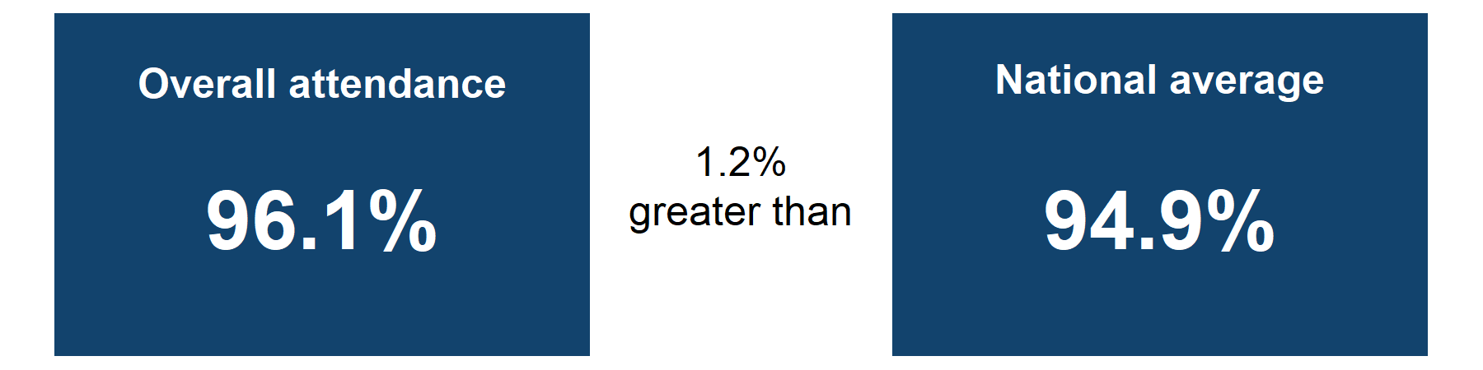
Overall attendance is 96.1% which is 1.2% higher than the national average.

Persistent absence
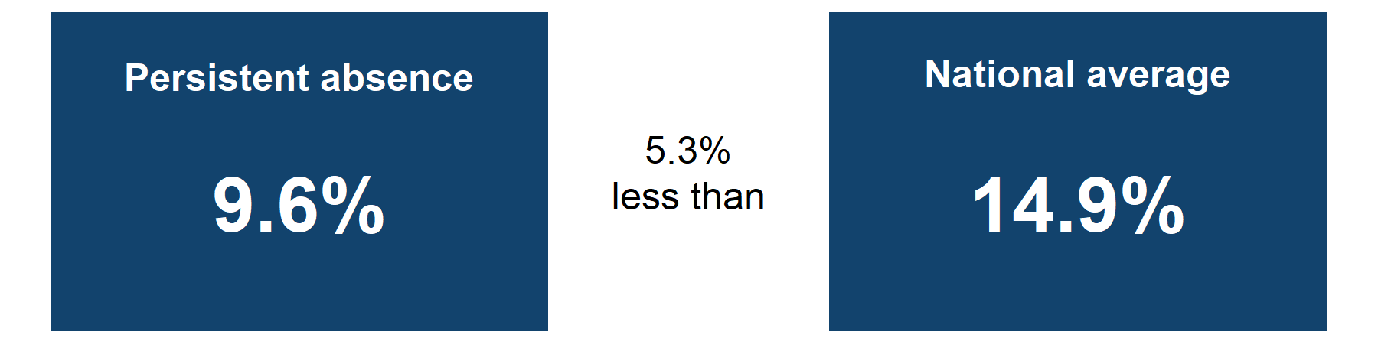
Persistent absence is 9.6% which is 5.3% lower than the national average.
Source:Monitor your school attendance results for your school and national data from the DfE.

Overall attendance comparison

Weekly attendance comparison for the autumn term 2025 to 2026
Figure 1: Graph showing the overall attendance percentage each week during the second half of the autumn term, compared to the national average. Results are for pupils in years 1 to 6 from Monday 3 November 2025 to Monday 22 December 2025.
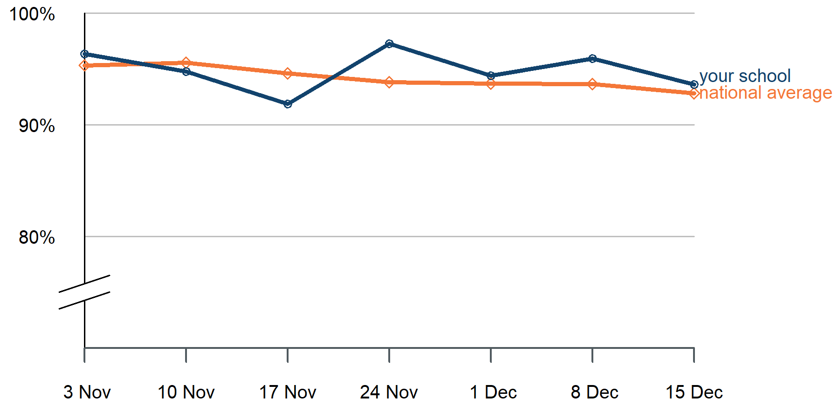

Graph alternative: table of weekly attendance for the autumn term 2025 to 2026.
Week start date | Attendance | National average
3 November | 96.4% | 95.3%
10 November | 94.8% | 95.6%
17 November | 91.9% | 94.6%
24 November | 97.3% | 93.8%
1 December | 94.4% | 93.7%
8 December | 95.9% | 93.7%
15 December | 93.6% | 92.8%
Source: Monitor your school attendance results for your school and nationally, data from the DfE.
Notes:
Attendance results for your school and individual pupils are updated daily in the Monitor your school attendance tool.
Explore education statistics publishes data from national and local authorities every 2 weeks.

Pupil group comparison
Figure 2: Bar chart showing the attendance percentage for pupils with and without free school meals (FSM) and special educational needs (SEN) support compared to the national averages. Results are for pupils in years 1 to 6 from the start of the academic year 2025 to 2026, up to Monday 22 December 2025.
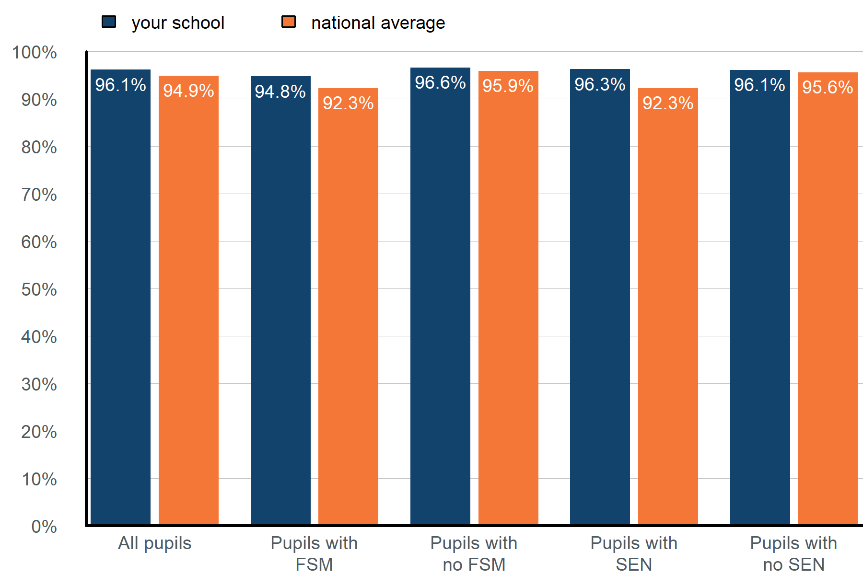

Graph alternative: table of attendance for different pupil groups from the start of the academic year 2025 to 2026, up to Monday 22 December 2025.
Pupil group | Attendance | National average
All pupils | 96.1% | 94.9%
Pupils with FSM | 94.8% | 92.3%
Pupils with no FSM | 96.6% | 95.9%
Pupils with no SEN | 96.1% | 95.6%
Pupils with SEN support | 96.3% | 92.3%
Source: Monitor your school attendance results for your school and nationally, data from the DfE.
Notes:
SEN support data is taken from the latest record available in your management information system (MIS). SEN support pupil numbers include those with an education health and care plan (EHCP).
Year-to-date attendance figures for SEN and EHCP pupils are available in the Monitor your school attendance dashboard.

Previous academic year comparison
Figure 3: Bar chart showing the attendance percentage for pupils with and without FSM and SEN support compared to last year. Results are for pupils in years 1 to 6 from the start of the academic year 2025 to 2026, up to Monday 22 December 2025.
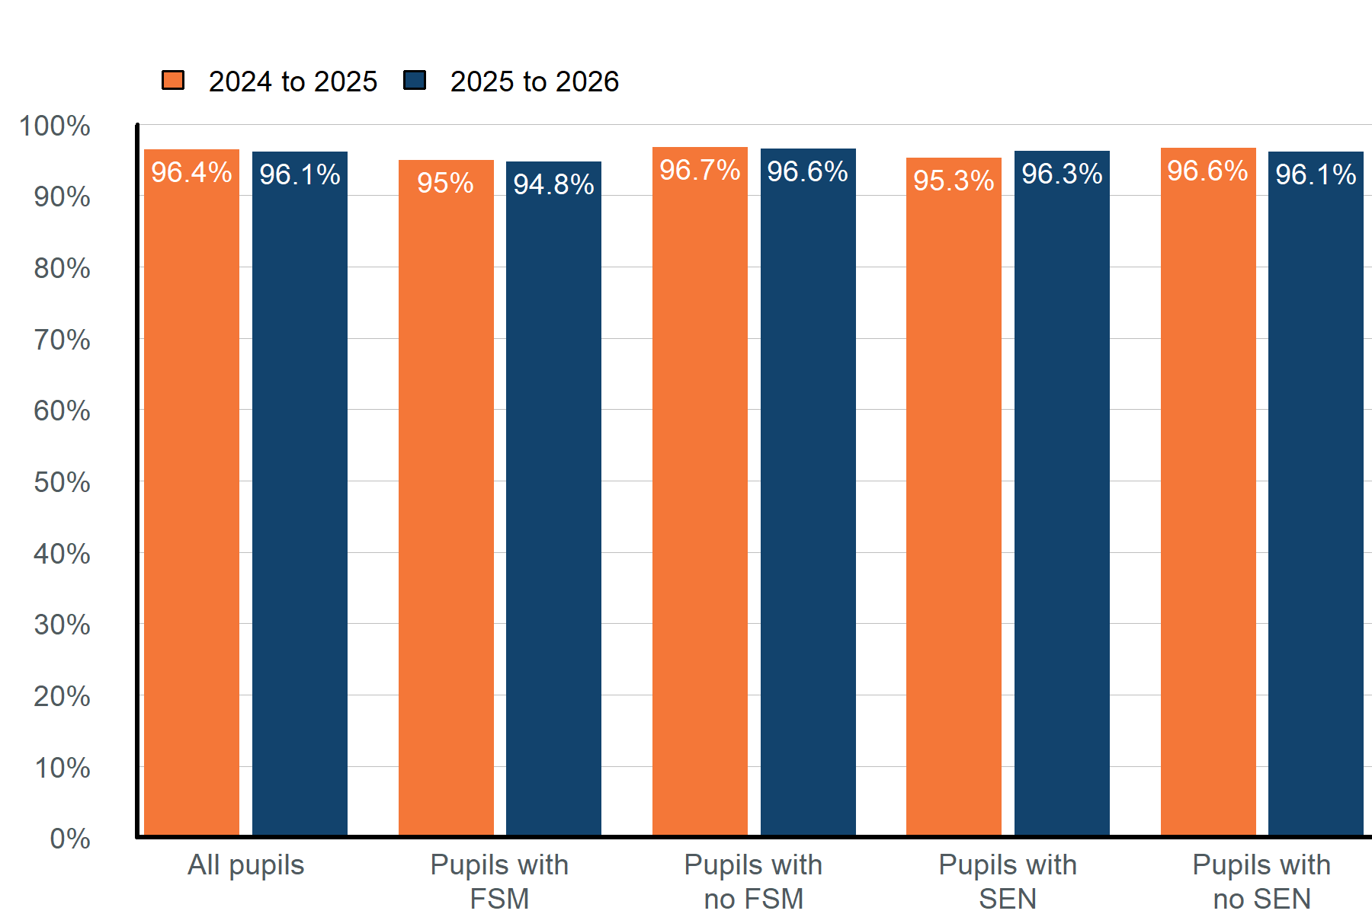

Graph alternative: table of attendance for different pupil groups from the start of the 2025 to 2026 academic year, up to Monday 22 December 2025, compared to the same period last year.
Pupil group | Attendance 2024 to 2025 | Attendance 2025 to 2026
All pupils | 96.4% | 96.1%
Pupils with FSM | 95% | 94.8%
Pupils with no FSM | 96.7% | 96.6%
Pupils with SEN | 95.3% | 96.3%
Pupils with no SEN | 96.6% | 96.1%
Source: Monitor your school attendance results for your school, data from the DfE.

Absence by year group
Figure 4: Table showing the percentage of pupils in each 5% absence band up to and above 50% absence for pupils in years Monday 22 December 2025. Results are based on pupils with 20 or more possible sessions in the current academic year, from the start of the academic year up to Monday 22 December 2025.
Overall absence band | Year 1 | Year 2 | Year 3 | Year 4 | Year 5 | Year 6
less than 5% | 52% | 79% | 77% | 72% | 65% | 87%
5% to less than 10% | 29% | 16% | 8% | 28% | 19% | 13%
10% to less than 15% | 14% | 0% | 15% | 0% | 12% | 0%
15% to less than 20% | 5% | 5% | 0% | 0% | 0% | 0%
20% to less than 25% | 0% | 0% | 0% | 0% | 4% | 0%
25% to less than 30% | 0% | 0% | 0% | 0% | 0% | 0%
30% to less than 35% | 0% | 0% | 0% | 0% | 0% | 0%
35% to less than 40% | 0% | 0% | 0% | 0% | 0% | 0%
40% to less than 45% | 0% | 0% | 0% | 0% | 0% | 0%
45% to less than 50% | 0% | 0% | 0% | 0% | 0% | 0%
50% and above (severely absent) | 0% | 0% | 0% | 0% | 0% | 0%
10% and above (persistently absent) | 19% | 5% | 15% | 0% | 15% | 0%
Source: Monitor your school attendance results for your school, data from the DfE.
Notes:
Absence data is updated daily in the Monitor your school attendance tool. Learn more about how to review absence patterns in the absence bandings user guide.
© Crown copyright 2025

