

Ashchurch Primary School -

Monitor your school attendance summary report

Spring term 2024 to 2025

February 2025

Version History
This table gives details of changes made to your summary report for the spring term.
Version | Changes | Date | Author
1.0 | Initial release | 27 February 2025 | FT

Your attendance summary report
This report is specific to your school. It is a summary of your school’s attendance for pupils in years 1 to 6 from the start of the academic year 2024 to 2025 up to Tuesday 18 February 2025. Results are based on the daily attendance data your school shares with the Department for Education (DfE). It comes from your school’s management information system (MIS)
Year-to-date attendance data for the whole schools and individual pupils is available in the Monitor your school attendance tool via the View your education data (VYED) service.

How to use this report
Attendance summary reports are designed to help you to meet expectations set out in the working together to improve school attendance guidance. We publish a new report for your school for each half and full term.
It can help you:
- identify pupils with and approaching persistent and severe absence rates
- consider the underlying causes of absence
- devise strategies to address absence challenges
Share it with your board to discuss current strategies to attendance, their effectiveness and whether alternative approaches are needed.

How we calculate your results
The data:
- is from the start of the academic year up to Tuesday 18 February 2025.
- is for pupils in years 1 to 6
- includes attendance, absence codes, and pupil characteristics as recorded in your school’s MIS.
Data in this report may be different from data in your MIS, official statistics and other attendance data tools. Other attendance data reports may be updated daily, termly or cover an entire academic year or the academic year-to-date. This can cause large differences in the number of persistently absent pupils.
Refer to the data definitions to understand how we calculate attendance.

National average
The national averages in this report are for pupils in years 1 to 6 in mainstream primary schools in England.

Comparng your results with other attendance statistics
Comparisons with other data sets should be used with caution. They may be calculated differently or cover different time periods. This can cause large differences in results for each attendance measure.

Data protection and data sharing
This report can contain sensitive information about your school. It is your responsibility to make sure you store and share the data securely. Review the data protection impact assessment (DPIA) for the daily attendance data collection.

Headline attendance and absence
Overall attendance and persistent absence percentage for your school compared to the national average from the start of the academic year 2024 to 2025, up to Tuesday 18 February 2025.

Overall school attendance
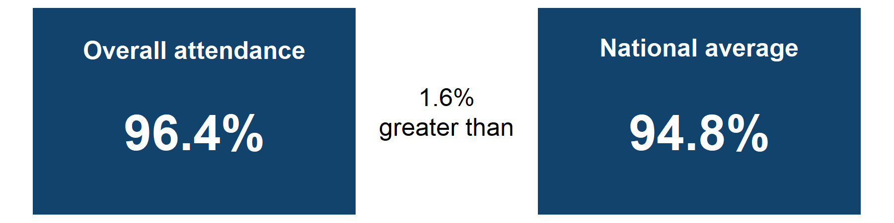
Overall attendance is 96.4% which is 1.6% greater than the national average.

Absence breakdown
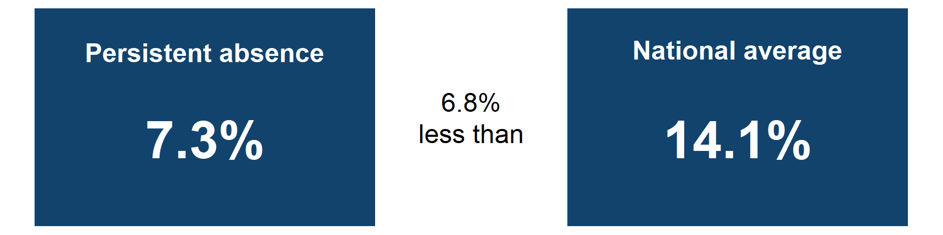
Persistent absence is 7.3% which is 6.8% less than the national average.
Sources:Monitor your school attendance results for your school and nationally, data from the DfE.

Overall school attendance

Weekly attendance comparison for the first half of the spring term 2024 to 2025
Figure 1: Overall attendance percentage for years 1 to 6 in your school compared to the national average. Data is broken down by week, from Sunday 05 January 2025 up to Tuesday 18 February 2025.
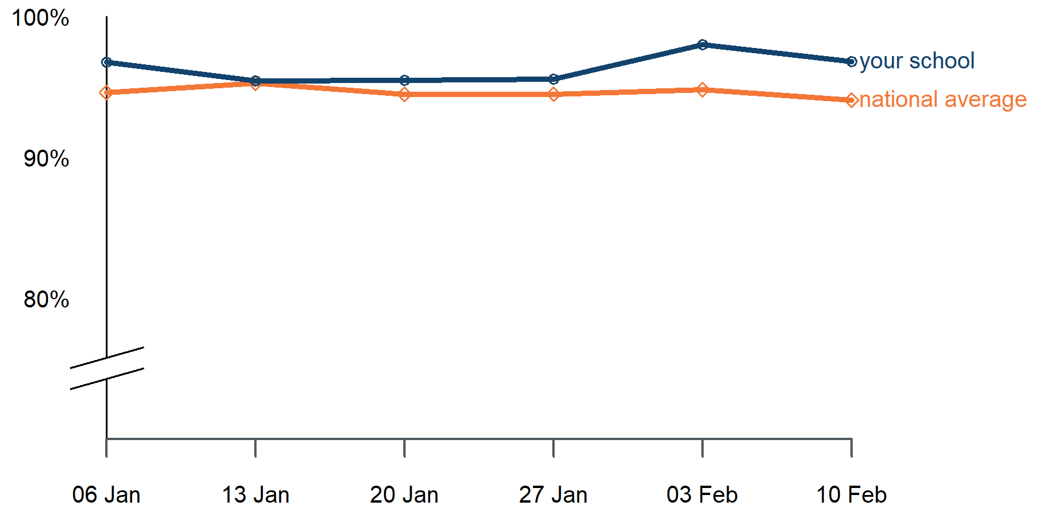

Graph alternative: table of weekly attendance for the first half of the spring term 2024 to 2025
Week start date | Attendance | National average
06/01/2025 | 96.8% | 94.6%
13/01/2025 | 95.5% | 95.3%
20/01/2025 | 95.5% | 94.5%
27/01/2025 | 95.6% | 94.5%
03/02/2025 | 98% | 94.8%
10/02/2025 | 96.8% | 94.1%
Sources: Monitor your school attendance results for your school and nationally, data from the DfE.
Notes:
Attendance results for your school and individual pupils are updated daily via the Monitor your school attendance tool.
Pupil attendance in schools data from national and local authorities is published on Explore Education Statistics every 2 weeks.

Attendance by pupil group
Figure 2: Bar chart showing attendance percentages for different pupil compared to the national averages. Results are based on pupils with free school meals (FSM) and special educational needs (SEN) support in years 1 to 6 from the start of the academic year 2024 to 2025, up to Tuesday 18 February 2025.
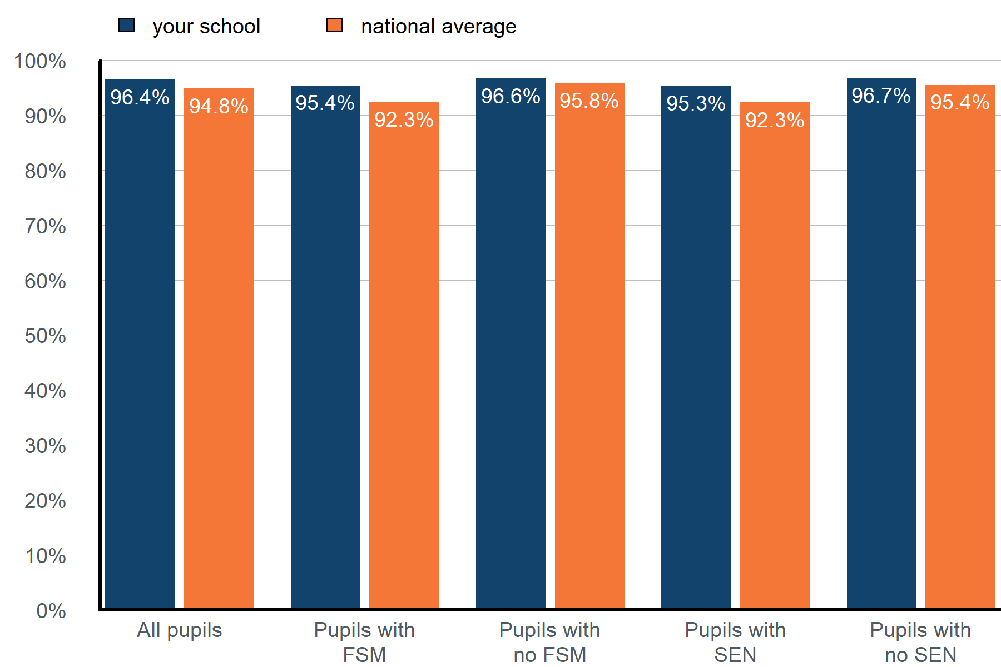

Graph alternative: table of attendance by pupil groups from the start of the academic year 2024 to 2025, up to Tuesday 18 February 2025.
Pupil group | Attendance | National average
All pupils | 96.4% | 94.8%
Pupils with FSM | 95.4% | 92.3%
Pupils with no FSM | 96.6% | 95.8%
Pupils with SEN | 95.3% | 92.3%
Pupils with no SEN | 96.7% | 95.4%
Sources: Monitor your school attendance results for your school and nationally, data from the DfE.
Notes:
Special education needs (SEN) support data is taken from the latest record available in your management information system (MIS). SEN support pupil numbers include those with an education health and care plan (EHCP).
Year-to-date attendance figures for SEN and EHCP pupils are available via the Monitor your school attendance tool.

Previous academic year comparison
Figure 3: Bar chart showing attendance for your school and different pupil groups from the start of the academic year 2024 to 2025, up to Tuesday 18 February 2025 compared to the same time period in the previous academic year.
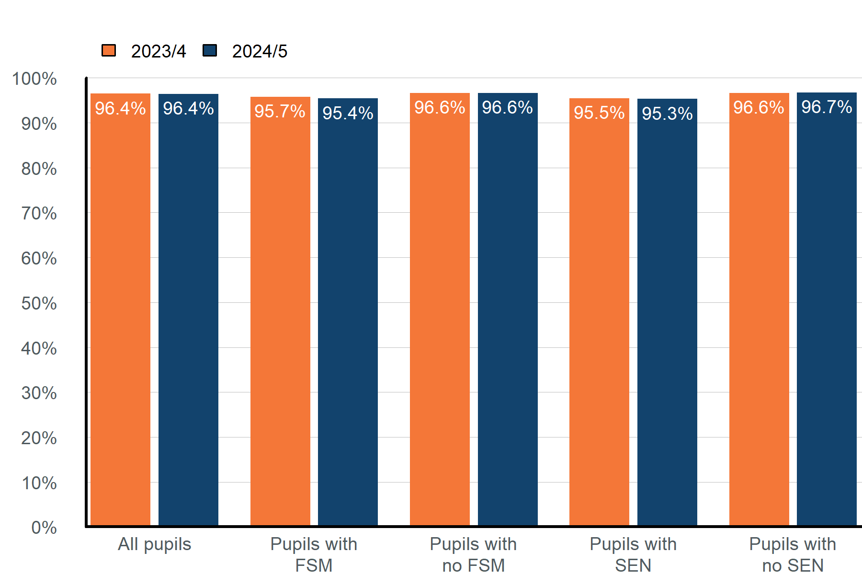

Graph alternative: table of attendance by pupil groups from the start of the academic year 2024 to 2025, up to Tuesday 18 February 2025 , compared to the same period in the previous academic year.
Pupil group | Attendance 2023/4 | Attendance 2024/5
All pupils | 96.4% | 96.4%
Pupils with FSM | 95.7% | 95.4%
Pupils with no FSM | 96.6% | 96.6%
Pupils with SEN | 95.5% | 95.3%
Pupils with no SEN | 96.6% | 96.7%
Sources: Monitor your school attendance results for your school, data from the DfE.
Notes:
You can compare the current and previous academic year for the whole school, an individual pupil or pupil characteristic groups via the Monitor your school attendance tool:
- Year-to-date report
- Previous academic year report

Absence by year group
Figure 4: Table showing the percentage of pupils in each year group in each 5% absence band up to 50% and above, from the start of the academic year 2024 to 2025, up toTuesday 18 February 2025. Results are based on pupils with 20 or more possible sessions in the academic year-to-date.
Overall Absence Band | Year 1 | Year 2 | Year 3 | Year 4 | Year 5 | Year 6
less than 5% | 65% | 85% | 90% | 80% | 82% | 75%
5% to less than 10% | 24% | 10% | 5% | 16% | 14% | 10%
10% to less than 15% | 12% | 0% | 0% | 4% | 5% | 10%
15% to less than 20% | 0% | 0% | 5% | 0% | 0% | 0%
20% to less than 25% | 0% | 0% | 0% | 0% | 0% | 5%
25% to less than 30% | 0% | 0% | 0% | 0% | 0% | 0%
30% to less than 35% | 0% | 5% | 0% | 0% | 0% | 0%
35% to less than 40% | 0% | 0% | 0% | 0% | 0% | 0%
40% to less than 45% | 0% | 0% | 0% | 0% | 0% | 0%
45% to less than 50% | 0% | 0% | 0% | 0% | 0% | 0%
50% and above (severely absent) | 0% | 0% | 0% | 0% | 0% | 0%
10% and above (persistently absent) | 12% | 5% | 5% | 4% | 5% | 15%
Sources: Monitor your school attendance results for your school, data from the DfE.
Notes:
Absence data is updated daily via the Monitor your school attendance tool. Use the absence bandings report to review the absence distribution for each of your schools, following the approach set out in the absence bandings user guide on GOV.UK.
© Crown copyright 2025

